(Below is the image reference taken from TRAI website - <https://www.trai.gov.in/sites/default/files/201506090333529087238siddharth.pdf>)

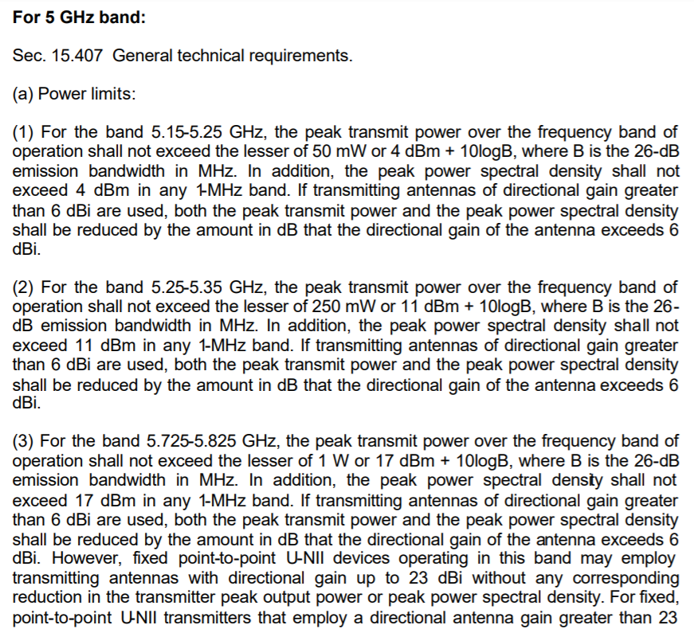

We can see in the above reference, that for every different frequency band mentioned above the directional gain of the antenna is to be fixed at 6 dBi.

And it is also important to note that there is no such gain limit for the receiving antenna.

**Directional Antenna:**

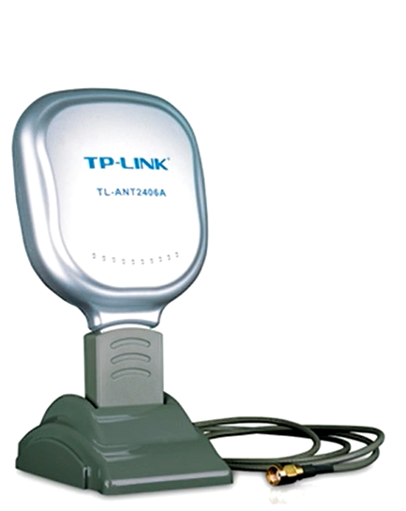 - This is usually how it looks like. And can be easily bought online.

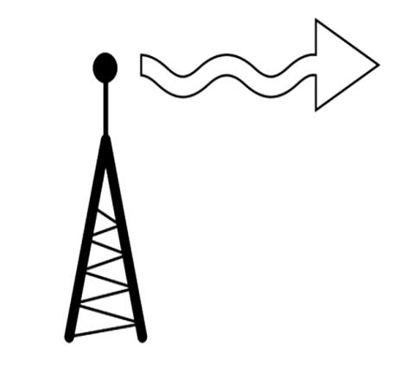 - This is what they do, make the radio wave propagate out in a specific direction.

* **What is the GAIN (dB) of an antenna**:

Gain of an antenna is a way of describing how much a directional antenna increases the strength of a signal. Gain is measured in dBi which is a logarithmic scale.

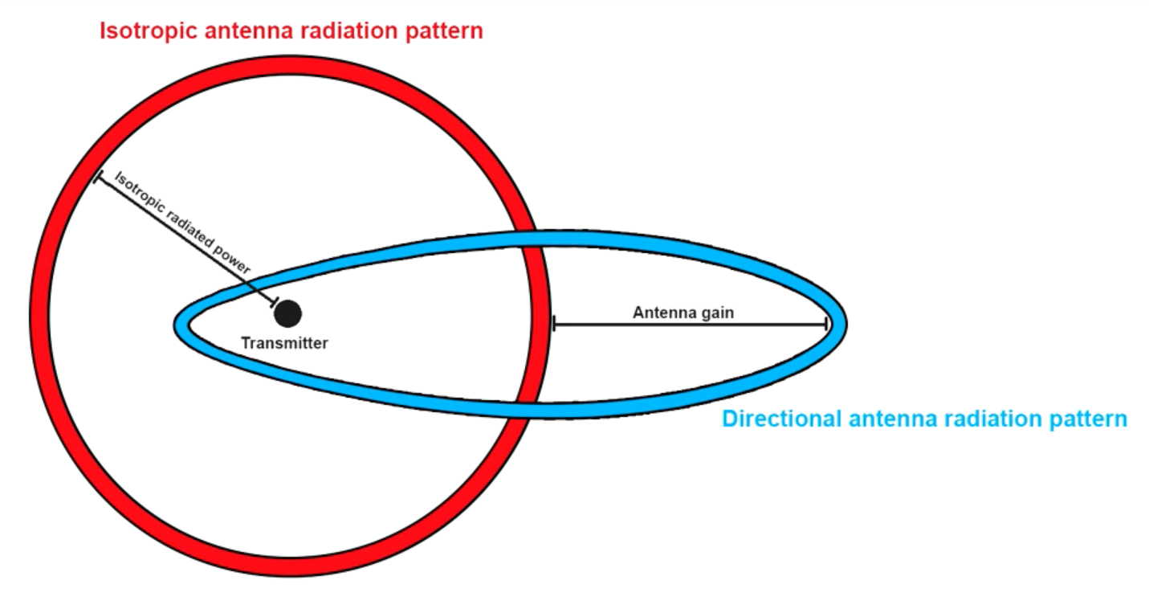

Directional antennas transmit and receive signals in a particular direction. And for now we could just gain the ability of our directional antenna to do this.

In the United States the FCC (Federal communication commission) decides the maximum power output of a radio transmitter. In India we have the TRAI (Telecom Regulatory Authority of India) And WPC (Wireless planning and coordination wing). The FCC limits the ability of the American locals to use high gain antennas on their transmitters to 6 dBi and it is same in India too (Image below).