* **Now let’s move on to the methods of wireless power transmission that work and which are widely being used in the industry right now:**

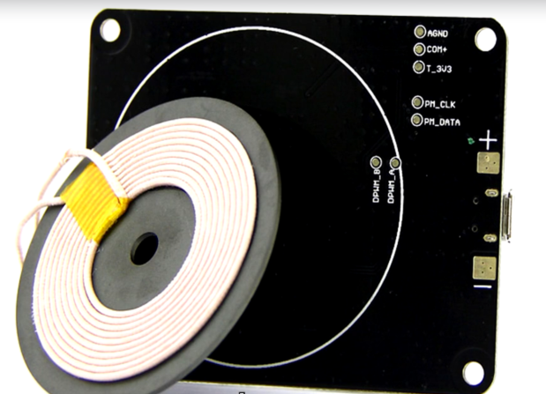It is the inductive methods that work were well for wireless charging. The wireless charging schemes that we see in the modern Samsung phones and apple watches uses a system called the “Inductive resonant power transfer”.

Here’s the game plan:

Let’s start out with a review of the **basics of electromagnetic induction and inductive coupling**. Then we're going to talk about **inverter circuits** and build a really simple wireless power transfer system. Then we're going to talk about **resonance** and why it makes all the difference in wireless power. Next we're going to upgrade our wireless power system and **observe the gains in range and efficiency** then we're going to talk about the shortcomings in our system and how modern solutions such as the standard and address them.

* 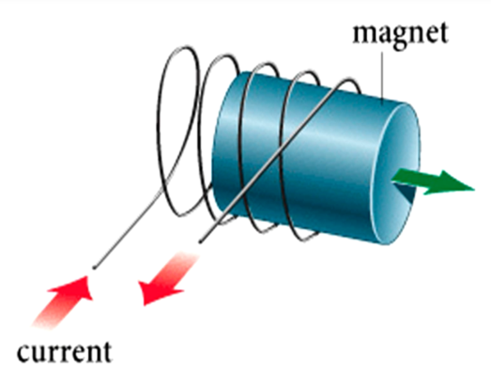**Basics of electromagnetic induction:**
* Whenever you have a magnetic field moving through a coil of wire you get an electric current.(Image 1)
* And whenever you have a electric current flowing through a coil, there is always a magnetic field around the it.(Image 2)

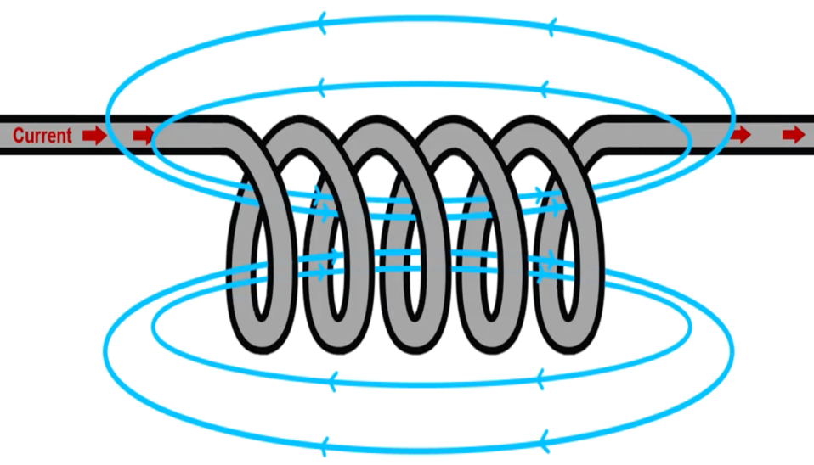

There are various methods of verifying this phenomenon.

We can take ample references from the internet. Thus, we will not dive deep into the basics.

Now let’s consider a **transformer**.

* 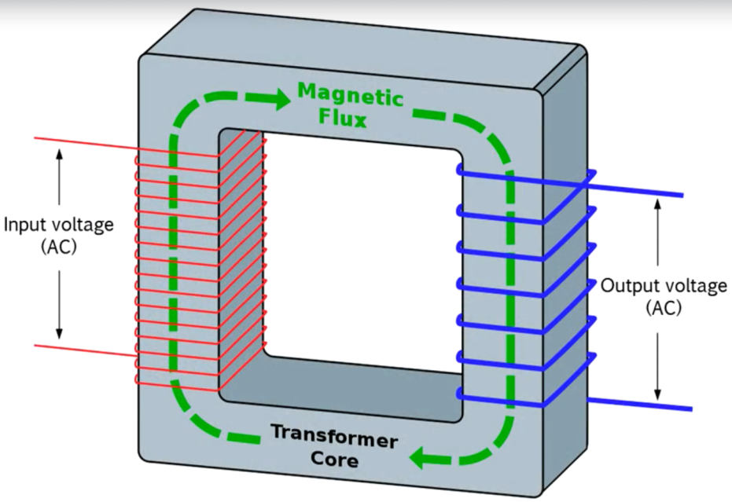**Transformer** is a device that works on the principle of mutual **Inductance.**
* A transformer takes in electricity

Turns it into magnetic field and again turns it back to electricity.

If you push and pull alternating current through the input of a transformer it creates an expanding and collapsing magnetic field within the Transformers core.

* Now when you put this alternating magnetic field in the presence of another coil the moving magnetic flux will induce electrical current into this secondary coil.
* So you'll get another AC voltage on the output side of the transformers.
* This only works with alternating current because of the rule we saw above where current only gets induced when magnetic flux is moving through the core of the transformer which is made of a metal that enhances the magnetic field increasing its strength for a given current flowing through the input thereby increasing its efficiency in real life.
* 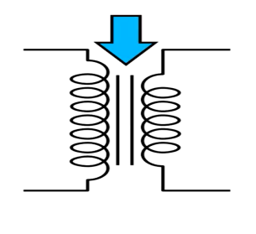These transformers of course are usually made out of a ferromagnetic material like Iron. And they tend to be really big and heavy.
* Now let us see the circuit symbol of transformer:

The two parallel lines that we see in between the windings symbolise the metallic core of the transformer.

Inductive wireless power transfer is basically the same thing as without an iron core.

* You essentially create an air core transformer and it works the same way as a regular transformer.
* You **push and pull current through the input** or the primary side of the transformer.
* This **causes a changing magnetic field to be created in the air gap**.
* And then this magnetic field moving through the secondary coil **induces alternating current on the output**.