**Basic Functionality of Oscilloscopes:**

* Display waveforms (Live)
* Capture waveforms (for analysis)
* Trigger Control (Detect change)
* Measuring multiple parameters (Like frequency, average current/ voltage….)
* Decoding (Information stored in waveform)

**Basic Controls:** When we look at an oscilloscope we see:

1. 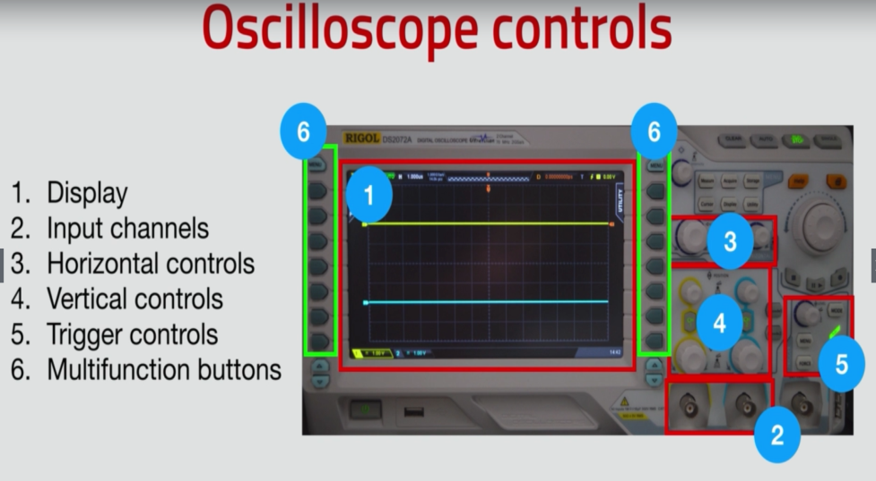Display
2. Input channels
3. Vertical controls
4. Horizontal controls
5. Trigger control
6. Multifunction buttons

**Probes:**

