DAILY ASSESSMENT REPORT

|  |  |  |  |
| --- | --- | --- | --- |
| **Date:** | **27 May 2020** | **Name:** | **Yalpi Nandika** |
| **Course:** | **DIGITAL SIGNAL PROCESSING** | **USN:** | **4AL17EC096** |
| **Topic:** | * **Fourier Transforms** * **FFT** * **FFT Fast Fourier Transform Matlab** * **FIR and IIR Filters** * **Study and analysis FIR and IIR using FDA tool in MatLab** * **Introduction to WT** * **CWT & DWT** * **Implementation of signal Filtering signal using WT in MatLAb** * **Short-time Fourier Transform and the Spectogram** * **Welch's method and windowing** * **ECG Signal Analysis Using MATLAB** | **Semester & Section:** | **6th sem & B sec** |
| **Github Repository:** | **Yalpi-Online-Courses** |  |  |

|  |
| --- |
| **FORENOON SESSION DETAILS** |
| **Image of session:** Fourier Transforms:  * **Digital Signal Processing/Discrete Fourier Transform. As the name implies, the**   Discrete Fourier Transform (DFT) is purely discrete: discrete-time data sets are converted into a discrete-frequency representation. This is in contrast to the DTFT that uses discrete time, but converts to continuous frequency. |

**FFT Fast Fourier Transform Matlab : Code:**

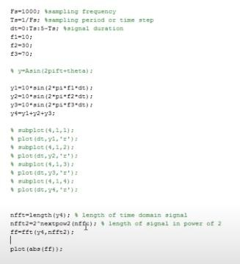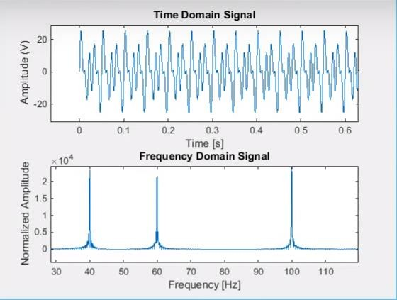

**Output:**

**FIR and IIR Filters:**

* 1. **FIR Filter**

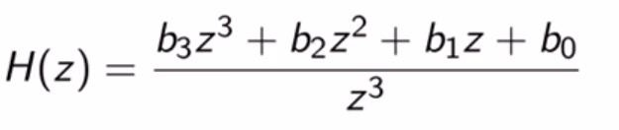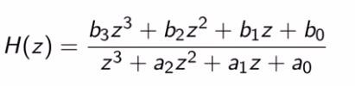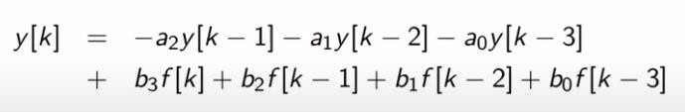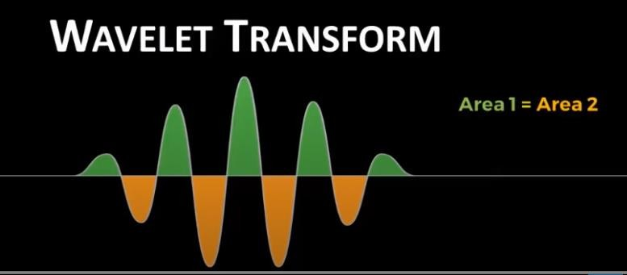

# 2. IIR Filter

# Introduction to WT:

* **A wavelet transform (WT) is the decomposition of a signal into a set of basis functions consisting of contractions, expansions, and translations of a mother function ψ(t), called the wavelet (Daubechies, 1991).**

# Implementation of signal Filtering signal using WT in MatLAb: Code:

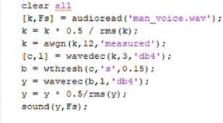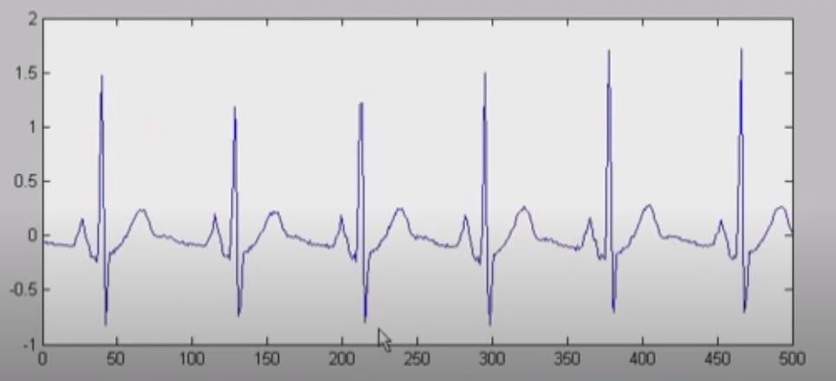

**Short-time Fourier Transform and the Spectogram:**

* **The Short-time Fourier transform (STFT), is a [Fourier-related transform](https://en.wikipedia.org/wiki/List_of_Fourier-related_transforms) used to determine the sinusoidal frequency and phase content of local sections of a signal as it changes over time.**
* **In practice, the procedure for computing STFTs is to divide a longer time signal into shorter segments of equal length and then compute the Fourier transform separately on each shorter segment.**
* **This reveals the Fourier spectrum on each shorter segment. One then usually plots the changing spectra as a function of time, known as a [spectrogram](https://en.wikipedia.org/wiki/Spectrogram) or waterfall plot.**

# ECG Signal Analysis Using MATLAB:

|  |  |  |  |
| --- | --- | --- | --- |
|  |  |  |  |
|  |  |  |  |