**DAILY ASSESSMENT FORMAT**

|  |  |  |  |
| --- | --- | --- | --- |
| **Date:** | **17/06/2020** | **Name:** | **Yashaswini.R** |
| **Course:** | **Statistical learning** | **USN:** | **4AL17EC98** |
| **Topic:** | **1.IntroductiontoProbability**  **2.RulesforProbabilitycalculation**  **3.Baye’s Theorem**  **4.NormalDistribution** | **Semester & Section:** | **6thsem ‘B’ sec** |
| **Github Repository:** | **Yashaswini** |  |  |

|  |
| --- |
| **FORENOON SESSION DETAILS** |

**Image of session**



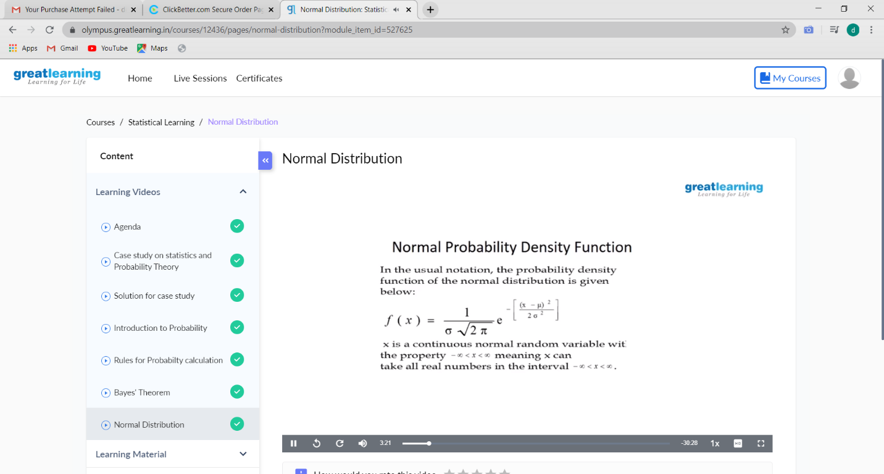

**Probability:**

* Probability is the science of how likely events are to happen.
* At its simplest, it's concerned with the roll of a dice, or the fall of the cards in a game.
* Probability is used, for example, in such diverse areas as weather forecasting and to work out the cost of your insurance premiums.

**Rules for Probability Calculation:**

Before discussing the rules of probability,We state the following definitions:

* Two Events are mutually exclusive or disjoint if they cannot occur at the same time.
* The probability that Event A occurs, given that Event B has occurred, is called aconditional probability.
* The conditional probability of Event A, given Event B, is denoted by the symbol P(A|B).
* The Complement of an event is the event not occurring.
* The probability that Event A will not occur is denoted by P(A').
* The probability that Events A and B both occur is the probability of the intersection of A and B.
* The probability of the intersection of Events A and B is denoted by P(A∩B). If Events A and B are mutually exclusive, P(A∩B) = 0.
* The probability that Events A or B occur is the probability of the union of A and B.
* The probability of the union of Events A and B is denoted by P(A∪B).
* If the occurrence of Event A changes the probability of Event B, then Events A and B are dependent
* On the other hand, if the occurrence of Event A does not change the probability of Event B, then Events A and B are independent

**Rule of Subtraction:**

* The probability of an event ranges from 0 to 1.
* The sum of probabilities of all possible events equals 1.
* The rule of subtraction follows directly from these properties