**DAILY ASSESSMENT FORMAT**

|  |  |  |  |
| --- | --- | --- | --- |
| **Date:** | **29/06/2020** | **Name:** | **Yashaswini R** |
| **Course:** | **Satellite Photogrammmetry and its Applications** | **USN:** | **4AL17EC098** |
| **Topic:** | **Introduction to Photogrammetric Concepts** | **Semester & Section:** | **6th sem ‘B’ sec** |
| **Github Repository:** | **Yashaswini** |  |  |

|  |
| --- |
| **AFTERNOON SESSION DETAILS** |

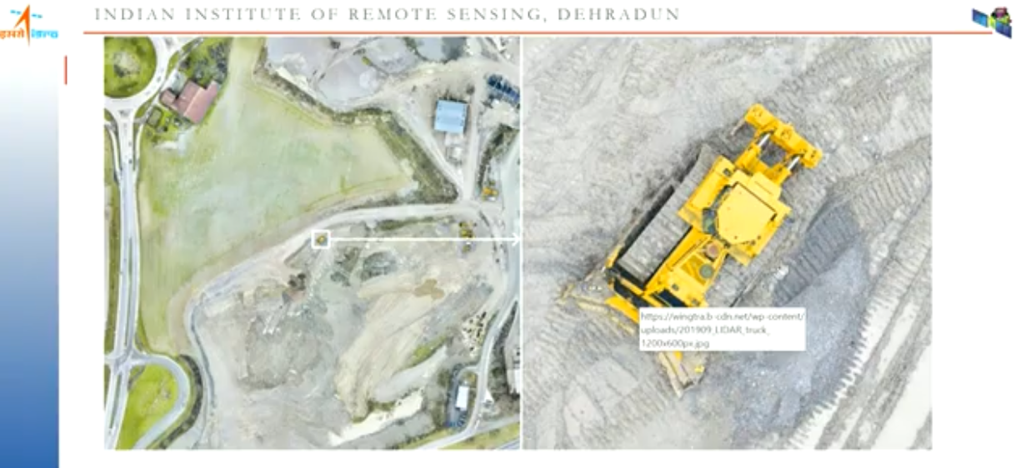

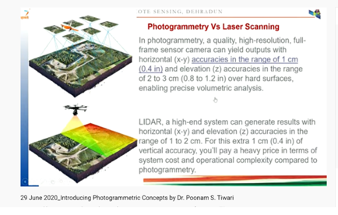

**Photogrammetry** is used in fields such as topographic mapping, architecture, engineering, manufacturing, quality control, police investigation, cultural heritage, and geology.

The four most common mapping projects that utilize satellite imagery include:

* Orthomosaics
* Planimetric mapping
* Classification mapping
* Topographic mapping

The **fundamental principle used by Photogrammetry** is

* Triangulation or more specifically called Aerial Triangulation.
* By taking photographs from at least two different locations, so-called “lines of sight” can be developed from each camera to points on the object.
* These lines of sight (sometimes called rays owing to their optical nature) are mathematically intersected to produce the 3-dimensional coordinates of the points of interest.

The **Photogrammetric** process can be resumed as follows:

* Image acquisition/recording;
* Image orientation and stereo-model generation;
* Stereo-plotting that is object measurement inside the generated stereo-model;
* Eventual orthoimage generation.

**Applications**:

* The measuring of coordinates
* Quantification of distances
* Heights, areas, and volumes
* 3D topographic mapping
* The extraction of 3D point clouds for surface reconstructions