DAILYASSESSMENTFORMAT

|  |  |  |  |
| --- | --- | --- | --- |
| Date: | 15-07-2020 | Name: | Yashwitha C N |
| Course: | Coursera | USN: | 4AL17EC099 |
| Topic: | MathematicsforMachine Learning:LinearAlgebra | Semester &Section: | 6thSEMand'B'section |
| Github Repositor y: | Yashwitha-coures |  |  |
| FORENOONSESSIONDETAILS(9.00amto1.00pm) | | | | | |
|  | | | | | |

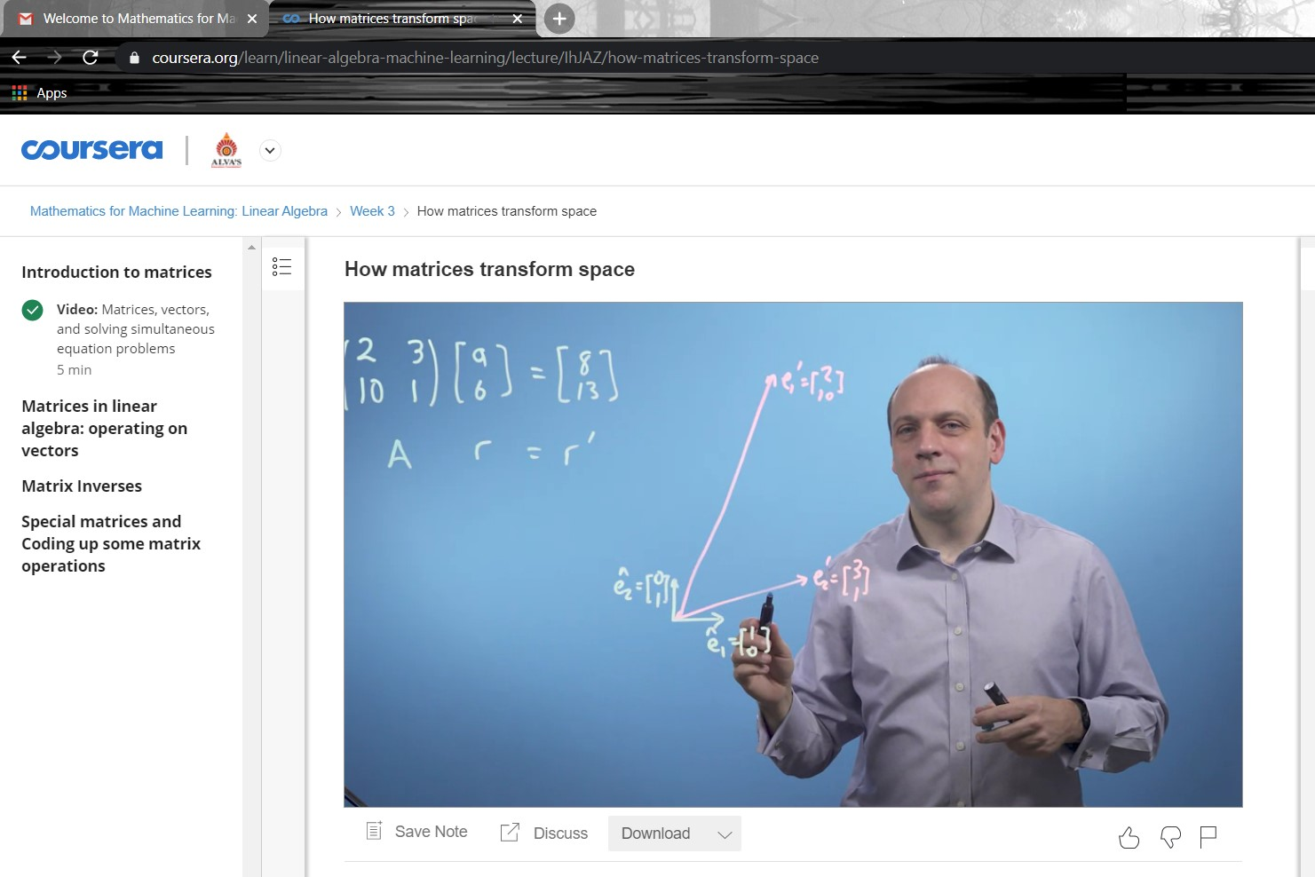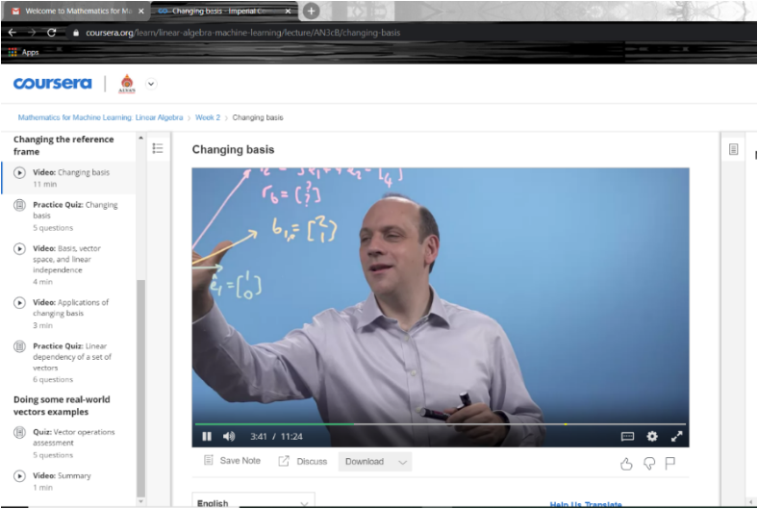

Matrix isanarrangementofnumbersintorowsandcolumns.Makeyour first introduction with matrices andlearnabouttheirdimensionsandelements. A matrix isarectangulararrangementofnumbersintorowsandcolumns.For example, matrix Ahastworowsandthreecolumns.

Themathematical concept ofa matrix referstoasetofnumbers,variablesorfunctions orderedinrowsandcolumns.Suchasetthencanbedefinedasadistinctentity, the matrix,anditcanbemanipulatedasawholeaccordingtosomebasicmathematical rules.

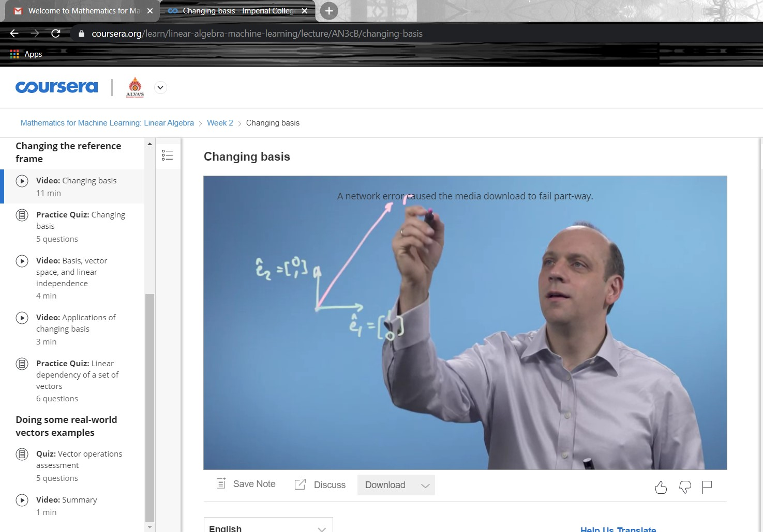

Matrices canbe usedto compactlywriteandworkwithmultiplelinearequations, referred to as a system of linear equations,

simultaneously. Matrices and matrix multiplicationrevealtheiressentialfeatureswhen relatedtolineartransformations,alsoknownaslinearmaps.

A matrix isacollectionofnumbersarrangedintoafixednumberofrowsandcolumns. Usuallythenumbersarerealnumbers.Ingeneral, matrices cancontaincomplex numbersbutwewon'tseethosehere.

Ingeology, matrices are used formakingseismicsurveys.Theyare used forplotting graphs,statisticsandalsotodoscientificstudiesandresearchinalmostdifferent fields. Matrices arealso used inrepresentingthe realworld data'slikethepopulationof people,infantmortalityrate,etc.

MainpointoftheMatrix

The Matrix trilogysuggeststhateveryonehastheindividualresponsibilitytomakethe choicebetweentherealworldandanartificialworld.ThoughNeoistheexemplaroffree will,fateplaysalargeroleinhisadventure.NeoreliesontheOracle,andeverythingshe sayscomestrueinsomeway.

Application of Matrices

Almosteverybranchofphysics,includingclassicalmechanics,optics,electromagnetism, quantummechanics,andquantumelectrodynamics, matrices areusedtostudyphysical phenomena,suchasthemotionofrigidbodies.

Matrices havealsocometohaveimportantapplicationsincomputergraphics,where theyhavebeenusedtorepresentrotationsandothertransformationsofimages.isa2× 3 matrix.A matrix withnrowsandncolumnsiscalledasquare matrix ofordern Matrices areclassifiedaccordingtothenumberofrowsandcolumns,andthespecific elementstherein.(i)Row Matrix:A matrix whichhasexactlyonerowiscalleda row matrix.Theabovetwo matrices arerow matrices becauseeachhasonlyonerow.

Matrices area useful waytorepresent,manipulateandstudylinearmapsbetweenfinite dimensionalvectorspaces(ifyouhavechosenbasis). Matrices canalsorepresent quadraticforms(it's useful,forexample,inanalysistostudyhessian matrices,which helpustostudythebehaviorofcriticalpoints).

The numbers in a matrix can represent data, and they can also represent mathematical equations.Evenmorefrequently,they'recalleduponto multiply matrices. Matrix multiplicationcanbethoughtofassolvinglinearequationsfor particularvariables.

Theseriesprimarilyconsistsofatrilogyofsciencefictionactionfilmsbeginningwith The Matrix (1999)andcontinuingwithtwosequels,The Matrix Reloadedand The Matrix Revolutions(bothin2003),allwrittenanddirectedbytheWachowskisand producedbyJoelSilver.

|  |  |  |  |  |  |  |  |  |  |  |  |  |  |  |  |  |
| --- | --- | --- | --- | --- | --- | --- | --- | --- | --- | --- | --- | --- | --- | --- | --- | --- |
| Theterm matrix wasintroducedbythe19th-centuryEnglishmathematicianJames Sylvester,butitwashisfriendthemathematicianArthurCayleywhodevelopedthe algebraicaspectof matrices intwopapersinthe1850s.  Inbiology, matrix isthematerial(ortissue)inanimalorplant.Structureofconnective tissuesisanextracellular matrix....Itisfoundinvariousconnectivetissue.Itisgenerally usedasajellylikestructureinsteadofcytoplasminconnectivetissue.  BONE CELLS. Bonematrix issynthesizedbyalayerofosteoblastsonthe bone surface (Figs.1-22and1-23).Theosteoblastsaremesenchymalinoriginandcharacterizedby theirabundantendoplasmicreticulumandtheir production oftheenzymealkaline phosphatase.  Inthe mitochondrion,the matrix isthespacewithintheinnermembrane.Theword "matrix"stemsfromthefactthatthisspaceisviscous,comparedtotherelatively aqueouscytoplasm.  The extracellularmatrix (ECM)isthenon-cellularcomponentpresentwithinalltissues andorgans,andprovidesnotonlyessentialphysicalscaffoldingforthecellula constituentsbutalsoinitiatescrucialbiochemicalandbiomechanicalcuesthatare requiredfortissuemorphogenesis,differentiationandhomeostasis.   |  |  |  |  | | --- | --- | --- | --- | | Date: | 15-07-2020 | Name: | Yashwitha C N | | Course: | Coursera | USN: | 4AL17EC099 | | Topic: | IndustrialIoTonGoogle CloudPlatform | Semester &Section: | 6thSEMand'B'section | | Github  Repository: | Yashwitha-coures |  |  | |

r

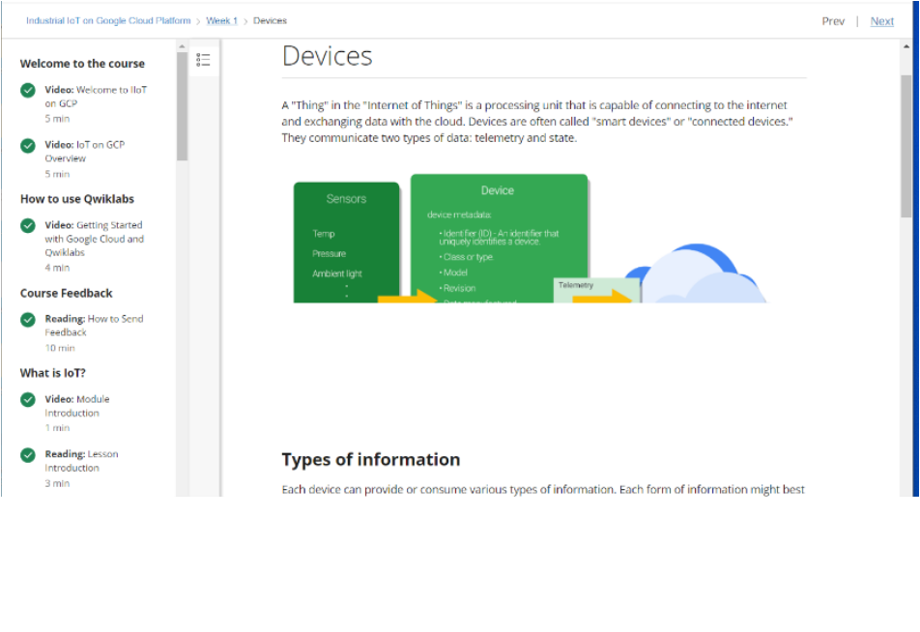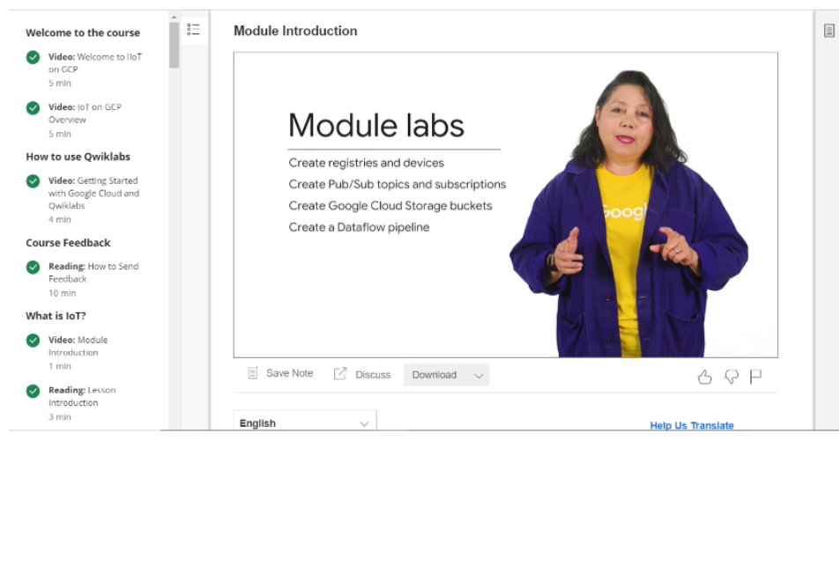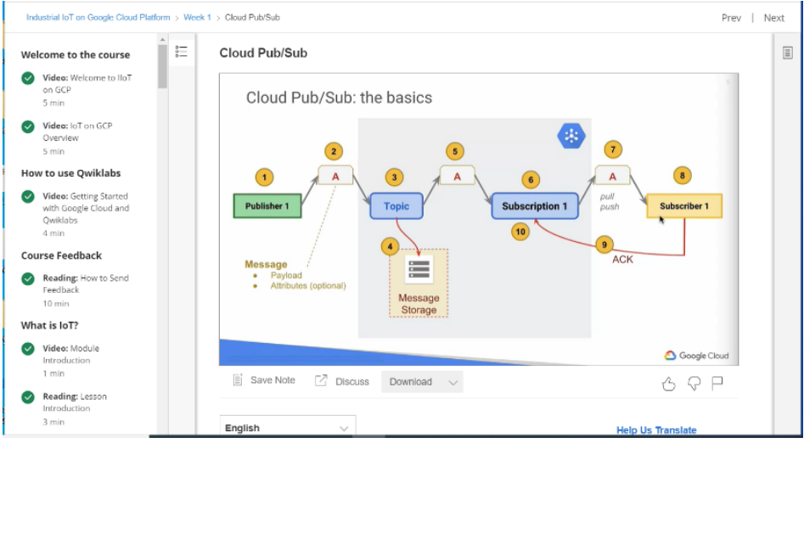

|  |  |  |
| --- | --- | --- |
| GoogleCloudPlatform (GCP),offeredby Google,isasuiteof cloudcomputing services thatrunsonthesameinfrastructurethatGoogleusesinternallyforitsend-userproducts, suchas GoogleSearch, Gmail and YouTube. Alongsideasetofmanagementtools,it providesaseriesofmodularcloudservicesincludingcomputing, datastorage, data analytics and machinelearning. Registrationrequiresa creditcard orbankaccount details.  GoogleCloudPlatformprovides infrastructureasaservice, platformasaservice, and serverlesscomputing environments.  InApril2008,Googleannounced AppEngine,aplatformfordevelopingandhostingweb applicationsinGoogle-managed datacentres,whichwasthefirstcloudcomputing servicefromthecompany.TheservicebecamegenerallyavailableinNovember2011. SincetheannouncementoftheAppEngine,Googleaddedmultiplecloudservicestothe platform.  GoogleCloudPlatformisapart of GoogleCloud,whichincludestheGoogleCloud Platformpubliccloudinfrastructure,aswellas GSuite,enterpriseversions  of Android and ChromeOS,and applicationprogramminginterfaces(APIs) for machine learning andenterprisemappingservices.  Storage&Databases   * CloudStorage - Objectstorage withintegratededgecachingtostore unstructured data. * CloudSQL- DatabaseasaService basedon MySQL and PostgreSQL. * CloudBigtable -Managed NoSQL databaseservice. * CloudSpanner -Horizontallyscalable,stronglyconsistent, relationaldatabase service. * CloudDatastore -NoSQLdatabaseforwebandmobileapplications. * PersistentDisk-Blockstorage forComputeEnginevirtualmachines. * CloudMemoryStore-Managedin-memorydatastorebasedonRadis. * LocalSSD:High-performance,transient,localblockstorage. * Filestore:High-performancefilestorageforGoogleCloudusers. | | |
|  | Networking |  |

|  |
| --- |
| * VPC- VirtualPrivateCloud formanagingthe softwaredefinednetwork ofcloud resources. * CloudLoadBalancing-Software-defined,managedservicefor loadbalancing the traffic. * CloudArmour- Webapplicationfirewall toprotectworkloadsfrom DDoS attacks. * CloudCDN- ContentDeliveryNetwork basedonGoogle'sgloballydistributededge pointsofpresence. * CloudInterconnect-ServicetoconnectadatacentrewithGoogleCloudPlatform * CloudDNS-Managed,authoritative DNS servicerunningonthesameinfrastructure asGoogle. * NetworkServiceTiers-OptiontochoosePremiumvsStandardnetworktierforhigher -performingnetwork.   BigData   * BigQuery -Scalable,managedenterprise datawarehouse foranalytics. * CloudDataflow -Managedservicebasedon ApacheBeam forstreamandbatchdata processing. * CloudDataproc - Bigdata platformforrunning ApacheHadoop and Apache Spark jobs. * CloudComposer-Managedworkfloworchestrationservicebuilton ApacheAirflow. * CloudDatalab-Toolfor dataexploration, analysis,visualizationandmachine learning.ThisisafullymanagedJupiterNotebookservice. * CloudDataprep-Dataservicebasedon Trifecta tovisuallyexplore,clean,and preparedataforanalysis. * CloudPub/Sub-Scalableeventingestionservicebasedon messagequeues. * CloudDataStudio- Businessintelligence tooltovisualizedatathroughdashboards andreports.   CloudAI  •CloudAutoML-Servicetotrainanddeploycustommachine,learningmodels.As ofSeptember2018,theserviceisinBeta. |

|  |
| --- |
| •Cloud TPU -AcceleratorsusedbyGoogletotrainmachinelearningmodels.  •CloudMachineLearningEngine-Managedservicefortrainingandbuilding machinelearningmodelsbasedonmainstreamframeworks.  •CloudJobDiscovery-ServicebasedonGoogle'ssearchandmachinelearning capabilitiesfortherecruitingecosystem.  •DialogflowEnterprise-DevelopmentenvironmentbasedonGoogle'smachine learningforbuilding conversationalinterfaces.  •CloudNaturalLanguage- Textanalysis servicebasedonGoogle Deep Learning models.   * CloudSpeech-to-Text- Speechtotext conversionservicebasedonmachine learning. * CloudText-to-Speech- Texttospeech conversionservicebasedonmachine learning. * CloudTranslationAPI-Servicetodynamicallytranslatebetweenthousandsof availablelanguagepairs * CloudVisionAPI- Imageanalysis servicebasedonmachinelearning * CloudVideoIntelligence- Videoanalysis servicebasedonmachinelearning   ManagementTools   * Stackdriver -Monitoring,logging,anddiagnosticsforapplicationsonGoogleCloud PlatformandAWS. * CloudDeploymentManager-TooltodeployGoogleCloudPlatformresources definedintemplatescreatedin YAML, Python or Jinja2. * CloudConsole-WebinterfacetomanageGoogleCloudPlatformresources. * CloudShell -Browser-basedshellcommand-lineaccesstomanageGoogleCloud Platformresources. * CloudConsoleMobileApp- Android and iOS applicationtomanageGoogleCloud Platformresources. |

•

C

l

o

u

d

A

P

I

s

-

A

P

I

s

t

o

p

r

o

g

r

a

m

m

a

t

i

c

a

l

l

y

a

c

c

e

s

s

G

o

o

g

l

e

C

l

o

u

d

P

l

a

t

f

o

r

m

r

e

s

o

u

r

c

e

s