**DAILY ONLINE ACTIVITIES SUMMARY**

|  |  |  |  |  |  |  |  |  |
| --- | --- | --- | --- | --- | --- | --- | --- | --- |
| **Date:** | **7/6/2020** | | | | | **Name:** | **Amogha U** | |
| **Sem & Sec** | **8th Sem** | | | | | **USN:** | **4AL16CS010** | |
| **Online Test Summary** | | | | | | | | |
| **Subject** | | **----** | | | | | | |
| **Max. Marks** | | **----** | | **Score** | | | **----** | |
| **Certification Course Summary** | | | | | | | | |
| **Course** | **Intermediate Python** | | | | | | | |
| **Certificate Provider** | | | **datacamp** | | **Duration** | | | **4hrs** |
| **Coding Challenges** | | | | | | | | |
| **Problem Statement:**  1. Program to multiply two floating point numbers | | | | | | | | |
| **Status:COMPLETED** | | | | | | | | |
| **Uploaded the report in Github** | | | | | **yes** | | | |
| **If yes Repository name** | | | | | amogha_u | | | |
| **Uploaded the report in slack** | | | | | **yes** | | | |

Online Test Details: (Attach the snapshot and briefly write the report for the same)

Certification Course Details: (Attach the snapshot and briefly write the report for the same)

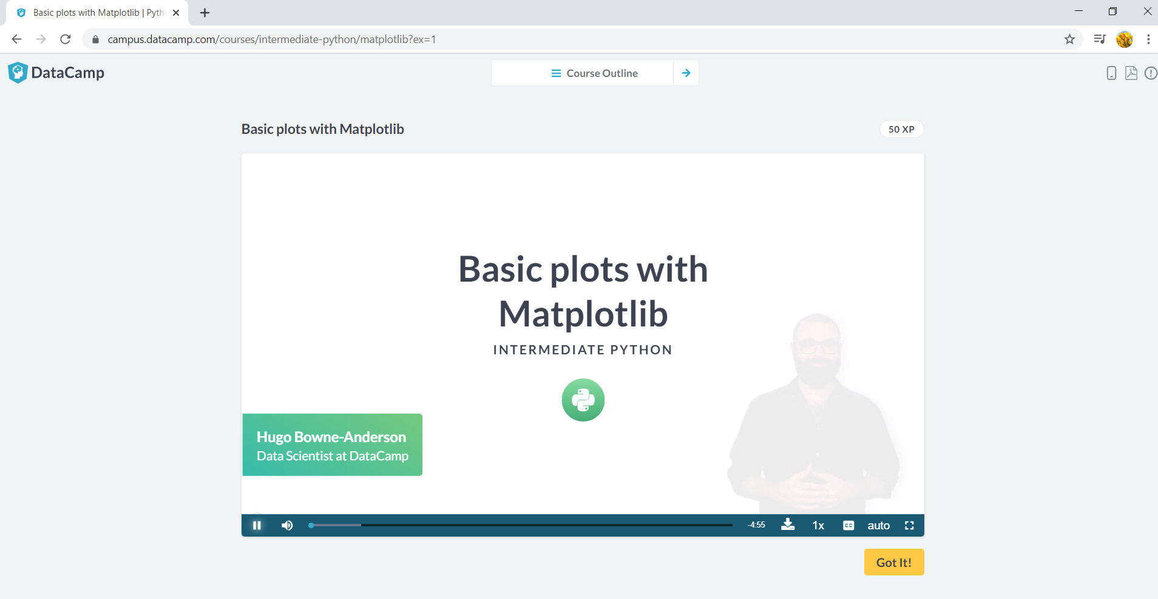

Coding Challenges Details: (Attach the snapshot and briefly write the report for the same)

Program to multiply two floating point numbers

#include<stdio.h>

int main()

{

double a,b,product;

printf("enter two numbers:");

scanf("%lf%lf",&a,&b);

product=a*b;

printf("Product=%.2lf",product);

return 0;

}