|  |  |  |  |
| --- | --- | --- | --- |
| **Date:** | **08/06/2020** | **Name:** | **Anand kumar k** |
| **Course:** | Management and leadership | **USN:** | **4AL16EC002** |
| **Topic:** |  | **Semester & Section:** | **8th sem ‘A’ sec** |
| **Github Repository:** | **Anand-courses** |  |  |

|  |
| --- |
| **Leadership** in business is the capacity of a company's **management** to set and achieve challenging goals, take fast and decisive action when needed, outperform the competition, and inspire others to perform at the highest level they can  **Screenshot (170).png** |

**DAILY ASSESSMENT**

**Leadership** is the action of leading people in an organization towards achieving goals. **Leaders** do this by influencing employee behaviors in several ways. A **leader** sets a clear vision for the organization, motivates employees, guides employees through the work process and builds morale.

There are three basic styles of leadership decision-making: authoritarian, democratic, and **laissez-faire**. Leaders who use authoritarian decision-making make all the major group decisions and demand compliance from the group members.

1. Autocratic. The ultimate task-oriented leadership style, autocratic or “command and control” leaders operate in an “I'm the boss” fashion. ...
2. Delegative. At the opposite end of the spectrum, the ultimate people-oriented leadership style is delegative or laissez-faire (“let it be”) leadership. ...
3. Democratic or Participative



**Context** is **importance** because it helps you connect and create a relationship with the reader. It helps you communicate your point of view clearly making it easier to understand. It allows you and others to be more creative.

**Team management tools:**

* 1- Delegation. An effective manager is humble enough to know that he can't do everything and needs to trust his members so that he can delegate the tasks to the proper person. ...
* 2- Motivation. ...
* 3- Development. ...
* 4- Communication. ...
* 5- Discipline.

**MY SQL REPORT**

**Name : Anand kumar k sem & sec : 8th sem ‘A’ sec**

**USN: 4AL16EC002**

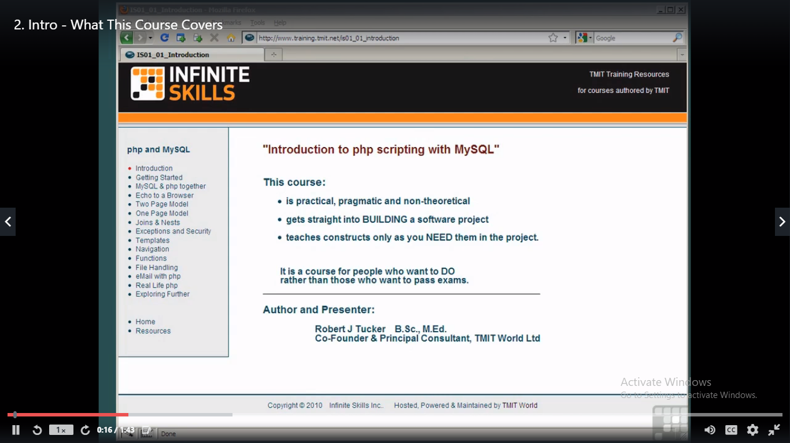

MySQL is a database management system. It may be anything from a simple shopping list to a picture gallery or the vast amounts of information in a corporate network. To add, access, and process data stored in a computer database, you need a database management system such as MySQL Server.

To add, access, and process data stored in a computer database, you need a database management system such as MySQL Server.

