**DAILY ONLINE ACTIVITIES SUMMARY**

|  |  |  |  |  |  |  |  |  |
| --- | --- | --- | --- | --- | --- | --- | --- | --- |
| **Date:** | **20-06-2020** | | | | | **Name:** | **Ankit Shetty** | |
| **Sem & Sec** | **6th B** | | | | | **USN:** | **4AL17CS086** | |
| **Online Test Summary** | | | | | | | | |
| **Subject** | |  | | | | | | |
| **Max. Marks** | |  | | **Score** | | |  | |
| **Certification Course Summary** | | | | | | | | |
| **Course** | **Cloud computing** | | | | | | | |
| **Certificate Provider** | | | **Great Learning** | | **Duration** | | | **5 hrs** |
| **Coding Challenges** | | | | | | | | |
| Python assignment program: To | | | | | | | | |
| **Status:completed** | | | | | | | | |
| **Uploaded the report in Github** | | | | | **yes** | | | |
| **If yes Repository name** | | | | | <https://github.com/alvas-education-foundation/ankit/tree/master/daily_progress> | | | |
| **Uploaded the report in slack** | | | | | **yes** | | | |

Certification details

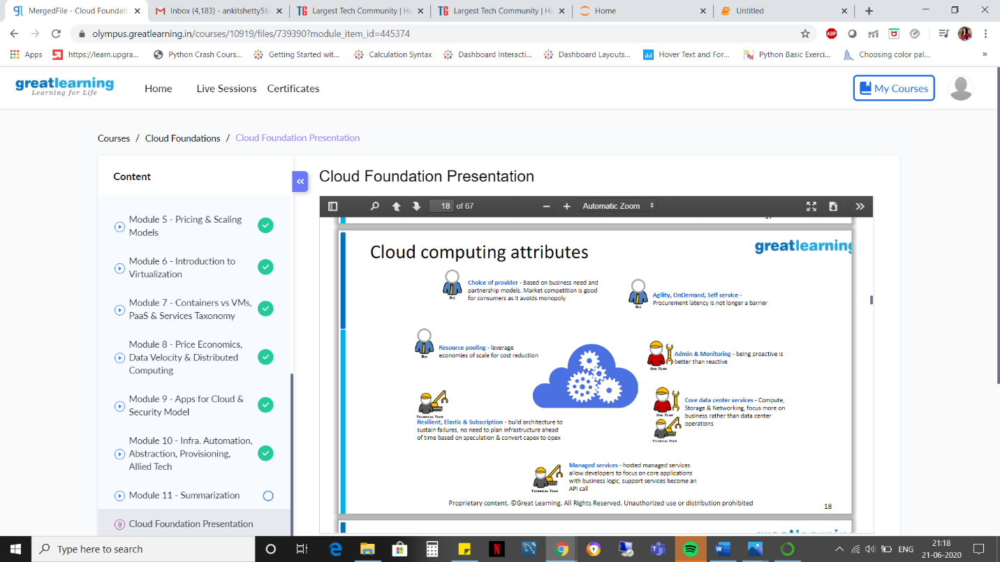

Assignment problem

Program1

