**DAILY ONLINE ACTIVITIES SUMMARY**

|  |  |  |  |  |  |  |  |  |
| --- | --- | --- | --- | --- | --- | --- | --- | --- |
| **Date:** | **22-05-2020** | | | | | **Name:** | **Ankit Shetty** | |
| **Sem & Sec** | **6th B** | | | | | **USN:** | **4AL17CS086** | |
| **Online Test Summary** | | | | | | | | |
| **Subject** | | **OR** | | | | | | |
| **Max. Marks** | | **30** | | **Score** | | | **30** | |
| **Certification Course Summary** | | | | | | | | |
| **Course** | **Data Visualization using python** | | | | | | | |
| **Certificate Provider** | | | **Great Learning** | | **Duration** | | | **4 hrs** |
| **Coding Challenges** | | | | | | | | |
| **Problem Statement: 1) Python program to print prime numbers in an interval**  **2) Python program to print sum of array** | | | | | | | | |
| **Status:completed** | | | | | | | | |
| **Uploaded the report in Github** | | | | | **yes** | | | |
| **If yes Repository name** | | | | | <https://github.com/alvas-education-foundation/ankit/tree/master/daily_progress> | | | |
| **Uploaded the report in slack** | | | | | **yes** | | | |

online test details

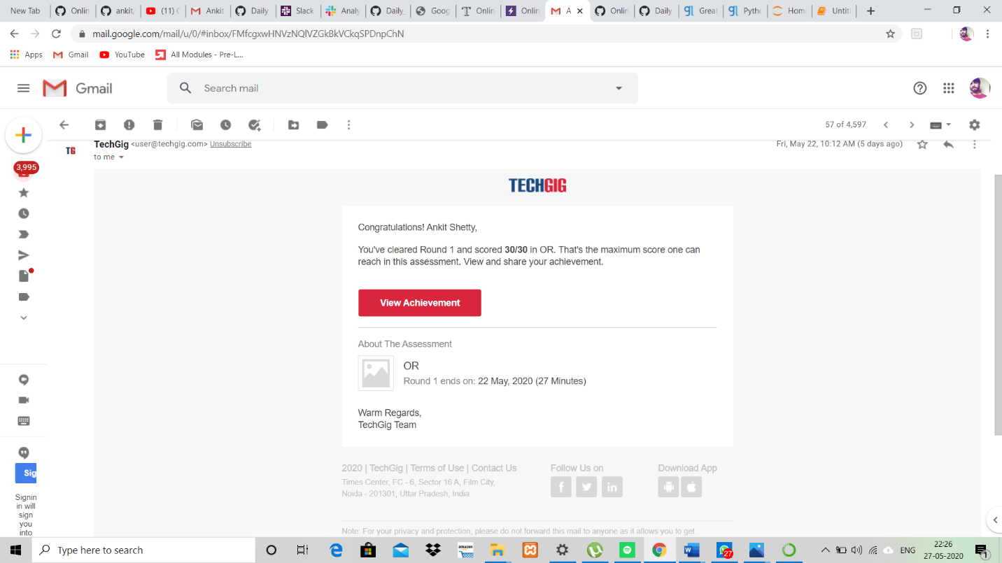

Certification details

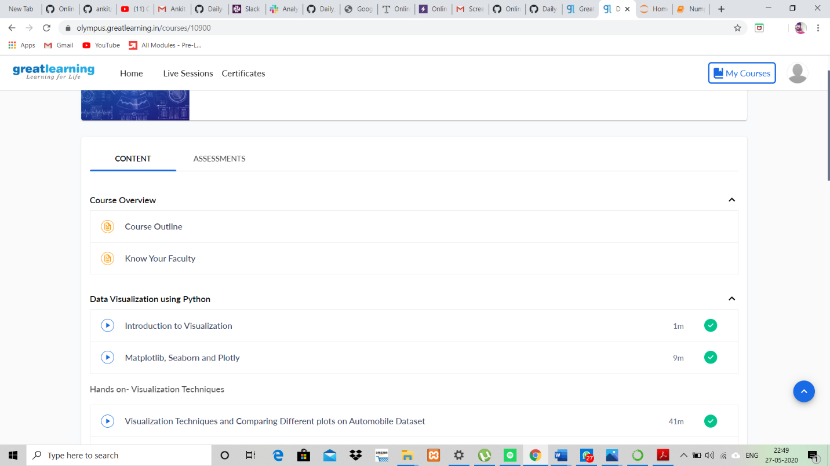

Coding Problems

Program1

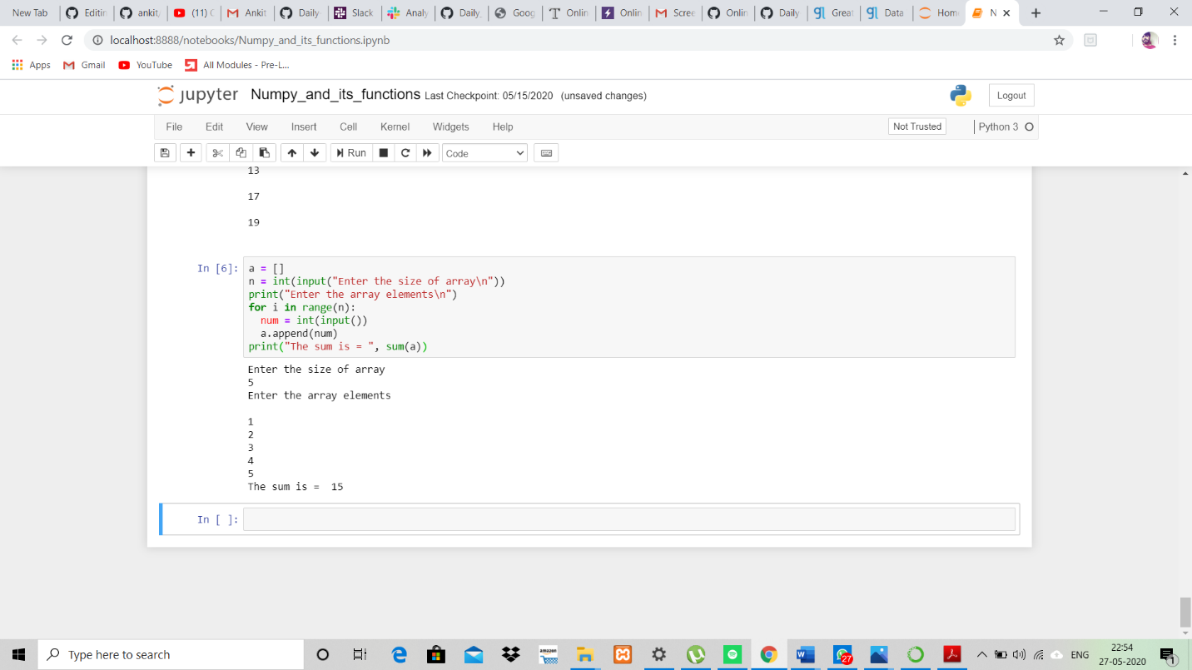

Program2

