**DAILY ONLINE ACTIVITIES SUMMARY**

|  |  |  |  |  |  |  |  |  |
| --- | --- | --- | --- | --- | --- | --- | --- | --- |
| **Date:** | **24/5/2020** | | | | | **Name:** | **Apoorva U** | |
| **Sem & Sec** | **8th Sem** | | | | | **USN:** | **4AL16CS017** | |
| **Online Test Summary** | | | | | | | | |
| **Subject** | | **----** | | | | | | |
| **Max. Marks** | | **---** | | **Score** | | | **----** | |
| **Certification Course Summary** | | | | | | | | |
| **Course** | **Introduction to Information Security** | | | | | | | |
| **Certificate Provider** | | | **greatlearning** | | **Duration** | | | **5.5 hrs** |
| **Coding Challenges** | | | | | | | | |
| **Problem Statement:**  Python program to read a number and compute a series | | | | | | | | |
| **Status:COMPLETED** | | | | | | | | |
| **Uploaded the report in Github** | | | | | **yes** | | | |
| **If yes Repository name** | | | | | apoorva-u | | | |
| **Uploaded the report in slack** | | | | | **yes** | | | |

Online Test Details: (Attach the snapshot and briefly write the report for the same)

Certification Course Details: (Attach the snapshot and briefly write the report for the same)

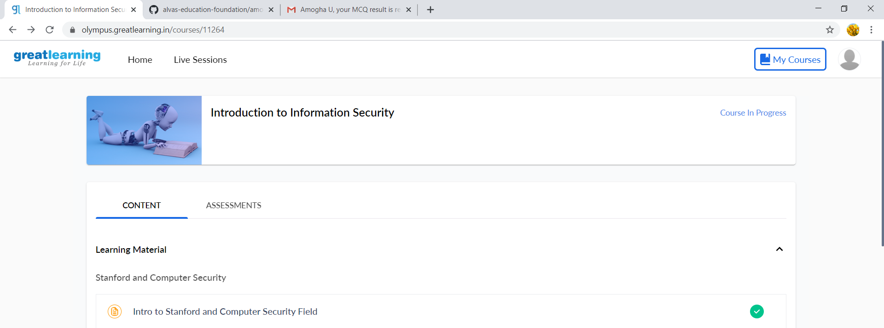

Coding Challenges Details: (Attach the snapshot and briefly write the report for the same)

Python program to read a number and compute a series

|  |
| --- |
| n=int(input("Enter a number: ")) |
|  | a=[] |
|  | for i in range(1,n+1): |
|  | print(i,sep=" ",end=" ") |
|  | if(i<n): |
|  | print("+",sep=" ",end=" ") |
|  | a.append(i) |
|  |  |
|  | print("=",sum(a)) print() |