**DAILY ONLINE ACTIVITIES SUMMARY**

|  |  |  |  |  |  |  |  |  |
| --- | --- | --- | --- | --- | --- | --- | --- | --- |
| **Date:** | **23/05/2020** | | | | | **Name:** | **Archana J C** | |
| **Sem & Sec** | **4th**  **‘A’** | | | | | **USN:** | **4AL18CS011** | |
| **Online Test Summary** | | | | | | | | |
| **Subject** | | **Data communication** | | | | | | |
| **Max. Marks** | | **30** | | **Score** | | | **25** | |
| **Certification Course Summary** | | | | | | | | |
| **Course** | **Python machine learning** | | | | | | | |
| **Certificate Provider** | | | **Great learning academy** | | **Duration** | | | **4-5days** |
| **Coding Challenges** | | | | | | | | |
| **Write a C Program to generate first N Triangular Numbers (Where N is Read from the Key board).** | | | | | | | | |
| **Status: Completed** | | | | | | | | |
| **Uploaded the report in Github** | | | | | **Yes** | | | |
| **If yes Repository name** | | | | | **Lockdown coding** | | | |
| **Uploaded the report in slack** | | | | | **Yes** | | | |

Online Test Details: (Attach the snapshot and briefly write the report for the same)The online test was from Data communication module 1 and module 2, in which its about introduction to data communication and networking, internet and protocols and standard of module1. Digital to digital conversion, Physical layer-2, analog to digital conversion, bandwidth utilization, swiching from module 2. There were 30 questions each of one mark, duration was 40 minutes. The question were easy to answer. The score that I received was 25/30.

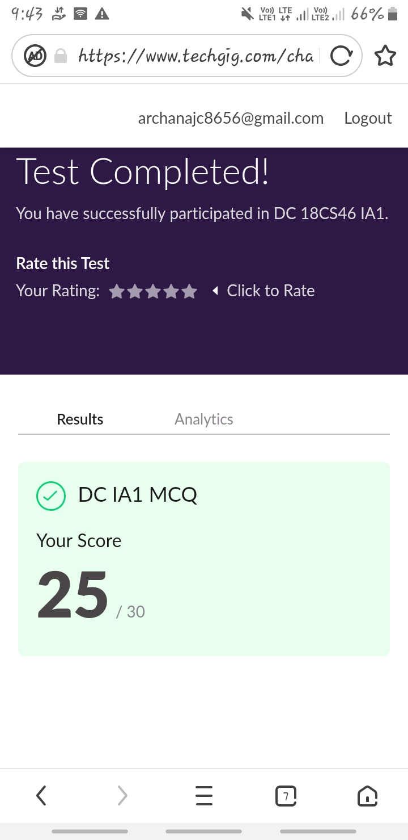

Certification Course Details: (Attach the snapshot and briefly write the report for the same)

COURSE NAME : Python machine learning

CERTIFICATION PROVOIDER : Great learning academy

Today I learnt about Pandas. Introduction to Pandas, Pandas series and data transfer, accessing and modification, combining data frames, functions, saving and loading data frames and some of the examples.

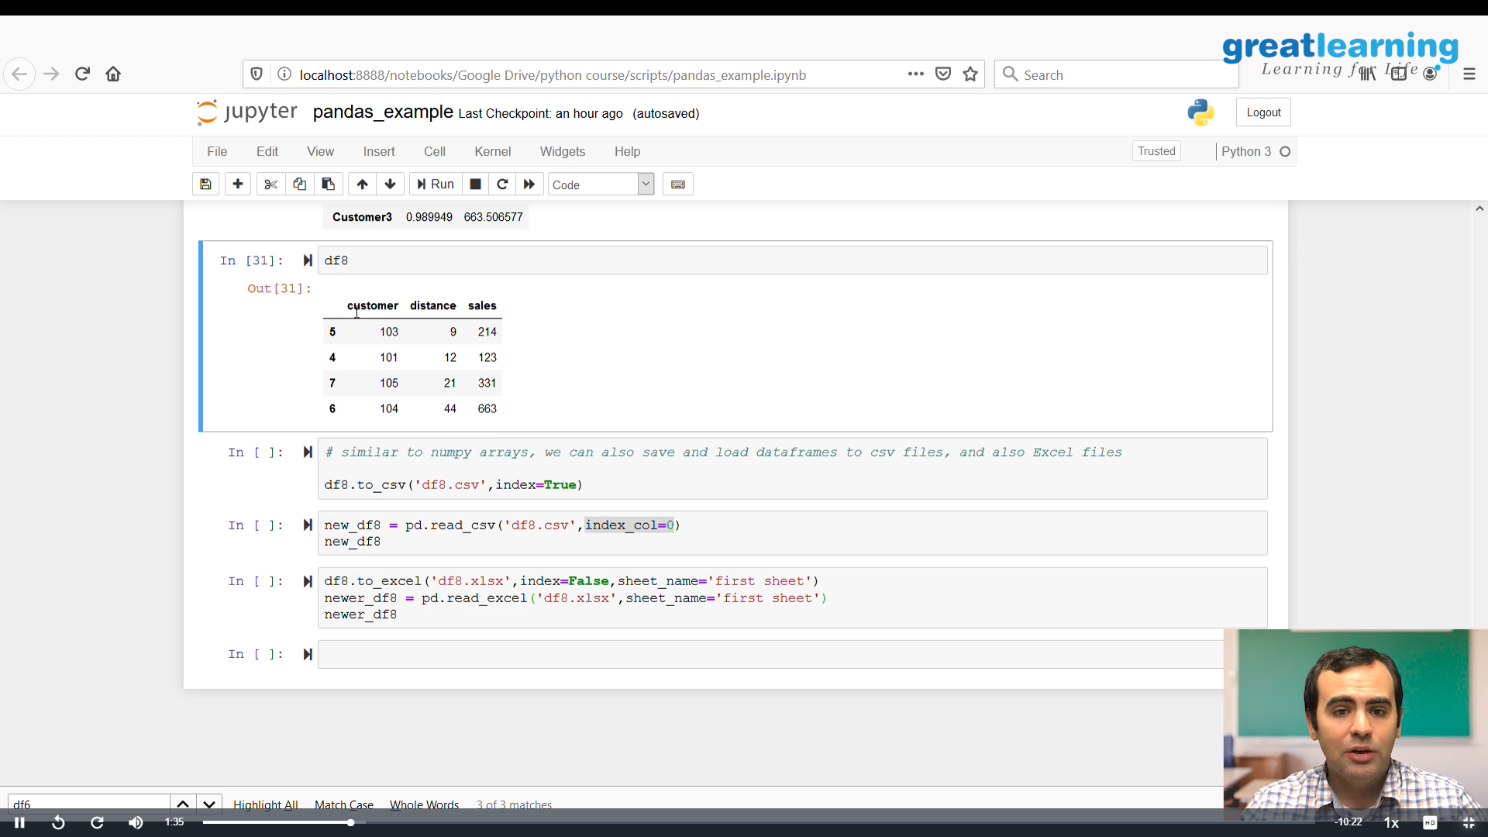

Coding Challenges Details: (Attach the snapshot and briefly write the report for the same)

PROBLEM : Write a C Program to generate first N Triangular Numbers (Where N is Read from the Key board).

