**DAILY ONLINE ACTIVITIES SUMMARY**

|  |  |  |  |  |  |  |  |  |
| --- | --- | --- | --- | --- | --- | --- | --- | --- |
| **Date:** | **04/06/2020** | | | | | **Name:** | **CHANDAN B** | |
| **Sem & Sec** | **8TH, A** | | | | | **USN:** | **4AL16CS400** | |
| **Online Test Summary** | | | | | | | | |
| **Subject** | | **SMS_IA_5** | | | | | | |
| **Max. Marks** | | **60** | | **Score** | | | **60** | |
| **Certification Course Summary** | | | | | | | | |
| **Course** | Step Into RPA | | | | | | | |
| **Certificate Provider** | | | **GUVI** | | **Duration** | | | **3hours** |
| **Coding Challenges** | | | | | | | | |
| **Problem Statement:** **To print the last interger after adding first and last number.** | | | | | | | | |
| **Status: completed** | | | | | | | | |
| **Uploaded the report in Github** | | | | | **yes** | | | |
| **If yes Repository name** | | | | | <https://github.com/alvas-education-foundation/chandan.b> | | | |
| **Uploaded the report in slack** | | | | | **yes** | | | |

Online Test Details:

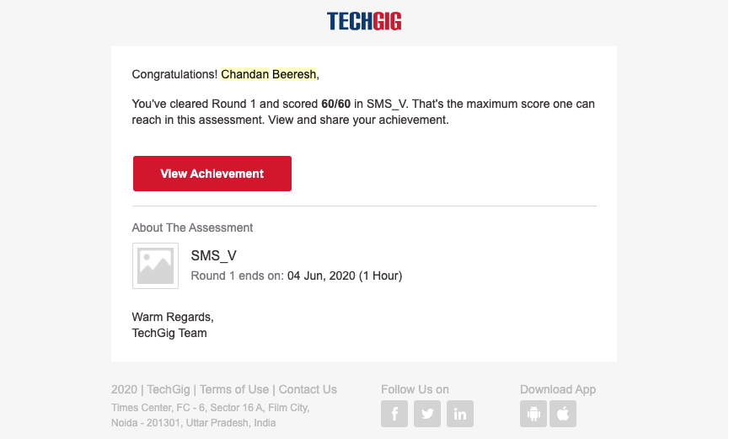

Certification Course Details:

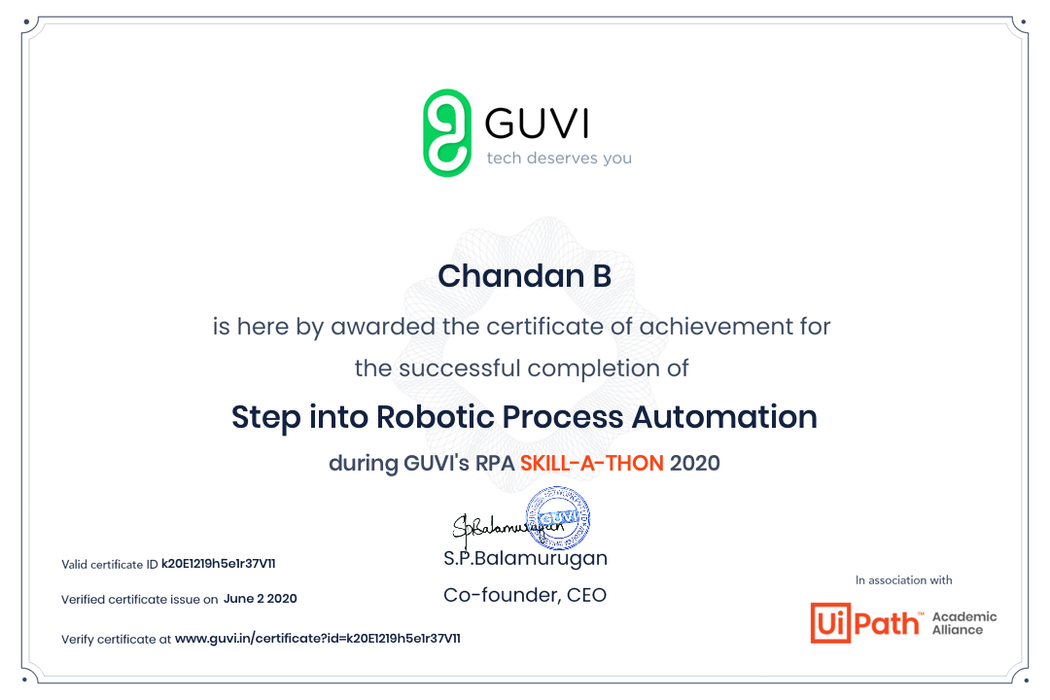

Coding Challenges Details:

**class Solution**

**{**

**public int reverse(int x)**

**{**

**int rev=0,rem=0,prev_rev=0;**

**while(x!=0){**

**rem=x%10;**

**rev=(rev*10)+rem;**

**x=x/10;**

**if((rem-rev)/10 !=prev_rev)**

**{**

**return 0;**

**}**

**prev_rev=rev;**

**}**

**return rev;**

**}**

**}**