**DAILY ONLINE ACTIVITIES SUMMARY**

|  |  |  |  |  |  |  |  |  |
| --- | --- | --- | --- | --- | --- | --- | --- | --- |
| **Date:** | **05/06/2020** | | | | | **Name:** | **CHANDAN B** | |
| **Sem & Sec** | **8TH, A** | | | | | **USN:** | **4AL16CS400** | |
| **Online Test Summary** | | | | | | | | |
| **Subject** | | **BDA_IA_5** | | | | | | |
| **Max. Marks** | | **40** | | **Score** | | | **13** | |
| **Certification Course Summary** | | | | | | | | |
| **Course** | Introduction To EC2 Auto Scaling | | | | | | | |
| **Certificate Provider** | | | **GUVI** | | **Duration** | | | **10min** |
| **Coding Challenges** | | | | | | | | |
| **Problem Statement:** **Write down a java program to print even and odd numbers series respectively.** | | | | | | | | |
| **Status: completed** | | | | | | | | |
| **Uploaded the report in Github** | | | | | **yes** | | | |
| **If yes Repository name** | | | | | <https://github.com/alvas-education-foundation/chandan.b> | | | |
| **Uploaded the report in slack** | | | | | **yes** | | | |

Online Test Details:

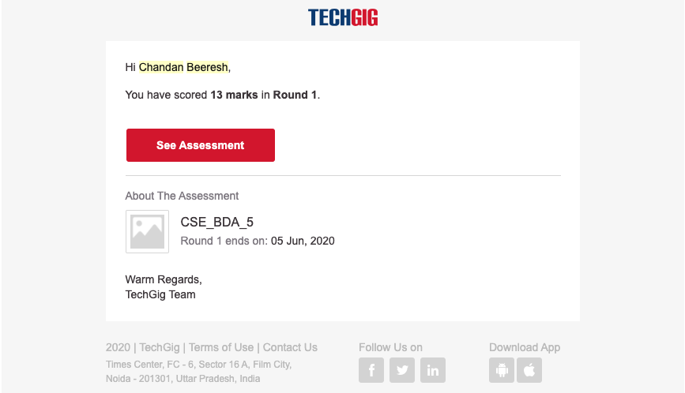

Certification Course Details:

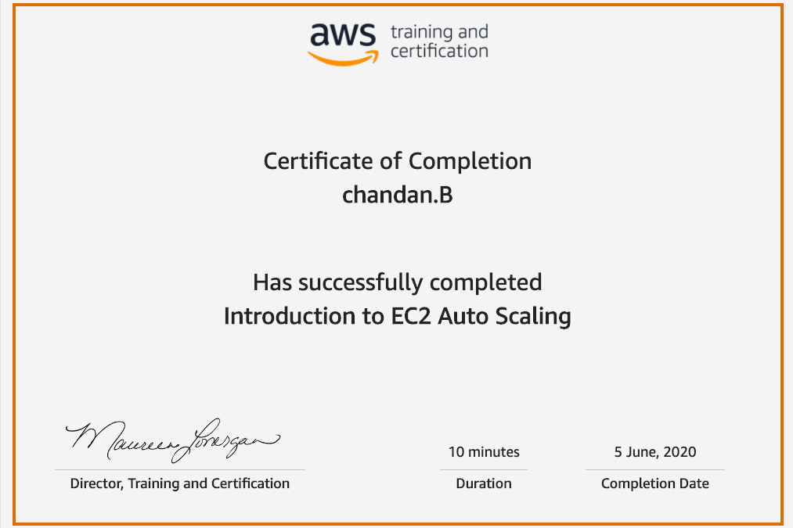

Coding Challenges Details:

|  |
| --- |
| **public class Main extends Thread {** |
|  | **static StringBuilder object = new StringBuilder("");** |
|  | **public static void main(String[] args) throws InterruptedException {** |
|  | **Thread t1 = new Main();** |
|  | **Thread t2 = new Main();** |
|  | **t1.setName("\nping");** |
|  | **t2.setName(" pong");** |
|  | **t1.start();** |
|  | **t2.start();** |
|  | **}** |
|  | **public void run() {** |
|  | **working();** |
|  | **}** |
|  | **void working() {** |
|  | **while (true) {** |
|  | **synchronized (object) {** |
|  | **try {** |
|  | **System.out.print(Thread.currentThread().getName());** |
|  | **object.notify();** |
|  | **object.wait();** |
|  | **}** |
|  | **catch (InterruptedException e) {** |
|  | **e.printStackTrace();** |
|  | **}** |
|  | **}** |
|  | **}** |
|  | **}** |
|  | **}** |