**DAILY ONLINE ACTIVITIES SUMMARY**

|  |  |  |  |  |  |  |  |  |
| --- | --- | --- | --- | --- | --- | --- | --- | --- |
| **Date:** | **06/06/2020** | | | | | **Name:** | **CHANDAN B** | |
| **Sem & Sec** | **8TH, A** | | | | | **USN:** | **4AL16CS400** | |
| **Online Test Summary** | | | | | | | | |
| **Subject** | | **IOT_IA_4** | | | | | | |
| **Max. Marks** | | **30** | | **Score** | | | **30** | |
| **Certification Course Summary** | | | | | | | | |
| **Course** | Nill | | | | | | | |
| **Certificate Provider** | | | **Nill** | | **Nill** | | | **Nill** |
| **Coding Challenges** | | | | | | | | |
| **Problem Statement:** **To rotate an array by N position.** | | | | | | | | |
| **Status: completed** | | | | | | | | |
| **Uploaded the report in Github** | | | | | **yes** | | | |
| **If yes Repository name** | | | | | <https://github.com/alvas-education-foundation/chandan.b> | | | |
| **Uploaded the report in slack** | | | | | **yes** | | | |

Online Test Details:

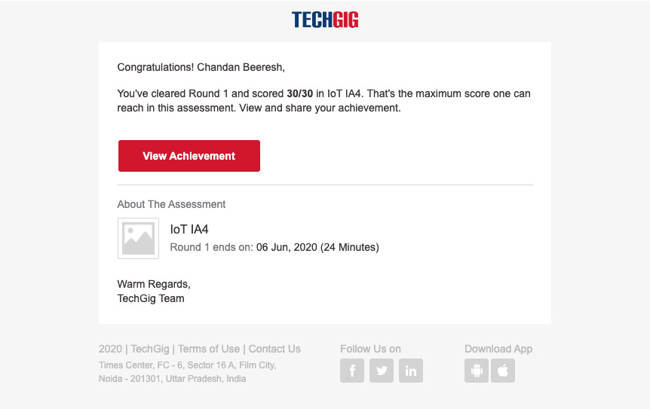

Coding Challenges Details:

|  |  |
| --- | --- |
| Write a program in C to rotate an array by N position | |
|  | #include <stdio.h> |
|  | void shiftArr1Pos(int *arr1, int arrSize) |
|  | { |
|  | int i, temp; |
|  | temp = arr1[0]; |
|  | for(i = 0; i < arrSize-1; i++) |
|  | { |
|  | arr1[i] = arr1[i+1]; |
|  | } |
|  | arr1[i] = temp; |
|  | } |
|  | void arr1Rotate(int *arr1, int arrSize, int rotFrom) |
|  | { |
|  | int i; |
|  | for(i = 0; i < rotFrom; i++) |
|  | { |
|  | shiftArr1Pos(arr1, arrSize); |
|  | } |
|  | return; |
|  | } |
|  | int main() |
|  | { |
|  | int arr1[] = {0,3,6,9,12,14,18,20,22,25,27}; |
|  | int ctr = sizeof(arr1)/sizeof(arr1[0]); |
|  | int i; |
|  | //---------- print original array ------------------------ |
|  | printf("The given array is : "); |
|  | for(i = 0; i < ctr; i++) |
|  | { |
|  | printf("%d ", arr1[i]); |
|  | } |
|  | printf("\n"); |
|  | //---------- print the values from 4th position ------------------------ |
|  | printf("From 4th position the values of the array are : "); |
|  | for(i = 4; i < ctr; i++) |
|  | { |
|  | printf("%d ", arr1[i]); |
|  | } |
|  | printf("\n"); |
|  | //---------- print the values before 4th position ------------------------ |
|  | printf("Before 4th position the values of the array are : "); |
|  | for(i = 0; i < 4; i++) |
|  | { |
|  | printf("%d ", arr1[i]); |
|  | } |
|  | printf("\n"); |
|  | //------------ after rotating the array -------------------- |
|  | arr1Rotate(arr1, ctr, 4); |
|  | printf("\nAfter rotating from 4th position the array is: \n"); |
|  | for(i = 0; i<ctr; i++) |
|  | { |
|  | printf("%d ", arr1[i]); |
|  | } |
|  | return 0; |
|  | } |