**DAILY ONLINE ACTIVITIES SUMMARY**

|  |  |  |  |  |  |  |  |  |
| --- | --- | --- | --- | --- | --- | --- | --- | --- |
| **Date:** | **07/06/2020** | | | | | **Name:** | **CHANDAN B** | |
| **Sem & Sec** | **8TH, A** | | | | | **USN:** | **4AL16CS400** | |
| **Online Test Summary** | | | | | | | | |
| **Subject** | | **Nill** | | | | | | |
| **Max. Marks** | | **Nill** | | **Score** | | | **Nill** | |
| **Certification Course Summary** | | | | | | | | |
| **Course** | Intermediate machine learning | | | | | | | |
| **Certificate Provider** | | | **Kaggle** | | **Duration** | | | **6days** |
| **Coding Challenges** | | | | | | | | |
| **Problem Statement:** **Find a factors of number.** | | | | | | | | |
| **Status: completed** | | | | | | | | |
| **Uploaded the report in Github** | | | | | **yes** | | | |
| **If yes Repository name** | | | | | <https://github.com/alvas-education-foundation/chandan.b> | | | |
| **Uploaded the report in slack** | | | | | **yes** | | | |

Certificate Course Details:

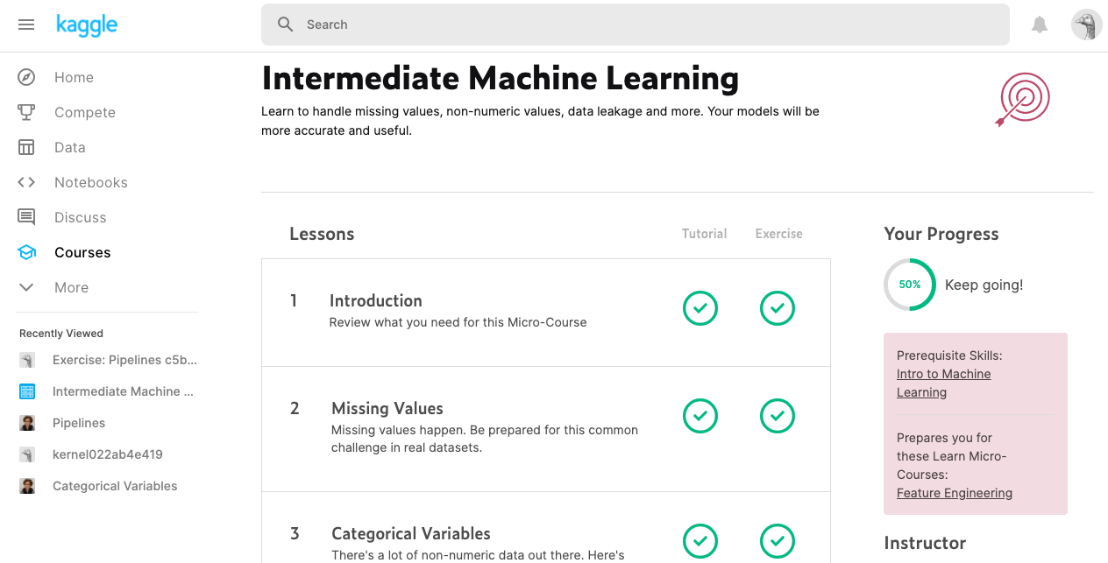

Coding Challenges Details:

find factors of a number

def print_factors(num):

print("The factors of",num,"are:")

for i in range(1,num+1):

if num%i == 0:

print(i)

num=input(int("Enter a number greater than 0"))

print_factors(num)