**DAILY ONLINE ACTIVITIES SUMMARY**

|  |  |  |  |  |  |  |  |  |
| --- | --- | --- | --- | --- | --- | --- | --- | --- |
| **Date:** | **11/06/2020** | | | | | **Name:** | **CHANDAN B** | |
| **Sem & Sec** | **8TH, A** | | | | | **USN:** | **4AL16CS400** | |
| **Online Test Summary** | | | | | | | | |
| **Subject** | | **SMS_IA7** | | | | | | |
| **Max. Marks** | | **60** | | **Score** | | | **60** | |
| **Certification Course Summary** | | | | | | | | |
| **Course** | Introduction to AWS FARGATE | | | | | | | |
| **Certificate Provider** | | | **AWS** | | **Duration** | | |  |
| **Coding Challenges** | | | | | | | | |
| **Problem Statement:** **Function to generate and return random numbers.** | | | | | | | | |
| **Status: completed** | | | | | | | | |
| **Uploaded the report in Github** | | | | | **yes** | | | |
| **If yes Repository name** | | | | | <https://github.com/alvas-education-foundation/chandan.b> | | | |
| **Uploaded the report in slack** | | | | | **yes** | | | |

Online Test Details:

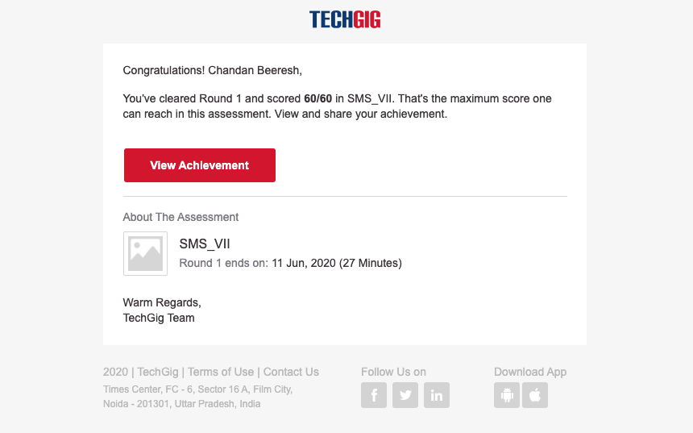

Certification Course Details:

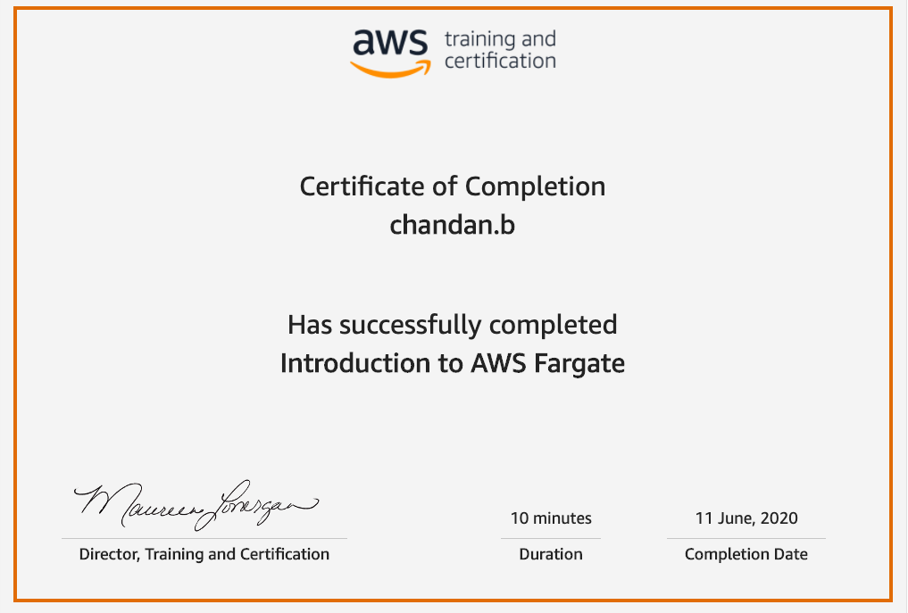

Coding Challenges Details:

**#include <stdio.h>**

**#include <time.h>**

**int * getRandom( ) {**

**static int r[10];**

**int i;**

**srand( (unsigned)time( NULL ) );**

**for ( i = 0; i < 10; ++i) {**

**r[i] = rand();**

**printf("%d\n", r[i] );**

**}**

**return r;**

**}**

**int main () {**

**int *p;**

**int i;**

**p = getRandom();**

**for ( i = 0; i < 10; i++ ) {**

**printf("*(p + [%d]) : %d\n", i, *(p + i) );**

**}**

**return 0;**

**}**