**DAILY ONLINE ACTIVITIES SUMMARY**

|  |  |  |  |  |  |  |  |  |
| --- | --- | --- | --- | --- | --- | --- | --- | --- |
| **Date:** | **12/06/2020** | | | | | **Name:** | **CHANDAN B** | |
| **Sem & Sec** | **8TH, A** | | | | | **USN:** | **4AL16CS400** | |
| **Online Test Summary** | | | | | | | | |
| **Subject** | | **BDA_IA7** | | | | | | |
| **Max. Marks** | | **30** | | **Score** | | | **14** | |
| **Certification Course Summary** | | | | | | | | |
| **Course** | Intermediate Machine Learning | | | | | | | |
| **Certificate Provider** | | | **Kaggle** | | **Duration** | | | **6days** |
| **Coding Challenges** | | | | | | | | |
| **Problem Statement:** **Multiplication of table.** | | | | | | | | |
| **Status: completed** | | | | | | | | |
| **Uploaded the report in Github** | | | | | **yes** | | | |
| **If yes Repository name** | | | | | <https://github.com/alvas-education-foundation/chandan.b> | | | |
| **Uploaded the report in slack** | | | | | **yes** | | | |

Online Test Details:

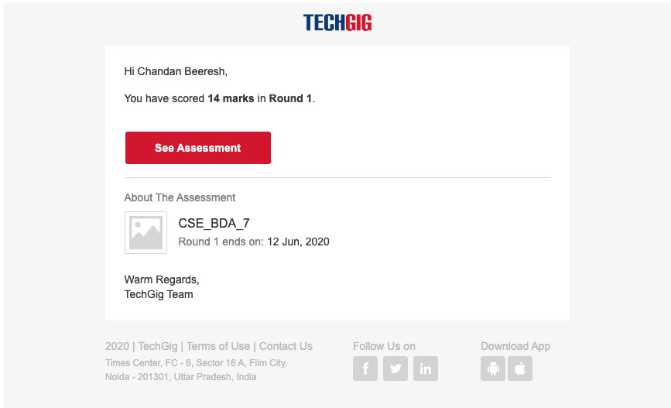

Certification Course Details:

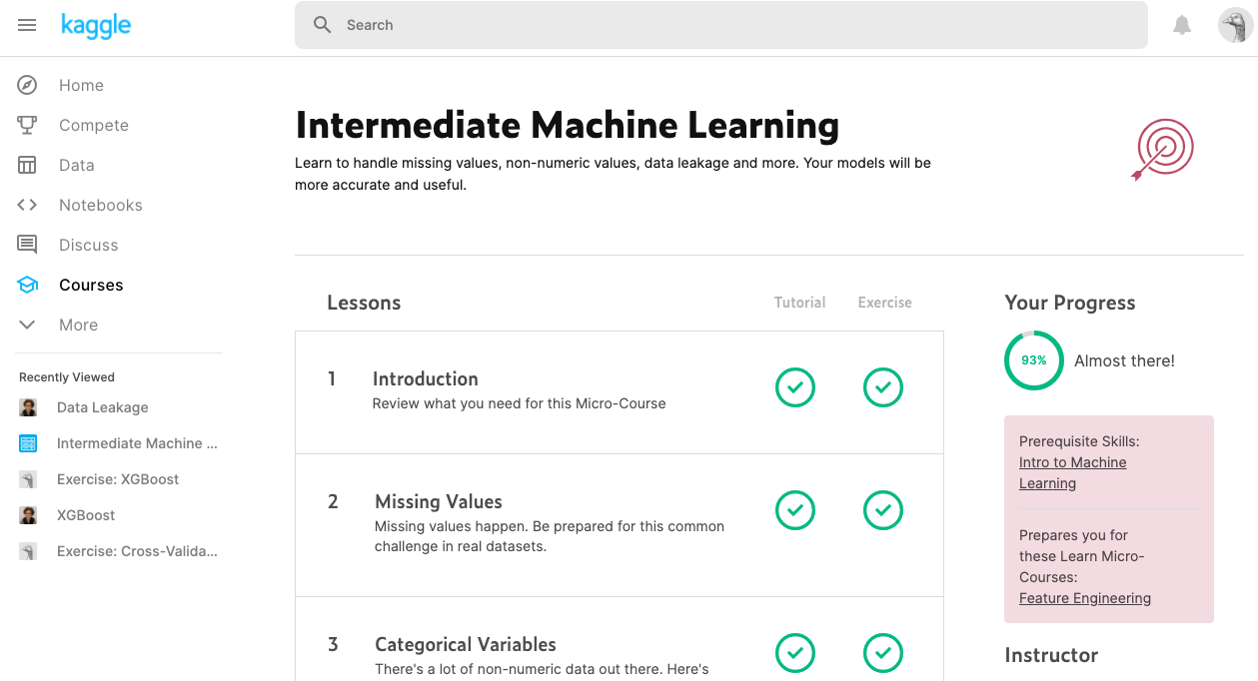

Coding Challenges Details:

|  |
| --- |
| num=int(input("Display multiplication table of? ")) |
|  |  |
|  | for i in range(1, 11): |
|  | print(num, 'x', i, '=', num*i) |