**DAILY ONLINE ACTIVITIES SUMMARY**

|  |  |  |  |  |  |  |  |  |
| --- | --- | --- | --- | --- | --- | --- | --- | --- |
| **Date:** | **13/06/2020** | | | | | **Name:** | **CHANDAN B** | |
| **Sem & Sec** | **8TH, A** | | | | | **USN:** | **4AL16CS400** | |
| **Online Test Summary** | | | | | | | | |
| **Subject** | | **IOT_IA5** | | | | | | |
| **Max. Marks** | | **30** | | **Score** | | | **29** | |
| **Certification Course Summary** | | | | | | | | |
| **Course** | Python Fundamentals | | | | | | | |
| **Certificate Provider** | | | **DataNex** | | **Duration** | | | **2.5hours** |
| **Coding Challenges** | | | | | | | | |
| **Problem Statement:** **Python** | | | | | | | | |
| **Status: Completed** | | | | | | | | |
| **Uploaded the report in Github** | | | | | **yes** | | | |
| **If yes Repository name** | | | | | <https://github.com/alvas-education-foundation/chandan.b> | | | |
| **Uploaded the report in slack** | | | | | **yes** | | | |

Online test details:

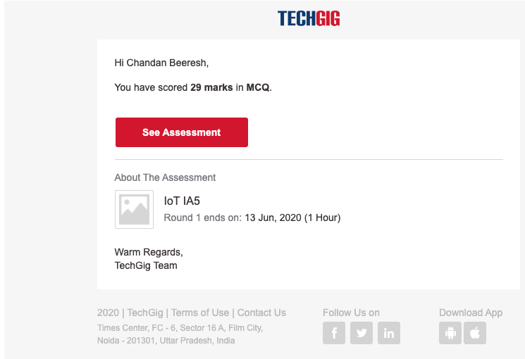

Certificate Course Details:

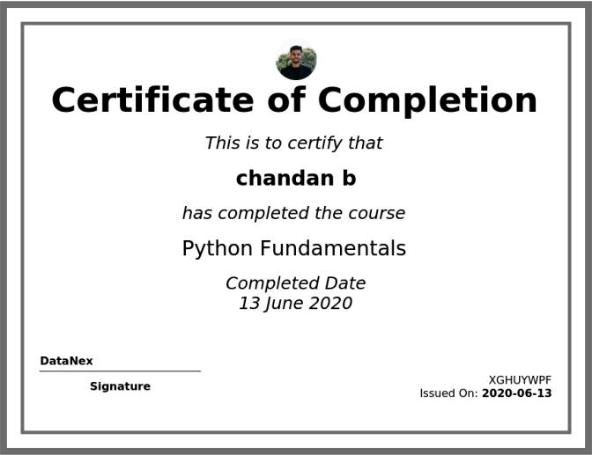

Coding Challenges:

