**DAILY ONLINE ACTIVITIES SUMMARY**

|  |  |  |  |  |  |  |  |  |
| --- | --- | --- | --- | --- | --- | --- | --- | --- |
| **Date:** | **16/06/2020** | | | | | **Name:** | **CHANDAN B** | |
| **Sem & Sec** | **8TH, A** | | | | | **USN:** | **4AL16CS400** | |
| **Online Test Summary** | | | | | | | | |
| **Subject** | | **BDA_IA8** | | | | | | |
| **Max. Marks** | | **30** | | **Score** | | | **18** | |
| **Certification Course Summary** | | | | | | | | |
| **Course** | Nill | | | | | | | |
| **Certificate Provider** | | | **Nill** | | **Duration** | | | **Nill** |
| **Coding Challenges** | | | | | | | | |
| **Problem Statement:** **Factors** | | | | | | | | |
| **Status: completed** | | | | | | | | |
| **Uploaded the report in Github** | | | | | **yes** | | | |
| **If yes Repository name** | | | | | <https://github.com/alvas-education-foundation/chandan.b> | | | |
| **Uploaded the report in slack** | | | | | **yes** | | | |

Online Test Details:

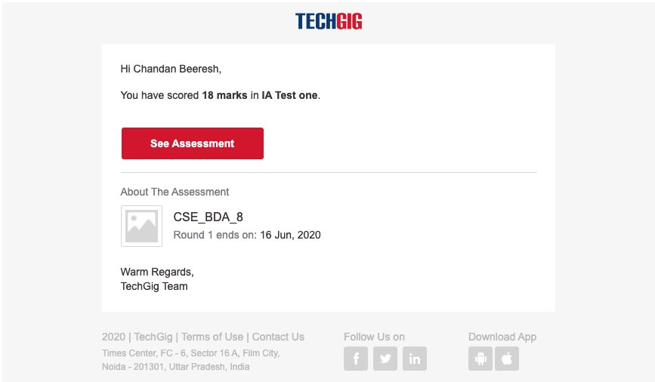

Certification Course Details:

Coding Challenges Details:

|  |
| --- |
| **def print_factors(x):** |
|  | **print("The factors of",x,"are:")** |
|  | **for i in range(1, x + 1):** |
|  | **if x % i == 0:** |
|  | **print(i)** |
|  |  |
|  | **num = 320** |
|  |  |
|  | **print_factors(num)** |