**DAILY ONLINE ACTIVITIES SUMMARY**

|  |  |  |  |  |  |  |  |  |
| --- | --- | --- | --- | --- | --- | --- | --- | --- |
| **Date:** | **17/06/2020** | | | | | **Name:** | **CHANDAN B** | |
| **Sem & Sec** | **8TH, A** | | | | | **USN:** | **4AL16CS400** | |
| **Online Test Summary** | | | | | | | | |
| **Subject** | | **Nill** | | | | | | |
| **Max. Marks** | |  | | **Score** | | |  | |
| **Certification Course Summary** | | | | | | | | |
| **Course** | Intermediate Machine Learning | | | | | | | |
| **Certificate Provider** | | | **KAGGLE** | | **Duration** | | | **6days** |
| **Coding Challenges** | | | | | | | | |
| **Problem Statement:** **Raccurence sum** | | | | | | | | |
| **Status: completed** | | | | | | | | |
| **Uploaded the report in Github** | | | | | **yes** | | | |
| **If yes Repository name** | | | | | <https://github.com/alvas-education-foundation/chandan.b> | | | |
| **Uploaded the report in slack** | | | | | **yes** | | | |

Online Test Details:

Certification Course Details:

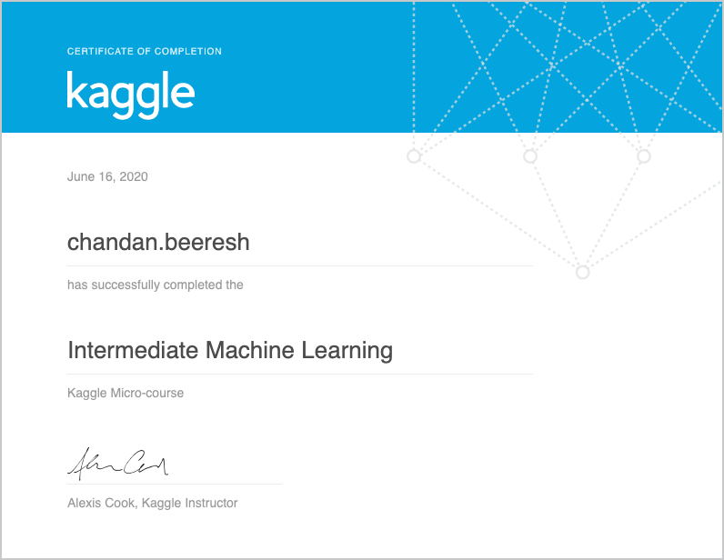

Coding Challenges Details:

|  |
| --- |
| **def recur_sum(n):** |
|  | **if n <= 1:** |
|  | **return n** |
|  | **else:** |
|  | **return n + recur_sum(n-1)** |
|  |  |
|  | **# change this value for a different result** |
|  | **num = 16** |
|  |  |
|  | **if num < 0:** |
|  | **print("Enter a positive number")** |
|  | **else:** |
|  | **print("The sum is",recur_sum(num))** |