**DAILY ONLINE ACTIVITIES SUMMARY**

|  |  |  |  |  |  |  |  |  |
| --- | --- | --- | --- | --- | --- | --- | --- | --- |
| **Date:** | **18/05/2020** | | | | | **Name:** | **CHANDAN B** | |
| **Sem & Sec** | **8TH, A** | | | | | **USN:** | **4AL16CS400** | |
| **Online Test Summary** | | | | | | | | |
| **Subject** | | **SMS_IA1** | | | | | | |
| **Max. Marks** | | **60** | | **Score** | | | **57** | |
| **Certification Course Summary** | | | | | | | | |
| **Course** | nill | | | | | | | |
| **Certificate Provider** | | | **nill** | | **Duration** | | | **nill** |
| **Coding Challenges** | | | | | | | | |
| **Problem Statement:** **Print the frequency of each character in a string.** | | | | | | | | |
| **Status: completed** | | | | | | | | |
| **Uploaded the report in Github** | | | | | **yes** | | | |
| **If yes Repository name** | | | | | <https://github.com/alvas-education-foundation/chandan.b> | | | |
| **Uploaded the report in slack** | | | | | **yes** | | | |

Online Test Details:

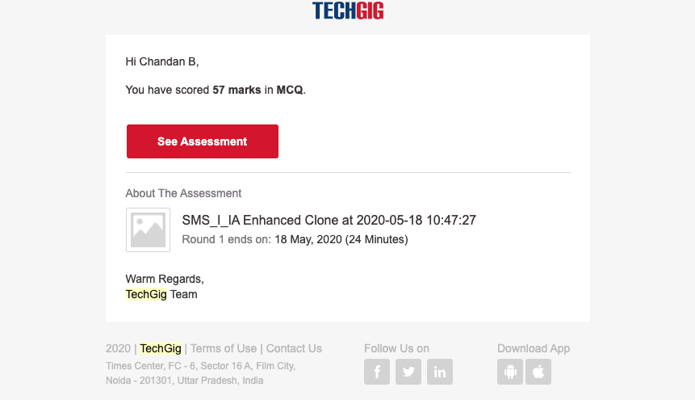

Coding Challenges Details:

Using methods charAt() & length() of String class, write a program to print the frequency of each character in a string.

import java.util.Scanner;  
public class Main  
{  
public static void main(String[] args) { int i;

String str;

int count[] = new int[256]; Scanner s = new Scanner(System.in);

System.out.print("Enter a String : "); str=s.nextLine();

for (i = 0; i < str.length(); i++) { count[(int) str.charAt(i)]++;

}  
for (i = 0; i < 256; i++) {

if (count[i] != 0) {  
System.out.println( (char) i + " : " + count[i]);

}-}}}