**DAILY ONLINE ACTIVITIES SUMMARY**

|  |  |  |  |  |  |  |  |  |
| --- | --- | --- | --- | --- | --- | --- | --- | --- |
| **Date:** | **20/06/2020** | | | | | **Name:** | **CHANDAN B** | |
| **Sem & Sec** | **8TH, A** | | | | | **USN:** | **4AL16CS400** | |
| **Online Test Summary** | | | | | | | | |
| **Subject** | | **Nill** | | | | | | |
| **Max. Marks** | | **Nill** | | **Score** | | | **Nill** | |
| **Certification Course Summary** | | | | | | | | |
| **Course** | Python | | | | | | | |
| **Certificate Provider** | | | **Kaggle** | | **Duration** | | | **6days** |
| **Coding Challenges** | | | | | | | | |
| **Problem Statement:** **Armstrong number.** | | | | | | | | |
| **Status: completed** | | | | | | | | |
| **Uploaded the report in Github** | | | | | **yes** | | | |
| **If yes Repository name** | | | | | <https://github.com/alvas-education-foundation/chandan.b> | | | |
| **Uploaded the report in slack** | | | | | **yes** | | | |

Online Test Details:

Certification Course Details:

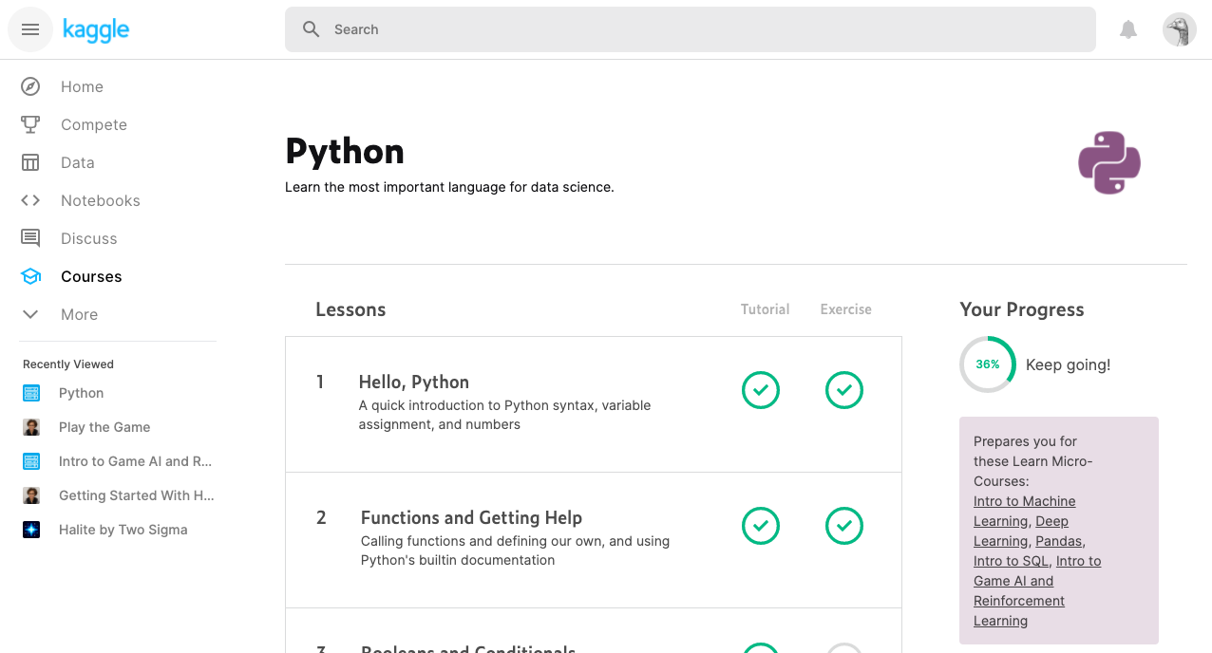

Coding Challenges Details:

|  |
| --- |
| **num = 1634** |
|  | **order = len(str(num))** |
|  | **sum = 0** |
|  | **temp = num** |
|  | **while temp > 0:** |
|  | **digit = temp % 10** |
|  | **sum += digit ** order** |
|  | **temp //= 10** |
|  | **if num == sum:** |
|  | **print(num,"is an Armstrong number")** |
|  | **else:** |
|  | **print(num,"is not an Armstrong number")** |