**DAILY ONLINE ACTIVITIES SUMMARY**

|  |  |  |  |  |  |  |  |  |
| --- | --- | --- | --- | --- | --- | --- | --- | --- |
| **Date:** | **20/05/2020** | | | | | **Name:** | **CHANDAN B** | |
| **Sem & Sec** | **8TH, A** | | | | | **USN:** | **4AL16CS400** | |
| **Online Test Summary** | | | | | | | | |
| **Subject** | | **IOT** | | | | | | |
| **Max. Marks** | | **30** | | **Score** | | | **24** | |
| **Certification Course Summary** | | | | | | | | |
| **Course** | Intro to Machine Learning | | | | | | | |
| **Certificate Provider** | | | **KAGGLE** | | **Duration** | | | **6days** |
| **Coding Challenges** | | | | | | | | |
| **Problem Statement:** To reverse the linked list | | | | | | | | |
| **Status: completed** | | | | | | | | |
| **Uploaded the report in Github** | | | | | **yes** | | | |
| **If yes Repository name** | | | | | <https://github.com/alvas-education-foundation/chandan.b> | | | |
| **Uploaded the report in slack** | | | | | **yes** | | | |

Online Test Details:



Certification Course Details:

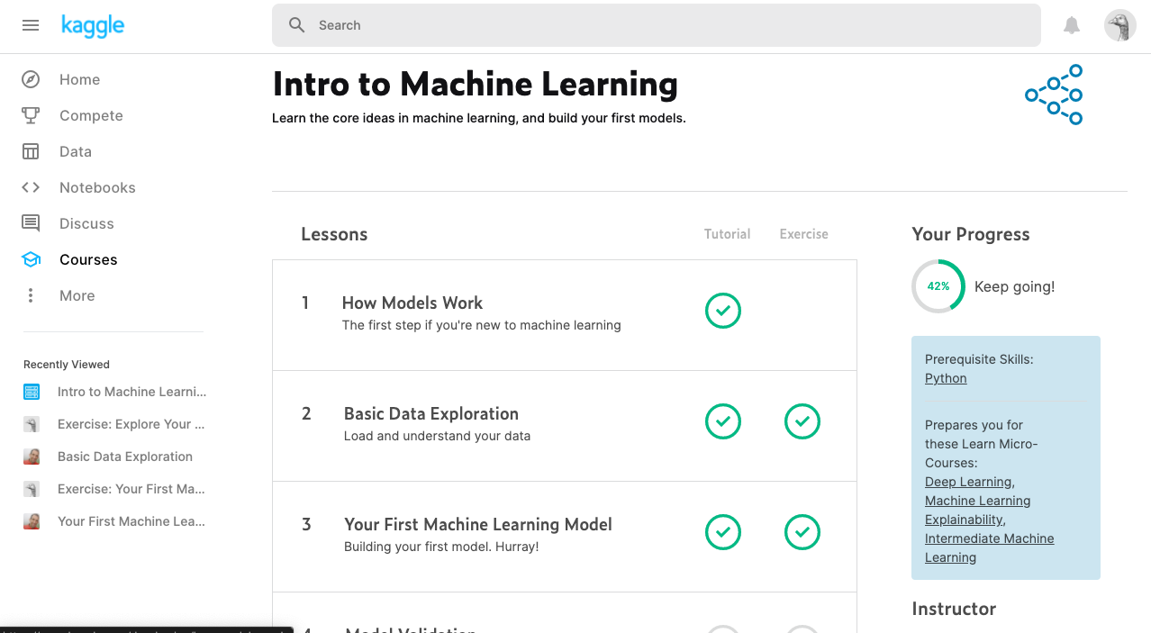

Coding Challenges Details:

struct Node  
{  
int data;  
struct Node* next;  
};

pointer to the new head node. */  
struct Node reverse (struct Node head, int k)  
{  
struct Node current = head;  
struct Node next = NULL;  
struct Node* prev = NULL;  
int count = 0;

while (current != NULL && count < k)

{

next = current->next;

current->next = prev;

prev = current;

current = next;

count++;

}

if (next != NULL)

head->next = reverse(next, k);

return prev;

}

void push(struct Node** head_ref, int new_data)  
{  
struct Node* new_node =  
(struct Node*) malloc(sizeof(struct Node));

new_node->data = new_data;

new_node->next = (*head_ref);

(*head_ref) = new_node;

}

void printList(struct Node *node)  
{  
while (node != NULL)  
{  
printf("%d ", node->data);  
node = node->next;  
}  
}

int main(void)  
{  
struct Node* head = NULL;  
push(&head, 8);  
push(&head, 7);  
push(&head, 6);  
push(&head, 5);  
push(&head, 4);  
push(&head, 3);  
push(&head, 2);  
push(&head, 1);

printf("\nGiven linked list \n");

printList(head);

head = reverse(head, 2);

printf("\nReversed Linked list \n");

printList(head);

return(0); }