**DAILY ONLINE ACTIVITIES SUMMARY**

|  |  |  |  |  |  |  |  |  |
| --- | --- | --- | --- | --- | --- | --- | --- | --- |
| **Date:** | **21/06/2020** | | | | | **Name:** | **CHANDAN B** | |
| **Sem & Sec** | **8TH, A** | | | | | **USN:** | **4AL16CS400** | |
| **Online Test Summary** | | | | | | | | |
| **Subject** | | **Nill** | | | | | | |
| **Max. Marks** | | **Nill** | | **Score** | | | **Nill** | |
| **Certification Course Summary** | | | | | | | | |
| **Course** | Python | | | | | | | |
| **Certificate Provider** | | | **Kaggle** | | **Duration** | | | **6days** |
| **Coding Challenges** | | | | | | | | |
| **Problem Statement:** **Right Rotate.** | | | | | | | | |
| **Status: completed** | | | | | | | | |
| **Uploaded the report in Github** | | | | | **yes** | | | |
| **If yes Repository name** | | | | | <https://github.com/alvas-education-foundation/chandan.b> | | | |
| **Uploaded the report in slack** | | | | | **yes** | | | |

Online Test Details:

Certification Course Details:

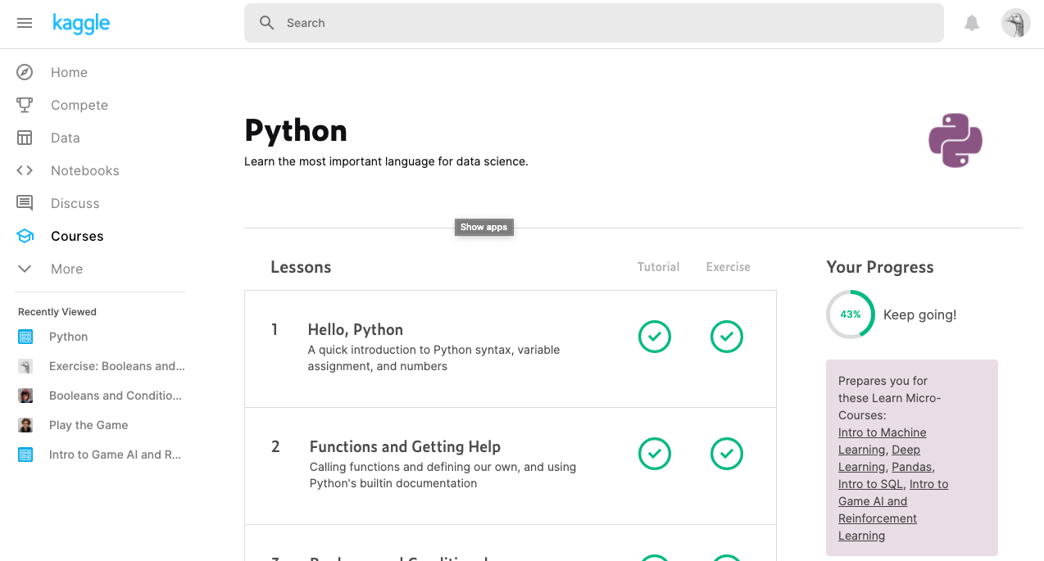

Coding Challenges Details:

|  |
| --- |
| **def right_rotate(l,n):** |
|  | **result=[]** |
|  | **for i in range(len(l)-n,len(l)):** |
|  | **result.append(l[i])** |
|  | **for j in range(0,len(l)-n):** |
|  | **result.append(l[j])** |
|  | **return result** |
|  | **k=int(input('enter a step to right rotate:'))** |
|  | **l=[1,2,3,4,5,6]** |
|  | **print(right_rotate(l,k))** |