**DAILY ONLINE ACTIVITIES SUMMARY**

|  |  |  |  |  |  |  |  |  |
| --- | --- | --- | --- | --- | --- | --- | --- | --- |
| **Date:** | **22/05/2020** | | | | | **Name:** | **CHANDAN B** | |
| **Sem & Sec** | **8TH, A** | | | | | **USN:** | **4AL16CS400** | |
| **Online Test Summary** | | | | | | | | |
| **Subject** | | **BDA_IA_2** | | | | | | |
| **Max. Marks** | | **40** | | **Score** | | | **25** | |
| **Certification Course Summary** | | | | | | | | |
| **Course** | Introduction to Amazon Elastic Compute Cloud (EC2) | | | | | | | |
| **Certificate Provider** | | | **AWS** | | **Duration** | | | **10min** |
| **Coding Challenges** | | | | | | | | |
| **Problem Statement:** **Create a Singly Linked List Stack with the node corresponding.** | | | | | | | | |
| **Status: completed** | | | | | | | | |
| **Uploaded the report in Github** | | | | | **yes** | | | |
| **If yes Repository name** | | | | | <https://github.com/alvas-education-foundation/chandan.b> | | | |
| **Uploaded the report in slack** | | | | | **yes** | | | |

Online Test Details:

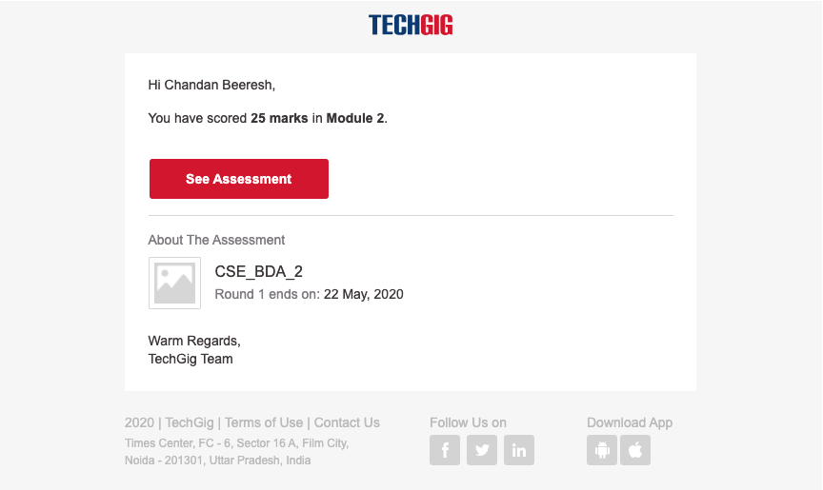

Certification Course Details:

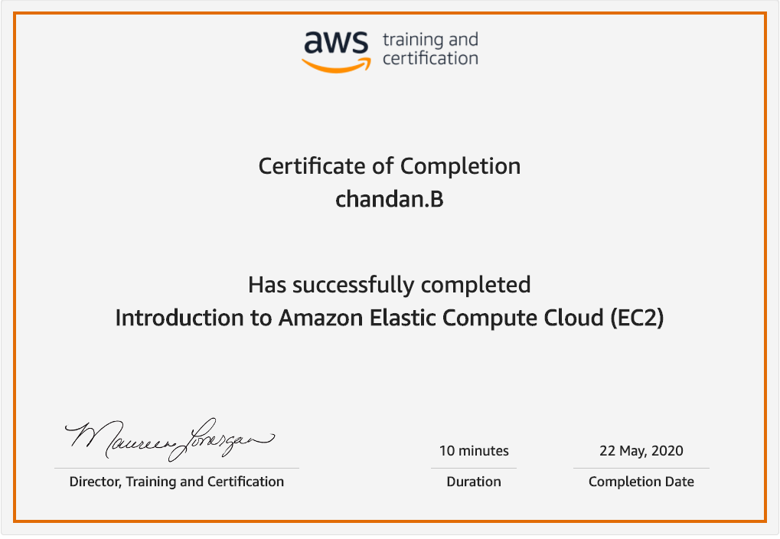

Coding Challenges Details:

**#include <stdio.h> #include <stdlib.h>**

**struct node { int info; struct node *ptr; }*top,*top1,*temp;**

**int topelement(); void push(int data); void pop(); void empty(); void display(); void destroy(); void stack_count(); void create();**

**int count = 0;**

**void main() { int no, ch, e;**

**printf("\n 1 - Push"); printf("\n 2 - Pop"); printf("\n 3 - Top"); printf("\n 4 - Empty"); printf("\n 5 - Exit"); printf("\n 6 - Dipslay"); printf("\n 7 - Stack Count"); printf("\n 8 - Destroy stack");**

**create();**

**while (1) { printf("\n Enter choice : "); scanf("%d", &ch);**

**switch (ch) case 1: printf("Enter data : "); scanf("%d", &no); push(no); break; case 2: pop(); break; case 3: if (top == NULL) printf("No elements in stack"); else { e = topelement(); printf("\n Top element : %d", e); } break; case 4: empty(); break; case 5: exit(0); case 6: display(); break; case 7: stack_count(); break; case 8: destroy(); break; default : printf(" Wrong choice, Please enter correct choice "); break; } } }**

**/* Create empty stack */void create() { top = NULL; }**

**/* Count stack elements */ void stack_count() { printf("\n No. of elements in stack : %d", count); }**

**/* Push data into stack */void push(int data) { if (top == NULL) { top =(struct node )malloc(1sizeof(struct node)); top->ptr = NULL; top->info = data; } else { temp =(struct node )malloc(1sizeof(struct node)); temp->ptr = top; temp->info = data; top = temp; } count++; }**

**/* Display stack elements */ void display() { top1 = top;**

**if (top1 == NULL) { printf("Stack is empty"); return; }**

**while (top1 != NULL) { printf("%d ", top1->info); top1 = top1->ptr; } }**

**/* Pop Operation on stack */ void pop() { top1 = top;**

**if (top1 == NULL) { printf("\n Error : Trying to pop from empty stack"); return; } else top1 = top1->ptr; printf("\n Popped value : %d", top->info); free(top); top = top1; count--; }**

**/* Return top element */ int topelement() { return(top->info); }**

**/* Check if stack is empty or not */ void empty() { if (top == NULL) printf("\n Stack is empty"); else printf("\n Stack is not empty with %d elements", count); }**

**/* Destroy entire stack */ void destroy() { top1 = top;**

**while (top1 != NULL) { top1 = top->ptr; free(top); top = top1; top1 = top1->ptr; } free(top1); top = NULL;**

**printf("\n All stack elements destroyed"); count = 0;**