**DAILY ONLINE ACTIVITIES SUMMARY**

|  |  |  |  |  |  |  |  |  |
| --- | --- | --- | --- | --- | --- | --- | --- | --- |
| **Date:** | **26/05/2020** | | | | | **Name:** | **CHANDAN B** | |
| **Sem & Sec** | **8TH, A** | | | | | **USN:** | **4AL16CS400** | |
| **Online Test Summary** | | | | | | | | |
| **Subject** | | **BDA_IA_3.2** | | | | | | |
| **Max. Marks** | | **20** | | **Score** | | | **16** | |
| **Certification Course Summary** | | | | | | | | |
| **Course** | Introduction Machine Learning | | | | | | | |
| **Certificate Provider** | | | **Kaggle** | | **Duration** | | | **8hours** |
| **Coding Challenges** | | | | | | | | |
| **Problem Statement:** **Permutation** | | | | | | | | |
| **Status: completed** | | | | | | | | |
| **Uploaded the report in Github** | | | | | **yes** | | | |
| **If yes Repository name** | | | | | <https://github.com/alvas-education-foundation/chandan.b> | | | |
| **Uploaded the report in slack** | | | | | **yes** | | | |

Online Test Details:

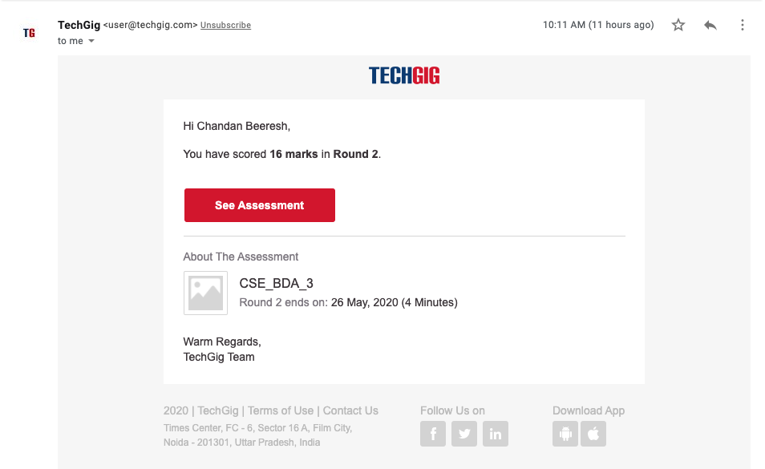

Certification Course Details:

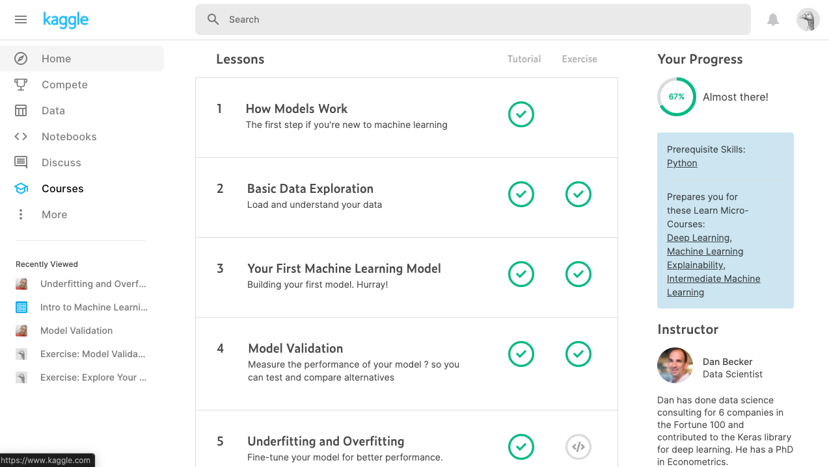

Coding Challenges Details:

#include <stdio.h>

void swap (char *x, char *y){

printf("0 ");

printf("x1=%c ,y1=%c ",*x,*y);

char temp;

temp = *x;

*x = *y;

*y = temp;

printf("x2=%c ,y2=%c ",*x,*y);

printf("1 ");}

void permute(char *a, int i, int n)

{

int j;

printf("2 ");

if (i == n)

{

printf("3 ");

printf("%s\n", a);}

else {

for (j = i; j <= n; j++)

{

printf("4 ");

swap((a + i), (a + j));

printf("5 ");

permute(a, i + 1, n);

printf("6 ");

swap((a + i), (a + j)); //backtrack

printf("7 /n");

}

}

}

/* The main() begins */

int main()

{

char a[20];

int n;

printf("8 ");

printf("Enter a string: ");

scanf("%s", a);

n = strlen(a);

printf("9 ");

printf("Permutaions:\n");

printf("11 ");

permute(a, 0, n - 1);

printf("12 ");

getchar();

printf("13 ");

return 0;

printf("14 ");

}