**DAILY ONLINE ACTIVITIES SUMMARY**

|  |  |  |  |  |  |  |  |  |
| --- | --- | --- | --- | --- | --- | --- | --- | --- |
| **Date:** | **29/05/2020** | | | | | **Name:** | **CHANDAN B** | |
| **Sem & Sec** | **8TH, A** | | | | | **USN:** | **4AL16CS400** | |
| **Online Test Summary** | | | | | | | | |
| **Subject** | | **BDA_IA_4** | | | | | | |
| **Max. Marks** | | **30** | | **Score** | | | **19** | |
| **Certification Course Summary** | | | | | | | | |
| **Course** | Machine Learning Foundation | | | | | | | |
| **Certificate Provider** | | | **GreatLearning** | | **Duration** | | | **5hours** |
| **Coding Challenges** | | | | | | | | |
| **Problem Statement:** **Write a C Program to generate first N Armstrong Numbers** | | | | | | | | |
| **Status: completed** | | | | | | | | |
| **Uploaded the report in Github** | | | | | **yes** | | | |
| **If yes Repository name** | | | | | <https://github.com/alvas-education-foundation/chandan.b> | | | |
| **Uploaded the report in slack** | | | | | **yes** | | | |

Online Test Details:

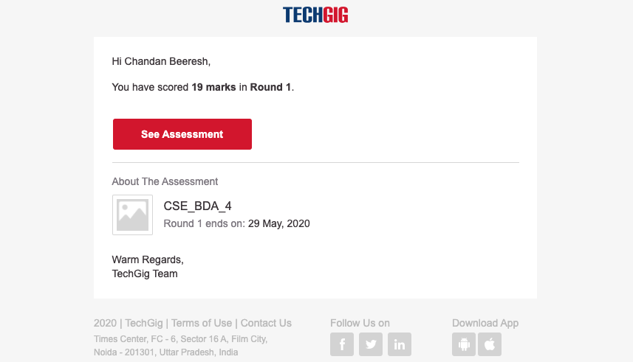

Certification Course Details:

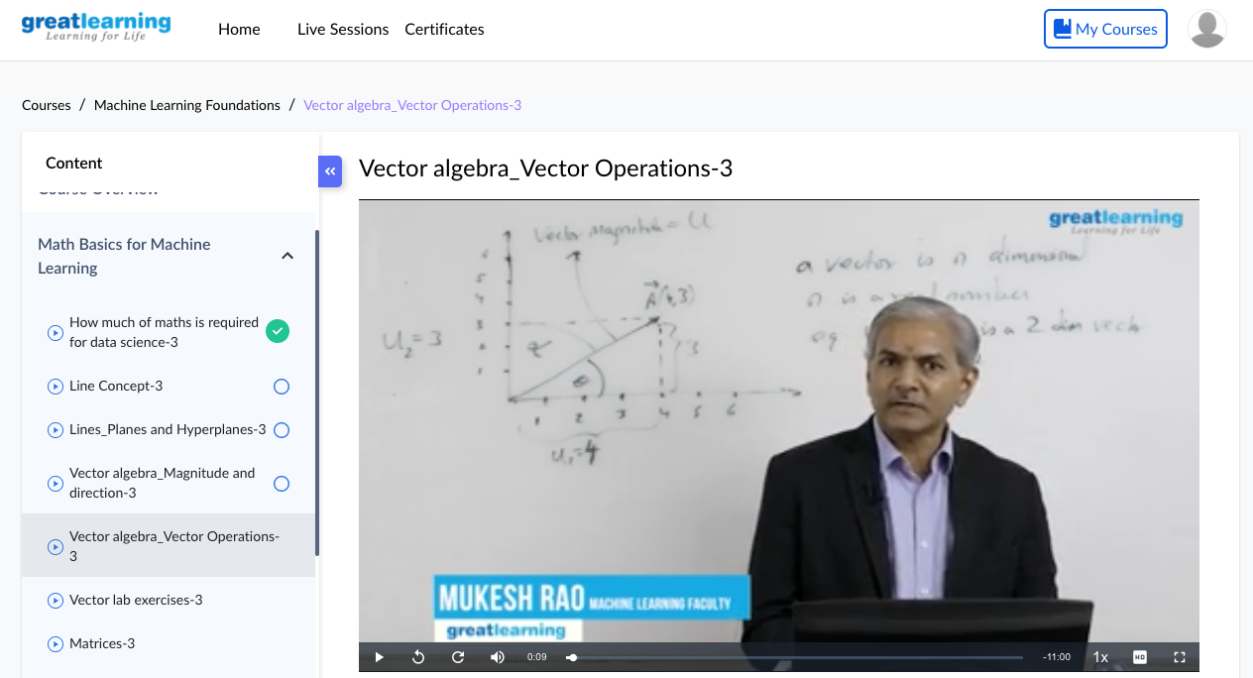

Coding Challenges Details:

**#include <stdio.h>**

**int main()**

**{**

**int n=0,r=0,sum=0,temp=0,key=0;**

**printf("enter the number to find till !\n");**

**scanf("%d",&key);**

**printf("\n\nArmstrong number are --> ");**

**for(int i=0;i<=key;i++)**

**{**

**n=i;**

**r=0;**

**sum=0;**

**temp=0;**

**temp=n;**

**while(n>0)**

**{**

**r=n%10;**

**sum=sum+(r*r*r);**

**n=n/10;**

**}**

**if(temp==sum)**

**{**

**printf(" %d,",i);**

**}**

**}**

**printf(" <--\n");**

**return 0;**

**}**