**DAILY ONLINE ACTIVITIES SUMMARY**

|  |  |  |  |  |  |  |  |  |
| --- | --- | --- | --- | --- | --- | --- | --- | --- |
| **Date:** | **31/05/2020** | | | | | **Name:** | **CHANDAN B** | |
| **Sem & Sec** | **8TH, A** | | | | | **USN:** | **4AL16CS400** | |
| **Online Test Summary** | | | | | | | | |
| **Subject** | | **IOT_IA_3** | | | | | | |
| **Max. Marks** | | **20** | | **Score** | | | **20** | |
| **Certification Course Summary** | | | | | | | | |
| **Course** | Machine Learning Foundation | | | | | | | |
| **Certificate Provider** | | | **GreatLearning** | | **Duration** | | | **5hours** |
| **Coding Challenges** | | | | | | | | |
| **Problem Statement:** **Find the number that is missing from the array containing n distinct number taken from** | | | | | | | | |
| **Status: completed** | | | | | | | | |
| **Uploaded the report in Github** | | | | | **yes** | | | |
| **If yes Repository name** | | | | | <https://github.com/alvas-education-foundation/chandan.b> | | | |
| **Uploaded the report in slack** | | | | | **yes** | | | |

Online Test Details:

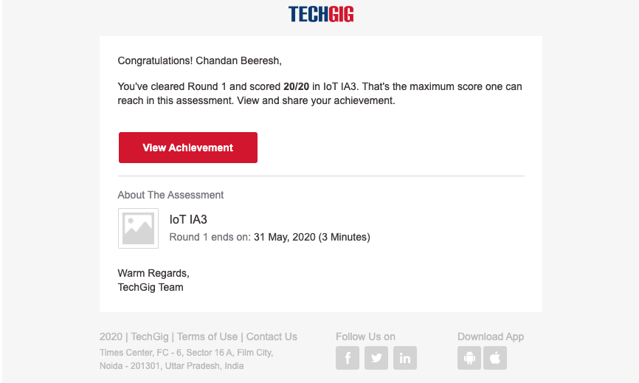

Certification Course Details:

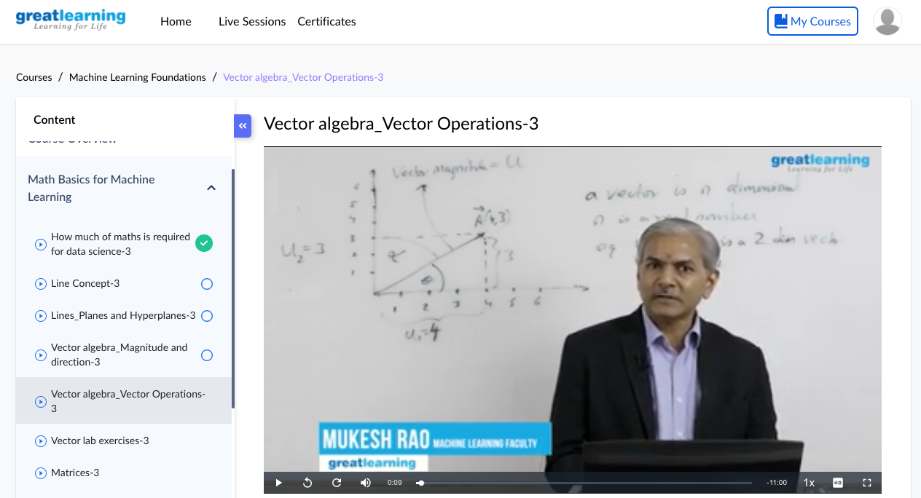

Coding Challenges Details:

**#include <stdio.h>**

**int getMissingNo(int a[], int n)**

**{**

**int i, total;**

**total = (n + 1) * (n + 2) / 2;**

**for (i = 0; i < n; i++)**

**total -= a[i];**

**return total;**

**}**

**int main()**

**{**

**int a[] = { 1, 2, 4, 5, 6 };**

**int miss = getMissingNo(a, 5);**

**printf("%d", miss);**

**getchar();**

**}**