**DAILY ONLINE ACTIVITIES SUMMARY**

|  |  |  |  |  |  |  |  |  |
| --- | --- | --- | --- | --- | --- | --- | --- | --- |
| **Date:** | 28/05/2020 | | | | | **Name:** | CHETHAN CK | |
| **Sem & Sec** | 4th SEM ‘A’ SEC | | | | | **USN:** | 4AL18CS017 | |
| **Online Test Summary** | | | | | | | | |
| **Subject** | | 1.Microcontroller and Embedded Systems(18CS44)  2.Aadalitha Kannada(18KAK49) | | | | | | |
| **Max. Marks** | | 1.20  2.50 | | **Score** | | | 1.20  2.26 | |
| **Certification Course Summary** | | | | | | | | |
| **Course** | Complete Python Bootcamp: Go from zero to hero in Python 3 | | | | | | | |
| **Certificate Provider** | | | Udemy | | **Duration** | | | 2.5 Hours |
| **Coding Challenges** | | | | | | | | |
| **Problem Statement:** 1. (Using C) To find digital root of a number | | | | | | | | |
| **Status:** Completed | | | | | | | | |
| **Uploaded the report in Github** | | | | | YES | | | |
| **If yes Repository name** | | | | | https://github.com/chethan-ck/lockdown_coding | | | |
| **Uploaded the report in slack** | | | | | YES | | | |

**Online Test Details:**

**Microcontroller and Embedded Systems:**

The online test was from module 2 which was about the Introduction to the ARM Instruction set, ARM programming using Assembly language. There were 20 questions and the duration was 40 minutes. The questions were optimal and were easy. The score that I got in the test is 20/20.

**Snapshot:**

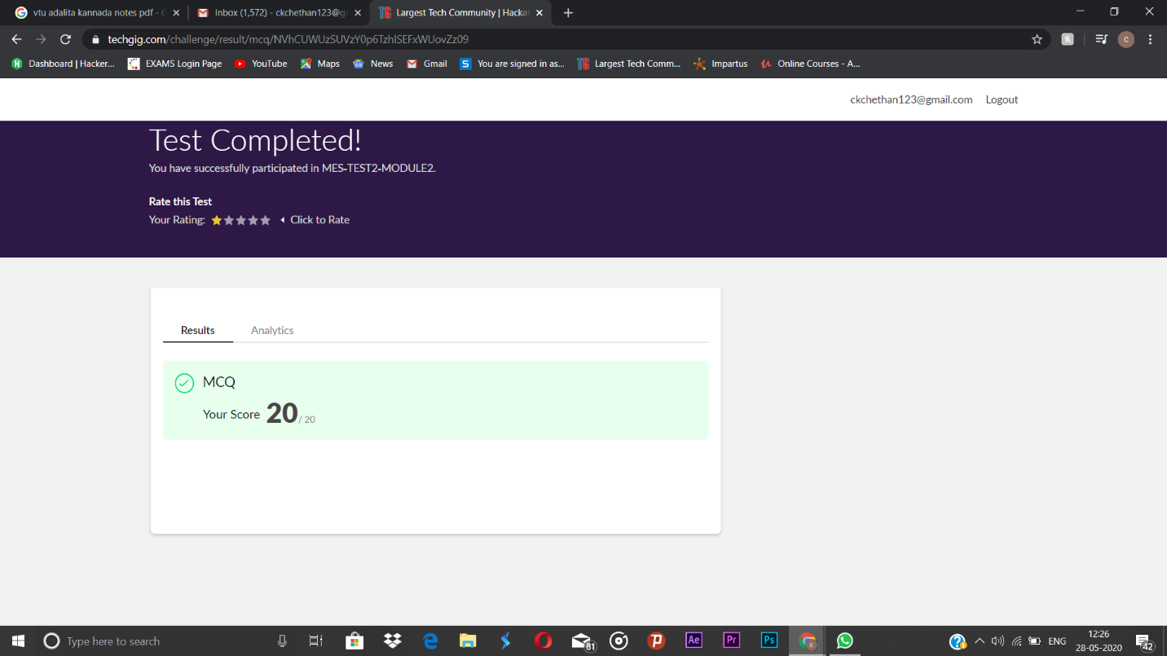

**Aadalitha Kannada:**

The online test was from 10 chapters. There were 50 questions and the duration was 50 minutes. The questions were optimal and were easy. The score that I got in the test is 26/50.

**Snapshot:**

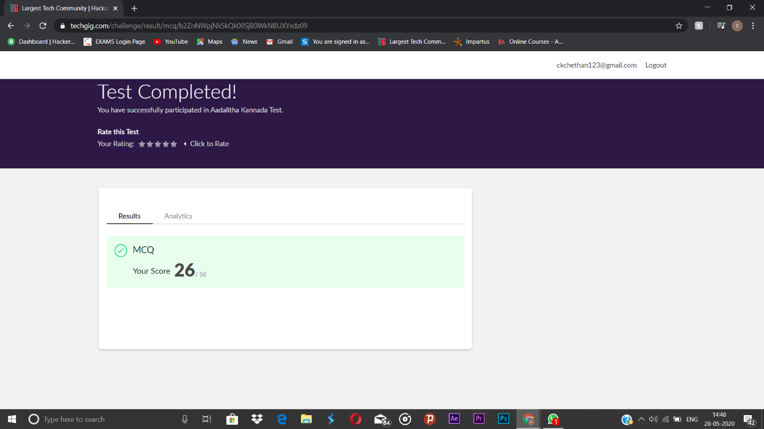

**Certification Course Details:**

**Name of the course**: Complete Python Bootcamp: Go from zero to hero in Python 3

**Certificate Provider**: Udemy

This course has 19 sections and the total duration is 24 hours.

In the tenth day I went through the section of the course that explained about defaultdict and how it can be used while programming in python.

**Snapshot:**

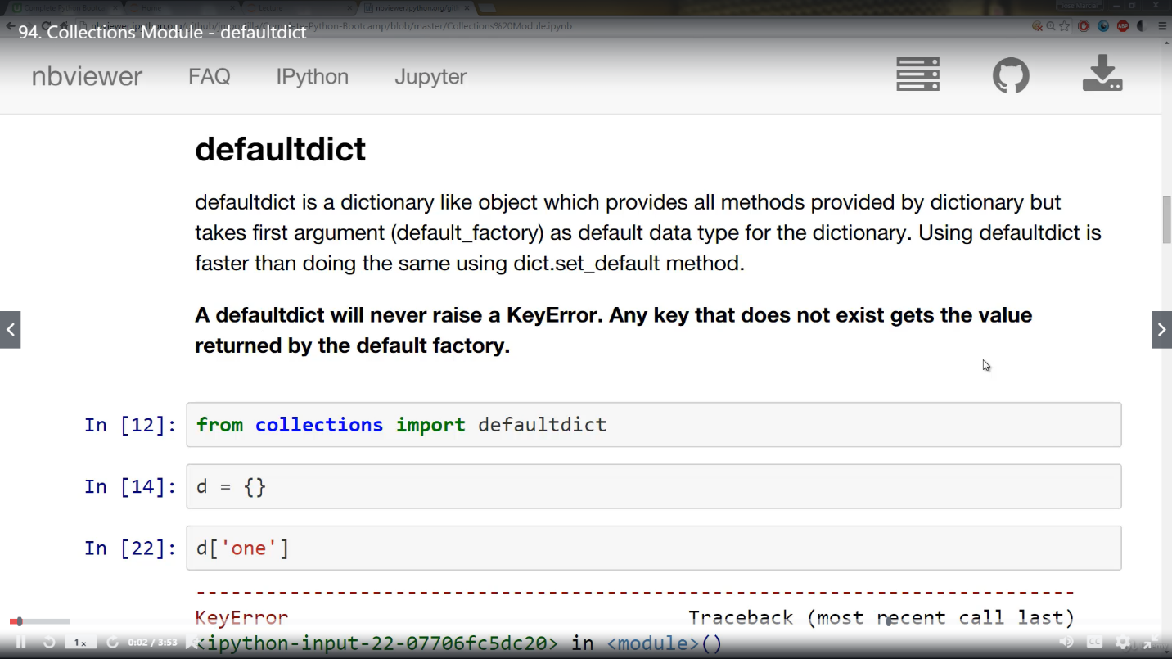

**Online Coding Details:**

Problem 1: (using C language) To find digital root of a number.

**Snapshot:**

