**DAILY ONLINE ACTIVITIES SUMMARY**

|  |  |  |  |  |  |  |  |
| --- | --- | --- | --- | --- | --- | --- | --- |
| **Date:** | 30/05/2020 | | | | **Name:** | CHETHAN CK | |
| **Sem & Sec** | 4th SEM ‘A’ SEC | | | | **USN:** | 4AL18CS017 | |
| **Online Test Summary** | | | | | | | |
| **Subject** | | 1.Data Communication(18CS46)  2.Complex Analysis, Probability and Statistical Methods(18MAT41) | | | | | |
| **Max. Marks** | | 1.30  2.30 | | **Score** | | 1.25  2.29 | |
| **Certification Course Summary** | | | | | | | |
| **Course** | Complete Python Bootcamp: Go from zero to hero in Python 3 | | | | | | |
| **Certificate Provider** | | | Udemy | **Duration** | | | 2.5 Hours |
| **Coding Challenges** | | | | | | | |
| **Problem Statement:** 1. Write a C Program to count Uppercase, Lowercase, special character and  numeric values for a given string.  2. Write a C Program to generate first N Armstrong Numbers. | | | | | | | |
| **Status:** Completed | | | | | | | |
| **Uploaded the report in Github** | | | | YES | | | |
| **If yes Repository name** | | | | https://github.com/chethan-ck/lockdown_coding | | | |
| **Uploaded the report in slack** | | | | YES | | | |

**Online Test Details:**

**Data Communication:**

The online test was from module 3 and 4 which was about the Bandwidth Utilization, Switching, Error Detection and Correction, Data link control, Media Access control, Introduction to Data-Link Layer, IPv4 Addressing and subnetting. There were 30 questions and the duration was 45 minutes. The questions were optimal and were easy. The score that I got in the test is 25/30.

**Snapshot:**

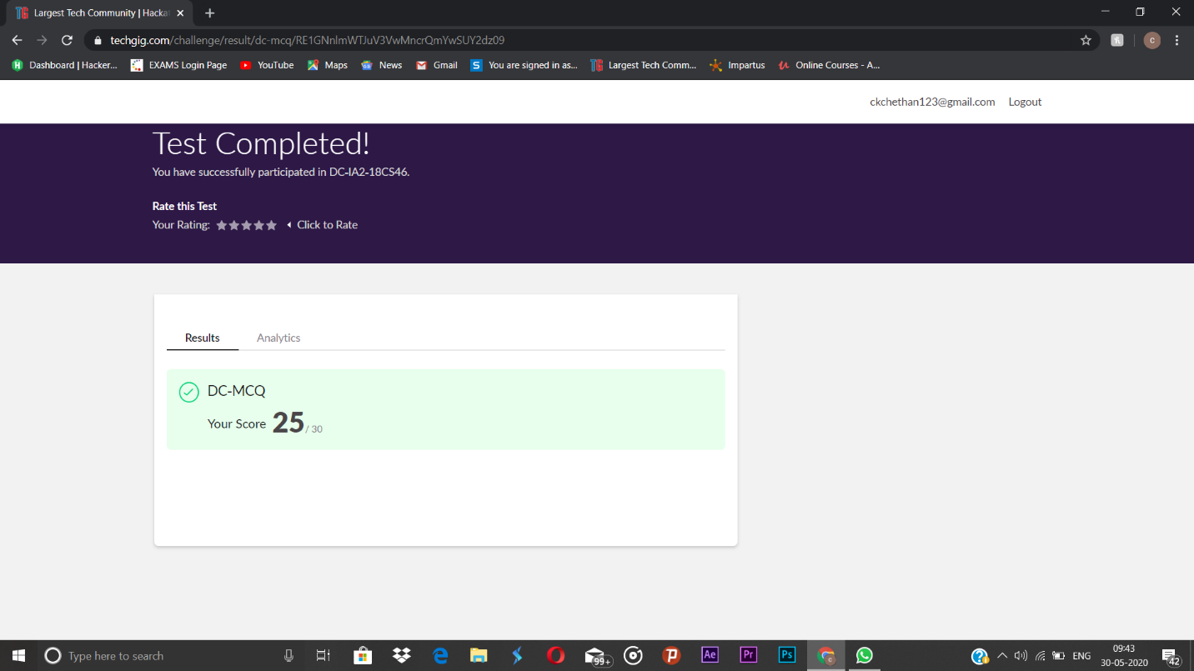

**Complex Analysis, Probability and Statistical Methods:**

The online test was from module 3 which was about the Probability Distributions. There were 20 questions and the duration was 40 minutes. The questions were optimal and were easy. The score that I got in the test is 29/30.

**Snapshot:** Not Taken

**Certification Course Details:**

**Name of the course**: Complete Python Bootcamp: Go from zero to hero in Python 3

**Certificate Provider**: Udemy

This course has 19 sections and the total duration is 24 hours.

In the twelveth day I went through the section of the course that explained about interact functionality with GUIs and how it can be used while programming in python.

**Snapshot:**

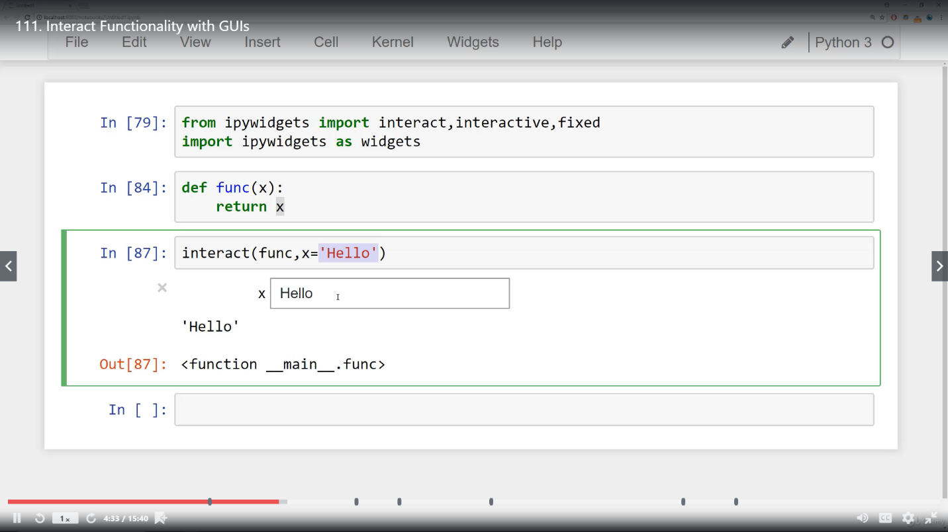

**Online Coding Details:**

Problem 1: (using C language) To count Uppercase, Lowercase, special character and numeric values for a given string.

**Snapshot:**

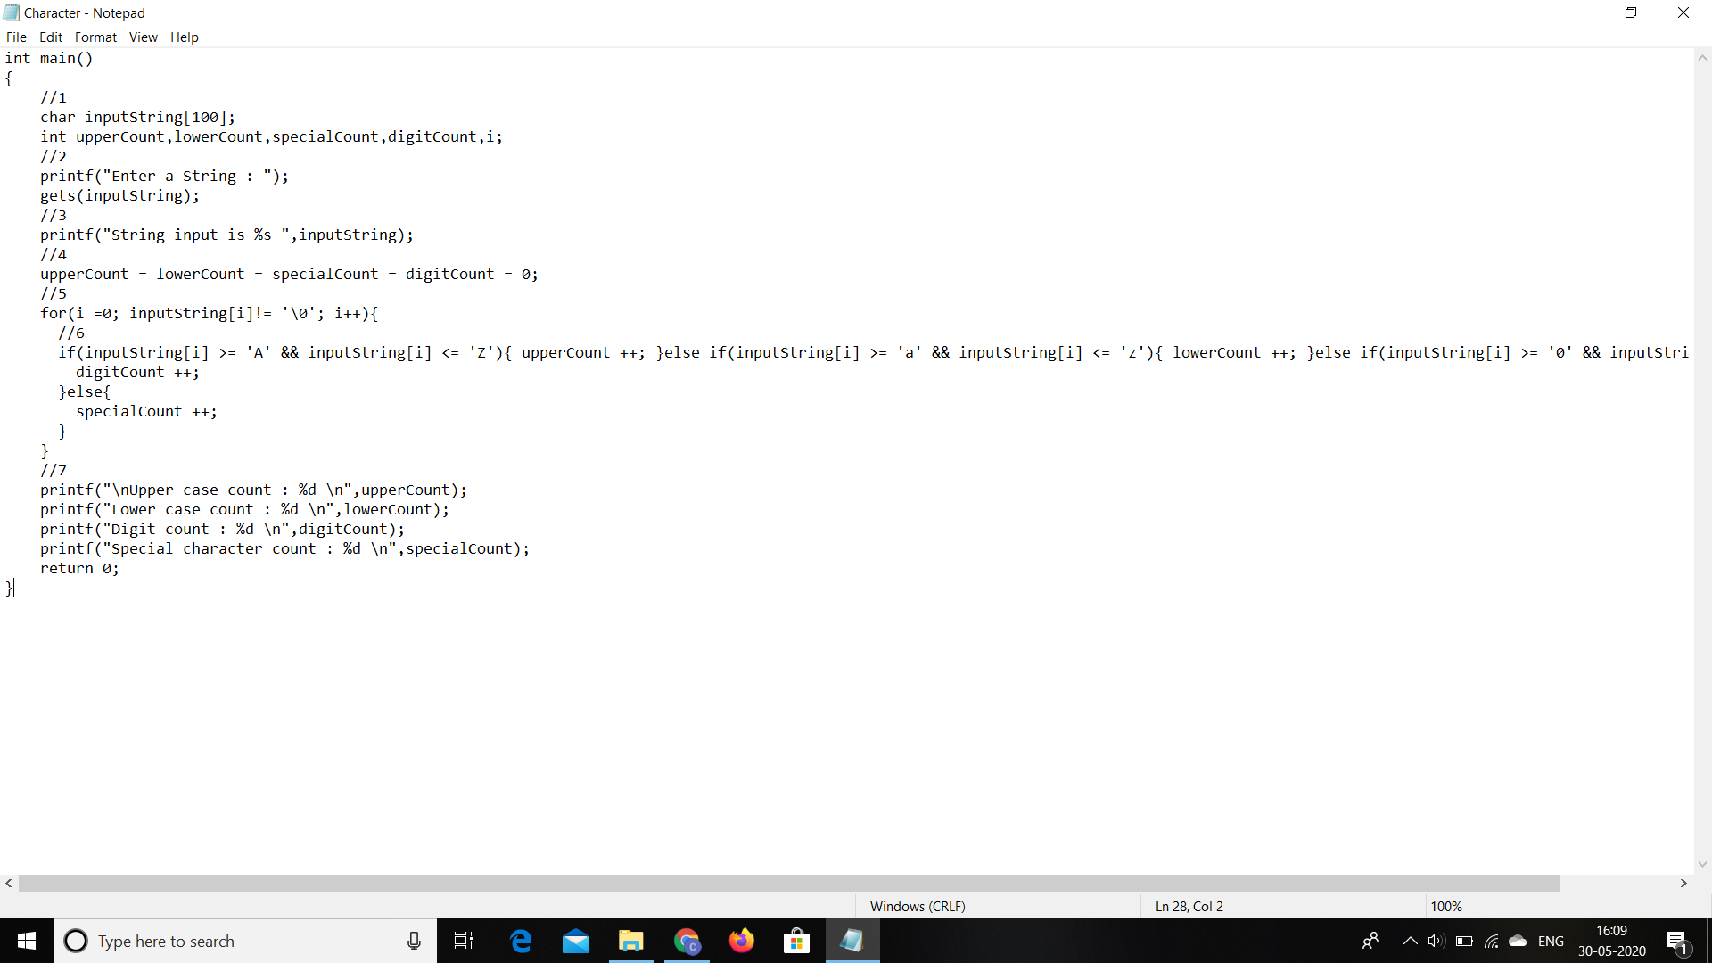

Problem 2:(Using C language) To generate first N Armstrong Numbers.

**Snapshot:**

