**DAILY ONLINE ACTIVITIES SUMMARY**

|  |  |  |  |  |  |  |  |  |
| --- | --- | --- | --- | --- | --- | --- | --- | --- |
| **Date:** | **19/05/2020** | | | | | **Name:** | **CHETHAN C K** | |
| **Sem & Sec** | **4TH&A** | | | | | **USN:** | **4AL18CS017** | |
| **Online Test Summary** | | | | | | | | |
| **Subject** | | **DESIGN AND ANALYSIS OF ALGORITHM** | | | | | | |
| **Max. Marks** | | **30** | | **Score** | | | **20** | |
| **Certification Course Summary** | | | | | | | | |
| **Course** | **COMPLETE PYTHOM BOOTCAMP** | | | | | | | |
| **Certificate Provider** | | | **UDEMY** | | **Duration** | | | **2 HOURS** |
| **Coding Challenges** | | | | | | | | |
| **Problem Statement:1:we have Letter or a word then we need add some letters to it and need to find out shortest palindrome**  **Problem statement 2:Write a simple code to identify given linked list is palindrome or not by using stack** | | | | | | | | |
| **Status: executed** | | | | | | | | |
| **Uploaded the report in Github** | | | | | **YES** | | | |
| **If yes Repository name** | | | | | **1.** <https://github.com/chethan-ck/lockdown_certification>  **2.** <https://github.com/chethan-ck/lockdown_coding> | | | |
| **Uploaded the report in slack** | | | | | **YES** | | | |

Online Test Summary: 18CS42 the test was from 1st module about Introduction to Algorithm. There are 25 questions and the duration 30minutes.The score that I received was 20/30.

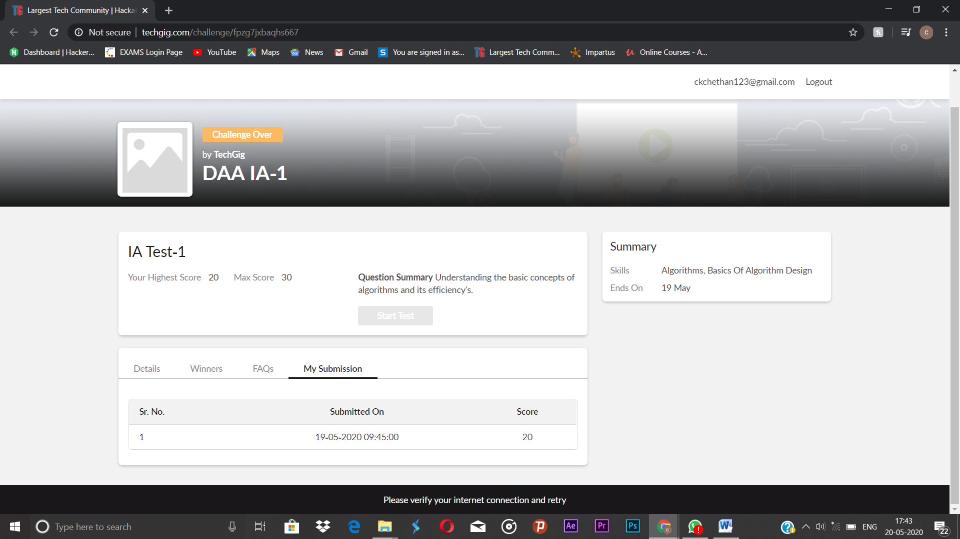

Online Certification course:

Name of the course: Complete Python Bootcamp.

Today I learnt the different Data structure available in python.

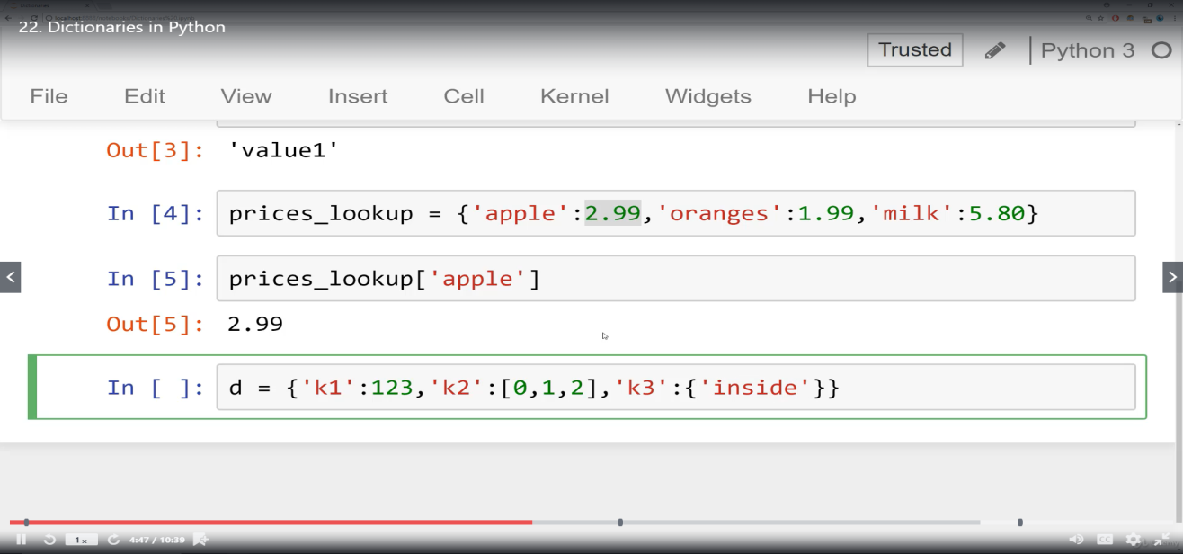

Online Coding summary:

1.We have a Letter or a word then we need add some letters to it and need to find out shortest palindrome  
For example we take "S": S will be the shortest palindrome string.  
If we take "xyz": zyxyz will be the shortest palindrome string  
So we need to add some characters to the given string or character and find out what will be the shortest palindrome string by using simple java program.

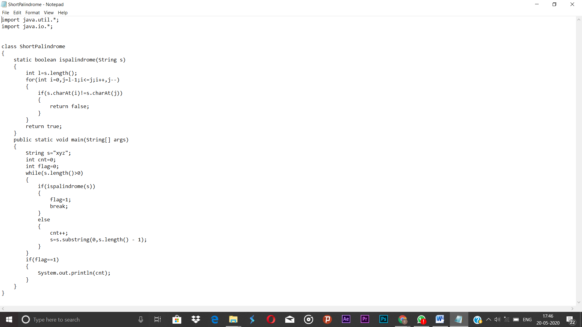

This the snap shot of the first program

2. Write a simple code to identify given linked list is palindrome or not by using stack.  
First take a Stack. Traverse through each node of the linked list and push each node value to Stack.  
Once the traversal & copying is done, iterate through linked list from head node again.  
In each iteration, pop one stack element and compare with node value in respective iteration. It is expected to match stack popped value with node value.  
In case of all matches, its a palindrome. Any one element mismatch makes it not a palindrome. 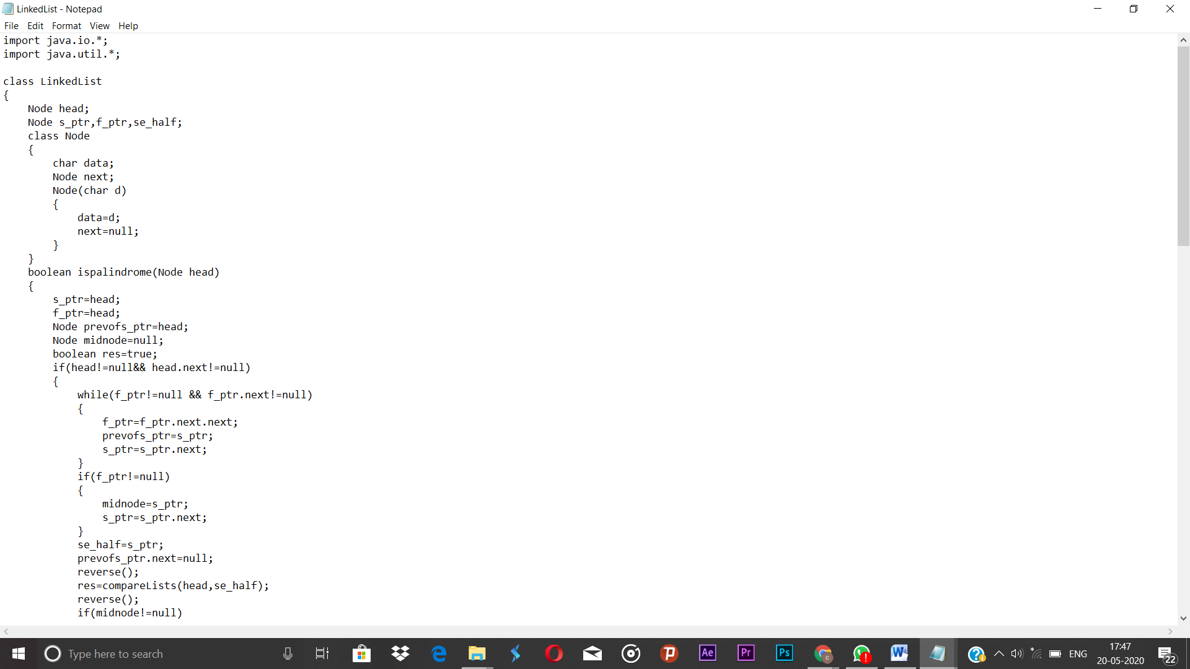

This the snapshot of the 2 program

**3.** A user will input two strings, and we find if one of the strings is a sub sequence of the other. Program prints “yes” if either the first string is a sub sequence of the second string or the second string is a sub sequence of the first string.  
Assume that, the length of the first string is smaller than or equal to the length of the second string.

**An expected output of the program:**

Input the first string  
tree  
Input the second string  
Computer science is awesome  
YES

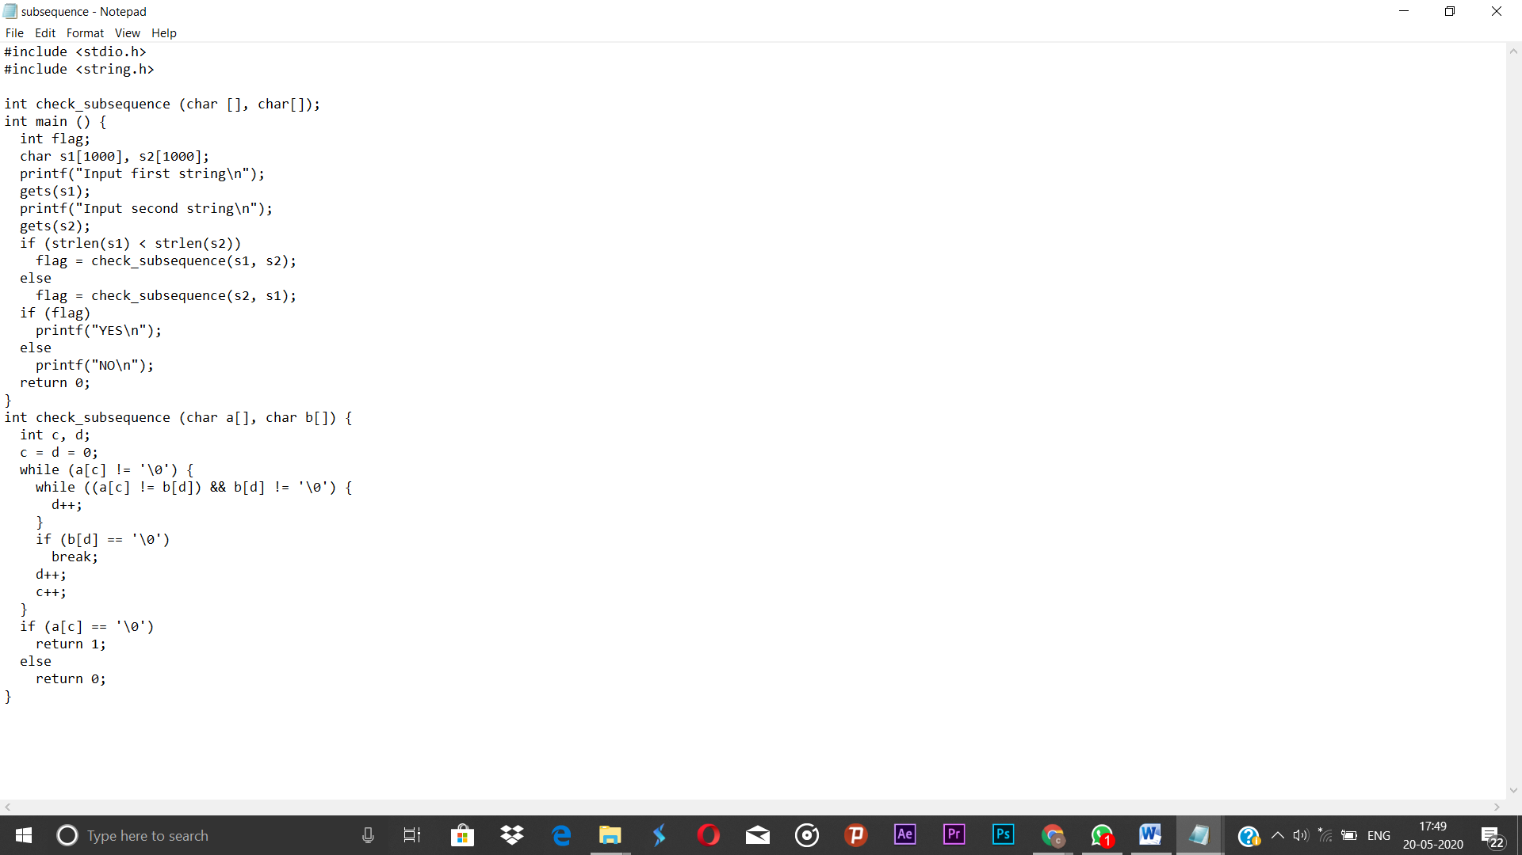

This the snapshot of the 3 program