**DAILY ONLINE ACTIVITIES SUMMARY**

|  |  |  |  |  |  |  |  |  |
| --- | --- | --- | --- | --- | --- | --- | --- | --- |
| **Date:** | **21/05/2020** | | | | | **Name:** | **CHETHAN C K** | |
| **Sem & Sec** | **4TH&A** | | | | | **USN:** | **4AL18CS017** | |
| **Online Test Summary** | | | | | | | | |
| **Subject** | | **Microcontroller and Embedded Systems** | | | | | | |
| **Max. Marks** | | **30** | | **Score** | | | **19** | |
| **Certification Course Summary** | | | | | | | | |
| **Course** | **COMPLETE PYTHOM BOOTCAMP** | | | | | | | |
| **Certificate Provider** | | | **UDEMY** | | **Duration** | | | **2 HOURS** |
| **Coding Challenges** | | | | | | | | |
| **Problem Statement:** **Write a C or Java program to implement FCFS and SJF process scheduling.**  **Input: Processes with burst time**  **Output: Process being scheduled** | | | | | | | | |
| **Status: executed** | | | | | | | | |
| **Uploaded the report in Github** | | | | | **YES** | | | |
| **If yes Repository name** | | | | | **1.** <https://github.com/chethan-ck/lockdown_certification>  **2.** <https://github.com/chethan-ck/lockdown_coding> | | | |
| **Uploaded the report in slack** | | | | | **YES** | | | |

Online Test Summary: 18CS44 the test was from 1st module about Arm Embedded Systems and Arm Processor Fundamentals. There are 30 questions and the duration 40minutes.The score that I received was 19/30.

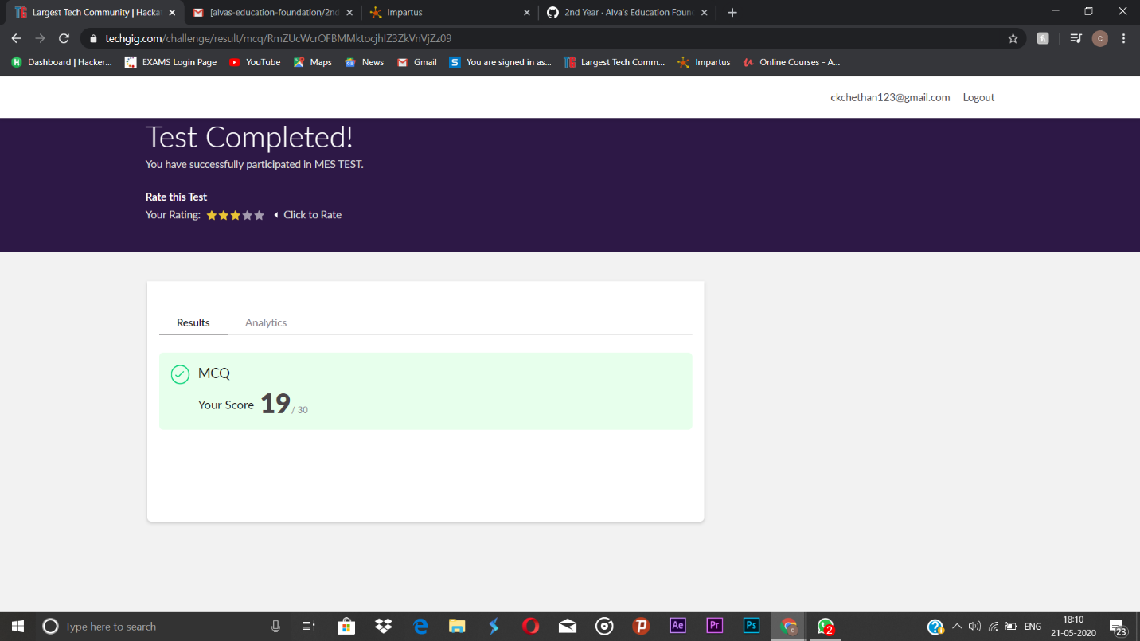

Online Certification course:

Name of the course: Complete Python Bootcamp.

Today I learnt the looping statements available in python.

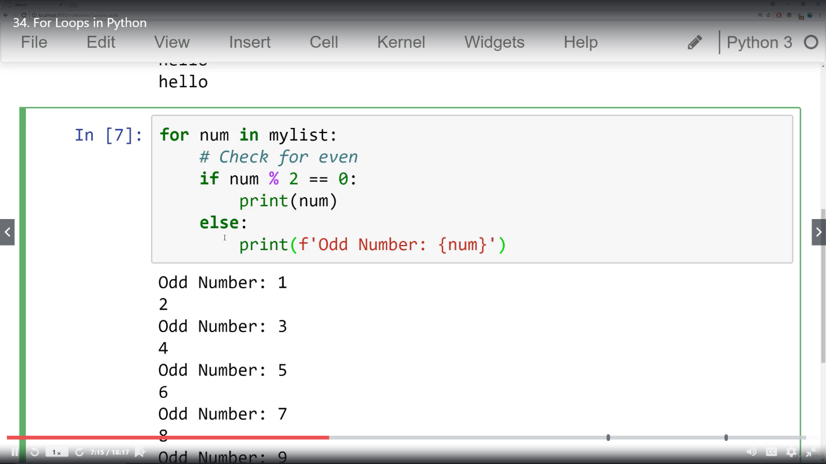

Online Coding summary:

1. Write a C or Java program to implement FCFS process scheduling.

Input: Processes with burst time

Output: Process being scheduled

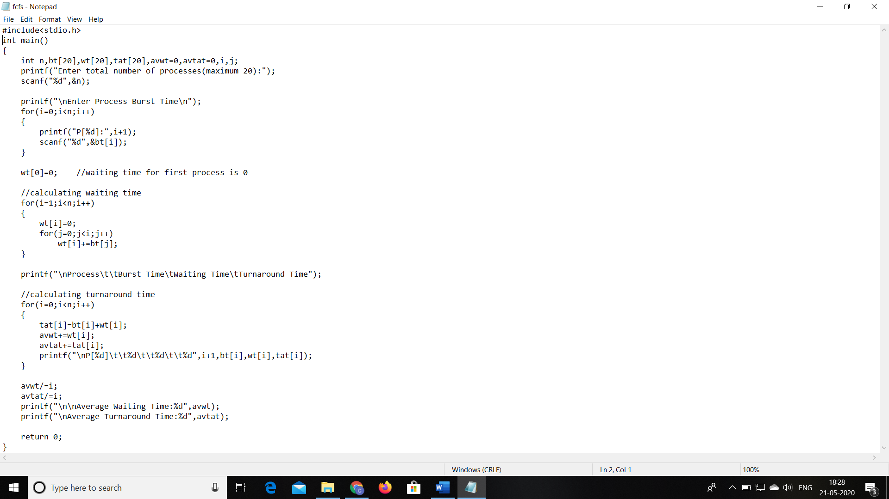

This the snap shot of the first program

2. Write a C or Java program to implement SJF process scheduling.

Input: Processes with burst time

Output: Process being scheduled

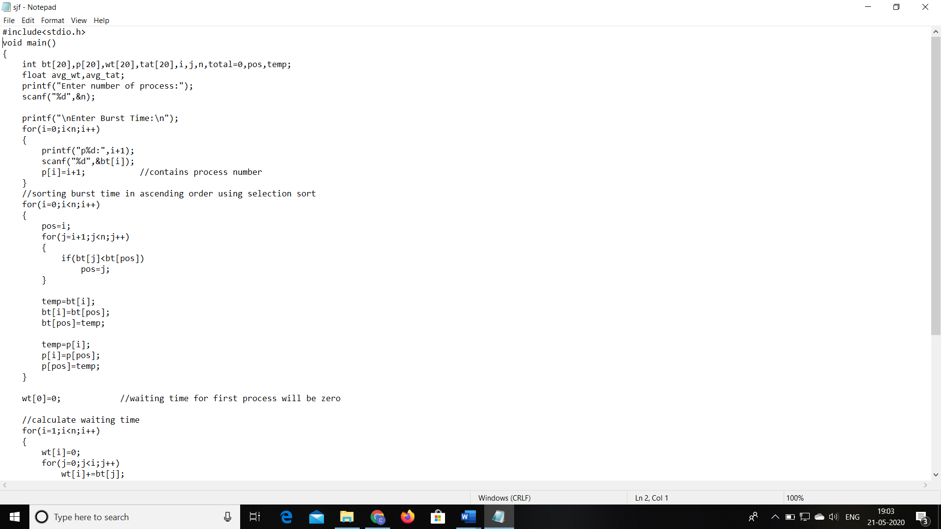

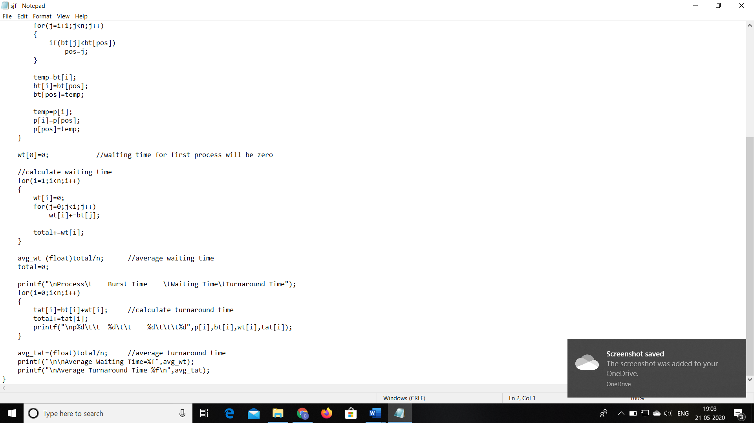

This the snap shot of the second program