**DAILY ONLINE ACTIVITIES SUMMARY**

|  |  |  |  |  |  |  |  |  |
| --- | --- | --- | --- | --- | --- | --- | --- | --- |
| **Date:** | 23/05/2020 | | | | | **Name:** | Chethan C K | |
| **Sem & Sec** | Fourth SEM section A | | | | | **USN:** | 4AL18CS017 | |
| **Online Test Summary** | | | | | | | | |
| **Subject** | | Data Communication | | | | | | |
| **Max. Marks** | | 30 | | **Score** | | | 29 | |
| **Certification Course Summary** | | | | | | | | |
| **Course** | Complete Python Bootcamp : Go from zero to hero in Python 3 | | | | | | | |
| **Certificate Provider** | | | Udemy | | **Duration** | | | 1 Hour 30 minutes |
| **Coding Challenges** | | | | | | | | |
| **Problem Statement:** 1. Write a C program to implement SRTF process scheduling.  Input: A set of processes with their burst time and arrival time  Output: The processes scheduled based on the arrival time and a smaller burst time. | | | | | | | | |
| **Status:** Completed | | | | | | | | |
| **Uploaded the report in Github** | | | | | YES | | | |
| **If yes Repository name** | | | | | <https://github.com/chethan-ck/lockdown_coding> | | | |
| **Uploaded the report in slack** | | | | | YES | | | |

**Online Test Details:**

The online test was from module 1and 2 which was about the introduction to data communication, network models,introduction to physical layer-1,digital transmission,physical layer-2,analog transmission. There were 30 questions and the duration was 40 minutes. The questions were optimal and were easy. The score that I got in the test is 29/30.

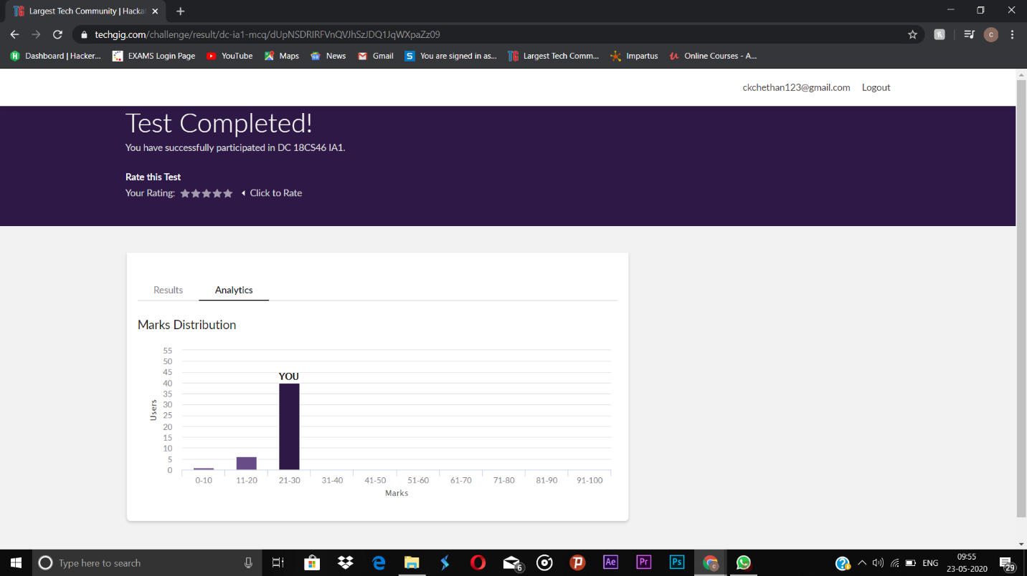

**Certification Course Details:**

**Name of the course**: Complete Python Bootcamp: Go from zero to hero in Python 3

**Certificate Provider**: Udemy

This course has 19 sections and the total duration is 24 hours.

In the sixth day I went through the section of the course that explained about object oriented programming and how it can be used while programming in python.

**Snapshot:**

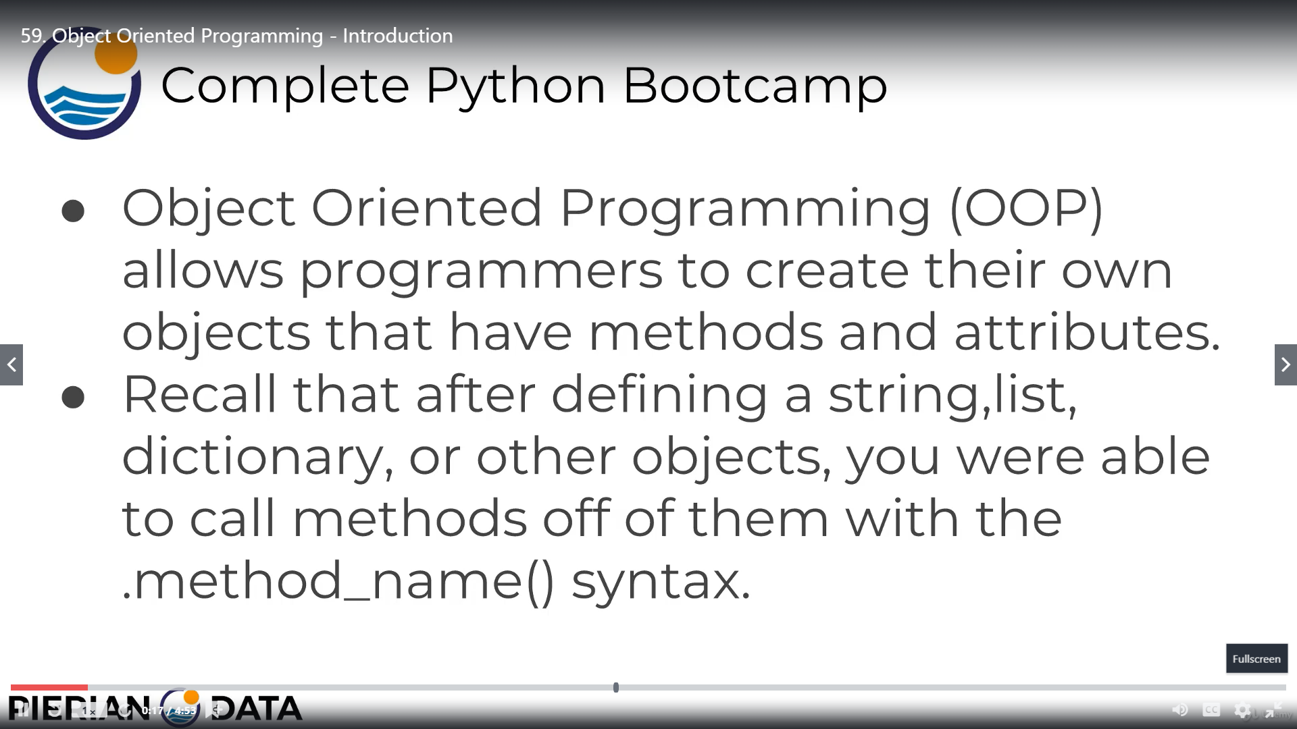

**Online Coding Details:**

Problem 1: (using C language) To implement SRTF process scheduling.

Input: A set of processes with their burst time and arrival time

Output: The processes scheduled based on the arrival time and a smaller burst time.

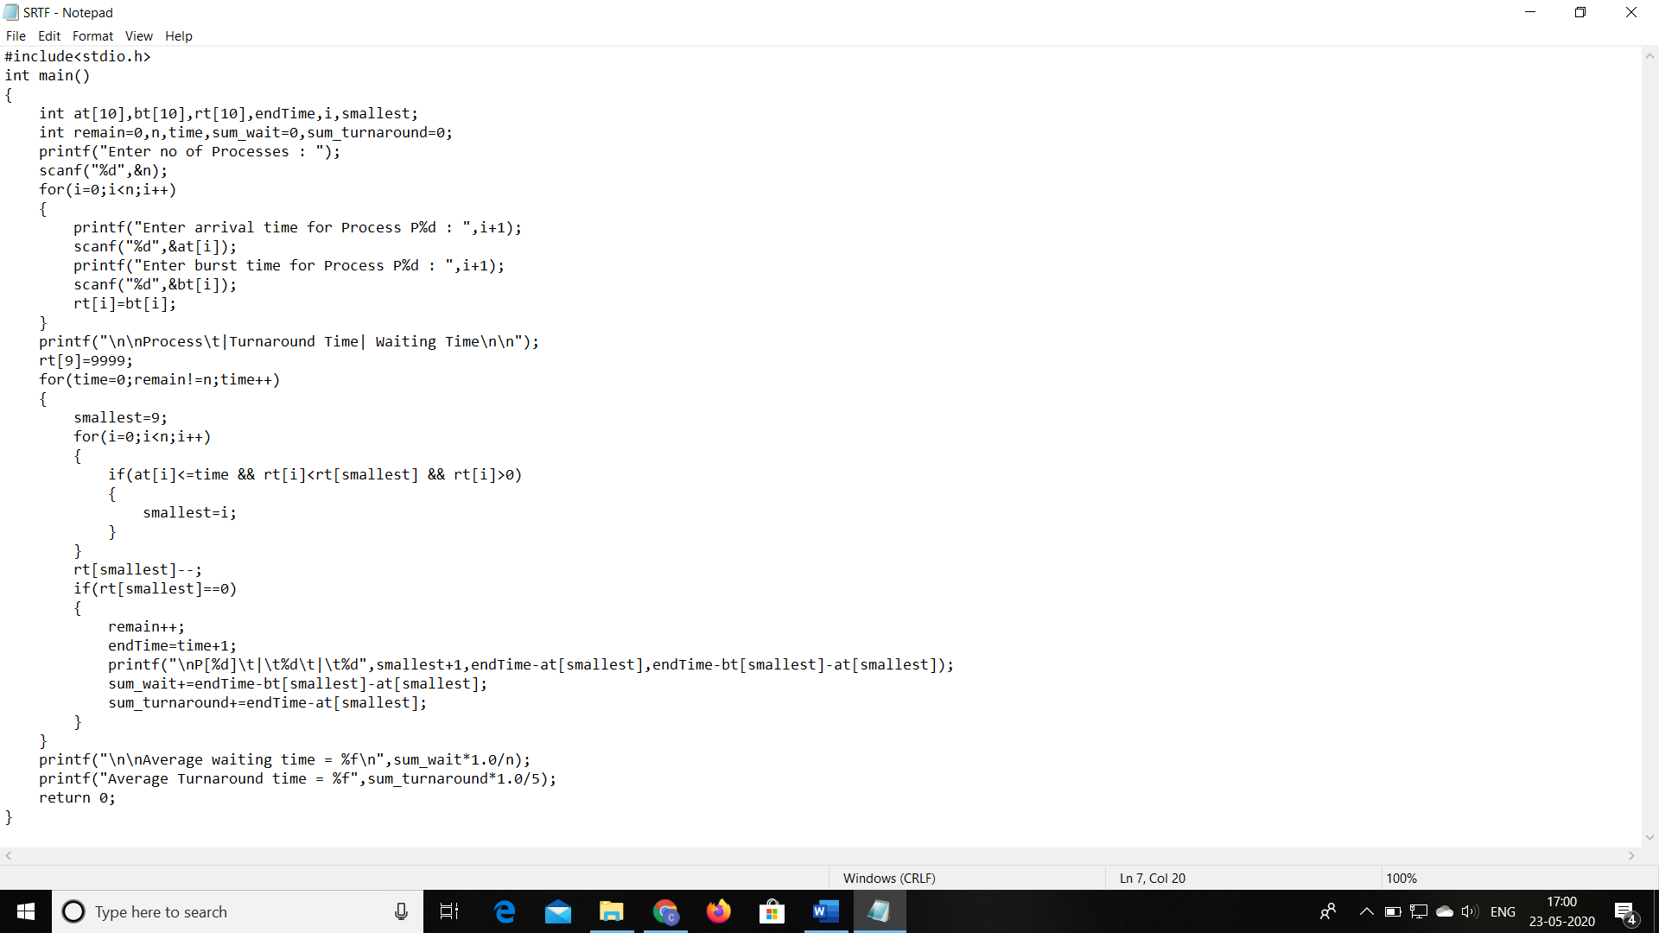

Problem 2: (Using C) To generate first N Triangular Numbers

