**DAILY ONLINE ACTIVITIES SUMMARY**

|  |  |  |  |  |  |  |  |  |
| --- | --- | --- | --- | --- | --- | --- | --- | --- |
| **Date:** | 27/05/2020 | | | | | **Name:** | Chethan C K | |
| **Sem & Sec** | Fourth SEM section A | | | | | **USN:** | 4AL18CS017 | |
| **Online Test Summary** | | | | | | | | |
| **Subject** | | Object Oriented Concepts(18CS45) | | | | | | |
| **Max. Marks** | | 30 | | **Score** | | | 27 | |
| **Certification Course Summary** | | | | | | | | |
| **Course** | Complete Python Bootcamp : Go from zero to hero in Python 3 | | | | | | | |
| **Certificate Provider** | | | Udemy | | **Duration** | | | 1 Hour |
| **Coding Challenges** | | | | | | | | |
| **Problem Statement:** 1. (Using C) To sort an array of integers in ascending order and display the  sorted array and number of passes performed for sorting.  2: (Using C) To find the largest element on the left side of each index which is  smaller than the element present at that index. | | | | | | | | |
| **Status:** Completed | | | | | | | | |
| **Uploaded the report in Github** | | | | | YES | | | |
| **If yes Repository name** | | | | | <https://github.com/chethan-ck/lockdown_coding> | | | |
| **Uploaded the report in slack** | | | | | YES | | | |

**Online Test Details:**

The online test was from module 5 which was about the Event Handling and Swings. There were 30 questions and the duration was 30 minutes. The questions were optimal and were easy. The score that I got in the test is 27/30.

**Snapshot:**

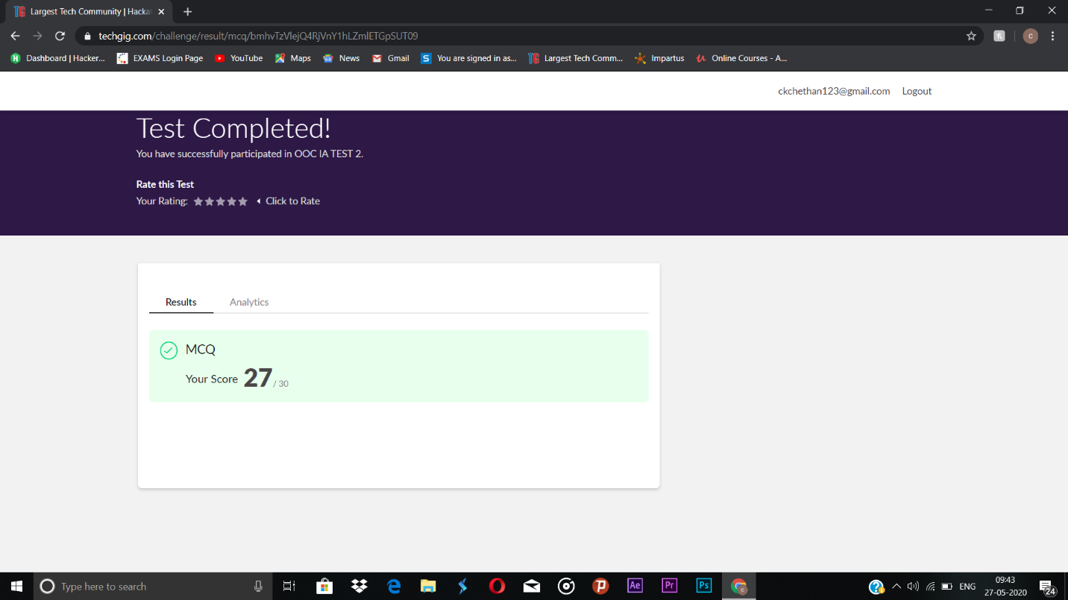

**Certification Course Details:**

**Name of the course**: Complete Python Bootcamp: Go from zero to hero in Python 3

**Certificate Provider**: Udemy

This course has 19 sections and the total duration is 24 hours.

In the ninth I went through the section of the course that explained about generators and how it can be used while programming in python.

**Snapshot:**

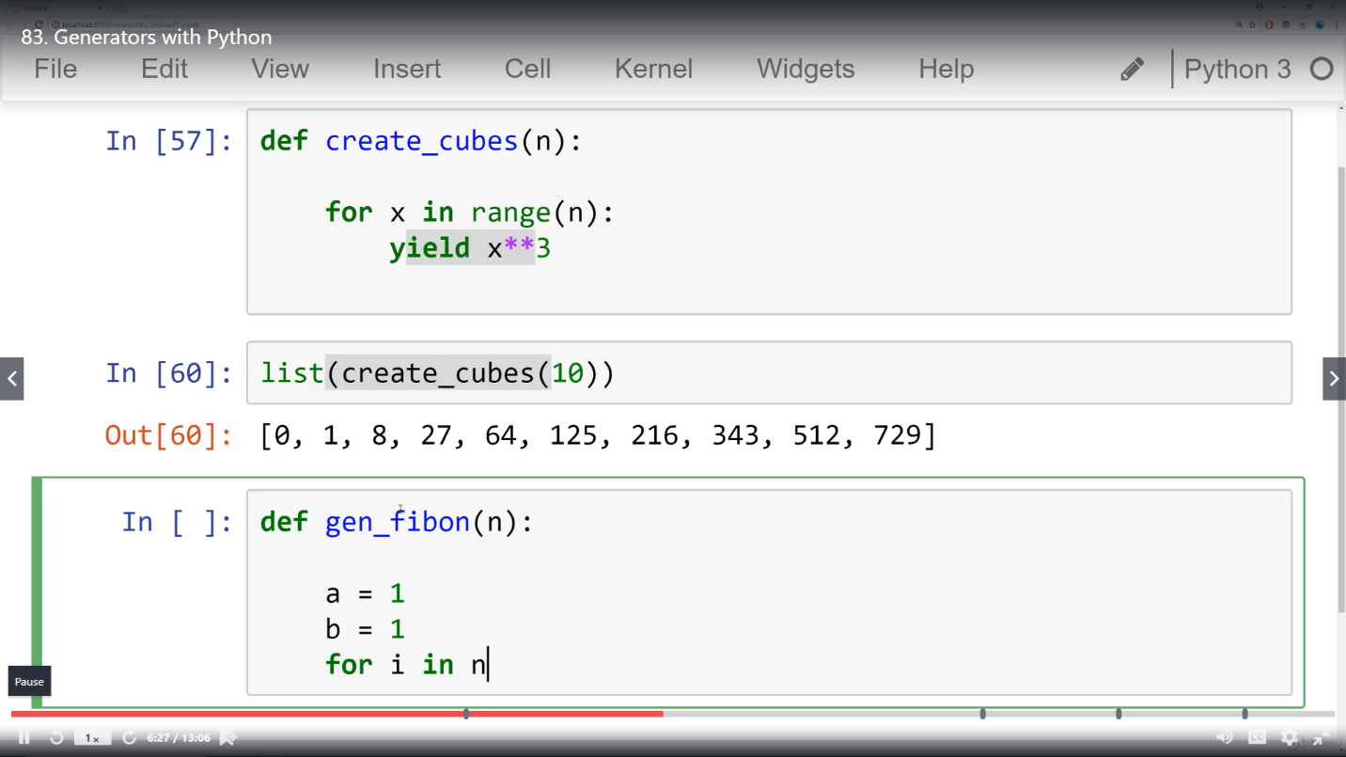

**Online Coding Details:**

Problem 1: (using C language) To sort an array of integers in ascending order and display the

sorted array and number of passes performed for sorting.

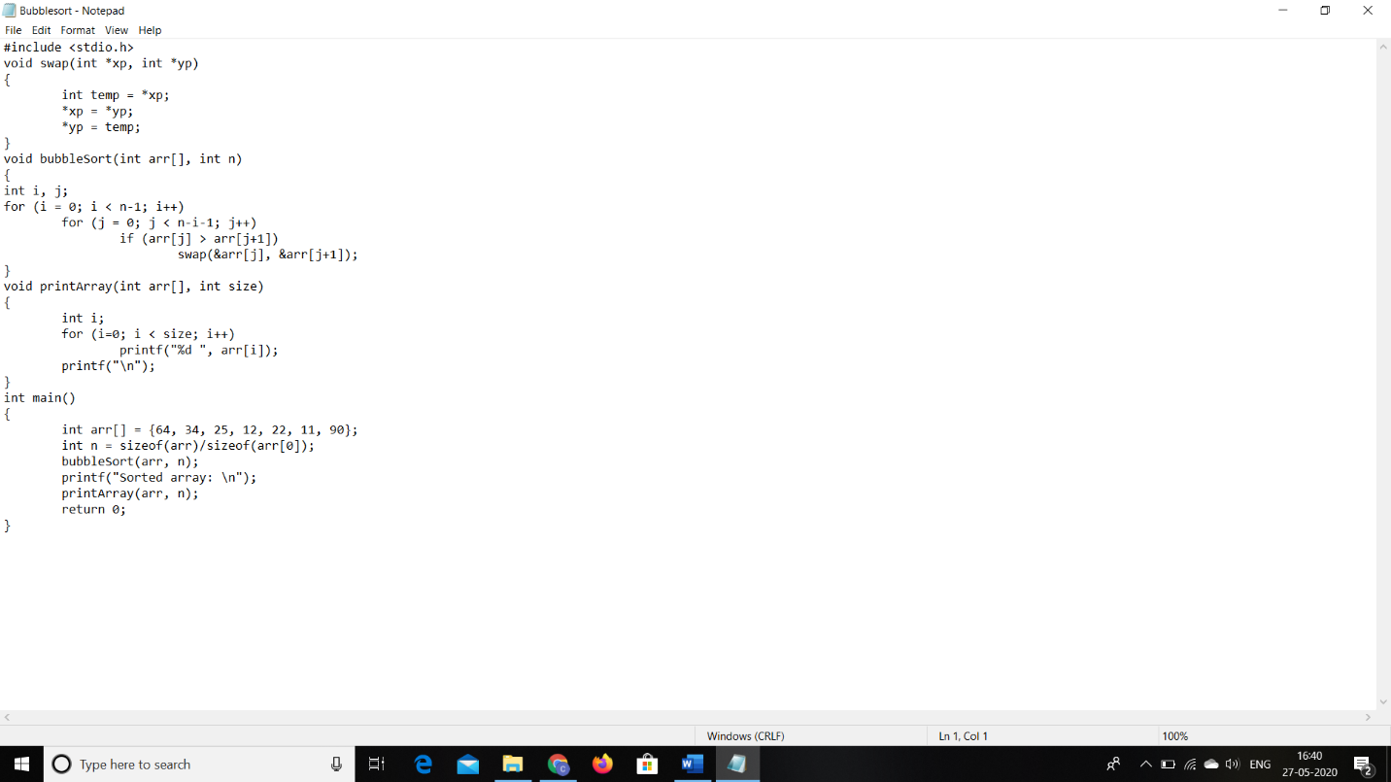

Problem 2: (Using C) To find the largest element on the left side of each index which is smaller than the element present at that index.

