DAILY ASSESSMENT FORMAT

|  |  |  |  |
| --- | --- | --- | --- |
| ***Date:*** | ***09/06/2020*** | ***Name:*** | ***DIVYASHREE LV*** |
| ***Course:*** | ***PCB design*** | ***USN:*** | ***4AL17EC030*** |
| ***Topic:*** | ***Introduction*** | ***Semester & Section:*** | ***6th Sem A sec*** |
| ***Github Repository:*** | ***divyalv*** |  |  |
| ***FORENOON SESSION DETAILS*** | | | |
| ***Image of session*** | | | |

***Report – Report can be typed or hand written for up to two pages.***

***What is Kicad ?***

* ***KiCad is a free software suite for electronic design automation.***
* ***It facilitates the design of schematics for electronic circuits and their conversion to PCB designs.***
* ***KiCad was originally developed by Jean-Pierre Charras.***
* ***It features an integrated environment for schematic capture and PCB layout design.***

*Setting Up a Project:*

* *\*\* *.pro** - Main project file to keep track of the file structure.*
* *\*\* *.cmp** - Defines which footprints go with which schematic components.*
* *\*\* *.kicad_pcb** - The PCB layout.*
* *\*\* *.sch** - The schematic. Editing the Schematic:*
  + *a - To add components.*
  + *c - Copy a component when the cursor is over another component.*
  + *w - To wire components.*
  + *v - Edit component value.*
  + *Esc - Escape mode or whatever command in progress and return to normal pointer mode.*
* *\*\* ctrl+z** - Undo. Use liberally to undo any mistakes.*
* *ctrl+s - To save. Make sure to save often!*

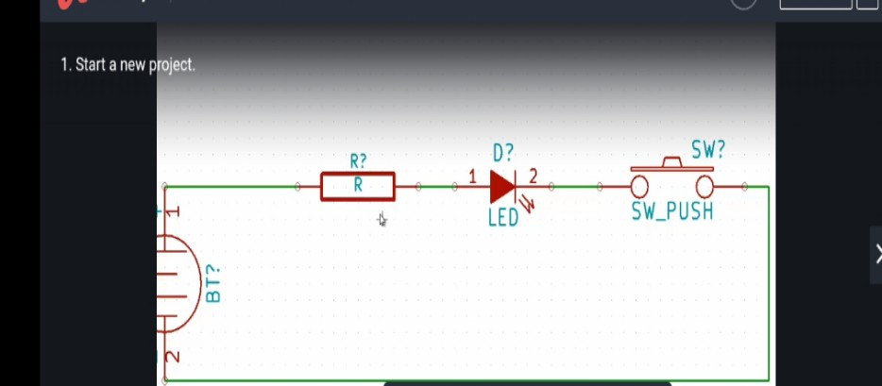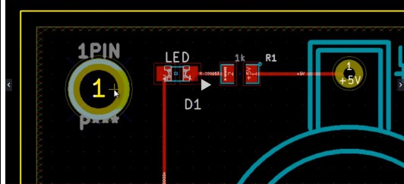

*How to Start a New Project Using KICAD: Example of Basic switch and LED*

***Netlist and Footprint of Schematic:***

|  |  |  |  |
| --- | --- | --- | --- |
| ***Date:*** | ***09/06/2020*** | ***Name:*** | ***DIVYASHREE LV*** |
| ***Course:*** | *Java* | ***USN:*** | ***4AL17EC030*** |
| ***Topic:*** | 1. *Hello wolrd Program* 2. *Using Variables* 3. *Strings: Working with Text* 4. *While Loops* 5. *For Loops* 6. *Getting User Input* 7. *Do While* 8. *Switch* 9. *Arrays* | ***Semester & Section:*** | ***6th Sem A sec*** |
| ***Github Repository:*** | ***divyalv*** |  |  |
| ***AFTERNOON SESSION DETAILS*** | | | |
| ***Image of session*** | | | |

***Report – Report can be typed or hand written for up to two pages.***

* *Learnt how to write “A Hello World” Program in Java Eclipse.*
* *Learnt how to make use of Variables.*
* *Learnt about Strings and the Working With Text*
* *Got familiarized with “While Loops” in Java.*
* *Got to know about “For Loops” in Java*
* *Learnt the "If" conditional statement usage in Java programing.*
* *Learnt how to get User Input from the user.*
* *Came across “Do ... While loop” in Java.*
* *Saw “Switch” statements and its working.*
* *Got introduced to the “Arrays” in Java.*

*Here is the example program in Java using Arrays:*

public class App {

public static void main(String[] args) { int value = 7;

int[ ] values;

values = new int[3];

System.out.println(values[0]);

values[0] = 10;

values[1] = 20;

values[2] = 30;

System.out.println(values[0]); System.out.println(values[1]); System.out.println(values[2]);

for(int i=0; i < values.length; i++) { System.out.println(values[i]);

}

int[] numbers = {5, 6, 7};

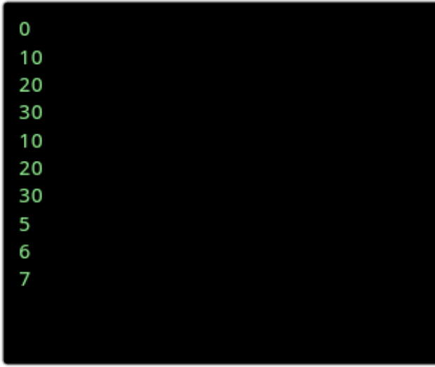

for(int i=0; i < numbers.length; i++) { System.out.println(numbers[i]);

}

}

}

*The Output for the above program looks :*