DAILY ASSESSMENT REPORT

|  |  |  |  |
| --- | --- | --- | --- |
| **Date:** | **12/06/2020** | **Name:** | **DIVYASHREE LV** |
| **Course:** | **PCB design using Kicad** | **USN:** | **4AL17EC030** |
| **Topic:** | 1. **Add footprint search path** 2. **Prepare production files** | **Semester & Section:** | **6th sem & ‘A’ sec** |

|  |
| --- |
| **FORENOON SESSION DETAILS** |
| **Image of session** |

**Report**

# Peel-off Mask Design Rule Specifications:

* Minimum width of any Peel-off element (P): 0.500mm (20mil)
* Maximum coverable hole ENDSIZE (H): 6.00mm (236mil)
* Minimum overlap on copper pattern (V): 0.600mm (24mil)
* Minimum clearance to free copper (W): 0.600mm (24mil)
* Minimum distance from PCB outline: 0.500mm (20mil)
* Tolerance on position: +/-0.300mm (12mil)

# Clipping Rules:

* Legend clipping clearance is 0.100mm (4mil) back from the Soldermask openings.
* Any parts of line smaller than 0.100mm (4mil) will be removed.

# Board Outline:

* Please always include the board outline in your legend layers output data as this helps avoid any potential misalignment, mirroring or rotation issues.
* This is best done using a small line – e.g. 0.500mm (20mil) wide – where the center of the line is the exact board outline.
* We will remove this line in the actual production data we use for manufacturing your boards.
* In all cases we will clip away any legend text within 0.200mm (10mil) of the board edge.

|  |  |  |  |
| --- | --- | --- | --- |
| **Date:** | **12/06/2020** | **Name:** | **DIVYASHREE LV** |
| **Course:** | **Java Tutorial for Complete Beginners** | **USN:** | **4AL17EC030** |
| **Topic:** | * **Generics and Wildcards** * **Anonymous Classes** * **Reading Files Using Scanner** * **Handling Exceptions** * **Multiple Exceptions** * **Runtime vs. Checked Exceptions** * **Abstract Classes** * **Reading Files With File Reader** * **Try-With-Resources** * **Creating and Writing Text**   **Files** | **Semester & Section:** | **6th sem & ‘A’ sec** |

|  |
| --- |
| **AFTERNOON SESSION DETAILS** |
| **Image of session:** |

**Report**

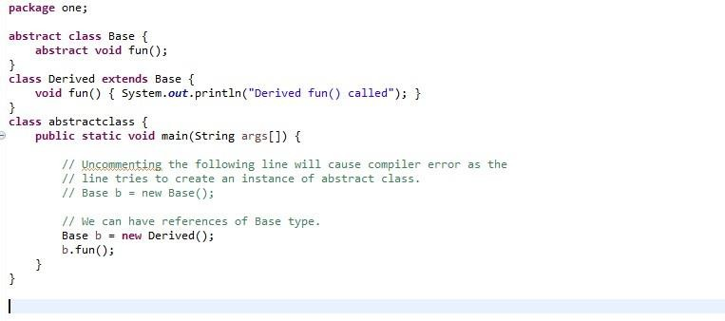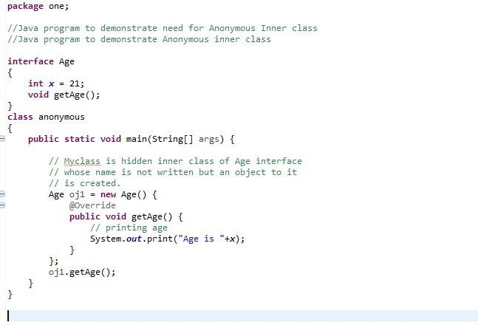

# Java:

* + **Generics and Wildcards usage in program was seen.**
  + **How to include “Anonymous Classes” was learnt.**
  + **Reading Files Using Scanner was shown in Java.**
  + **Handling Exceptions was practiced.**
  + **Multiple Exceptions was shown.**
  + **Runtime vs. Checked Exceptions was learnt.**
  + **How to include “Abstract Classes” was taught.**
  + **Reading Files with File Reader in Java.**
  + **Try-With-Resources was practiced.**
  + **Creating and Writing Text Files using Java was learnt.**
  + **Anonymous class Example:**