**DAILY ASSESSMENT FORMAT**

|  |  |  |  |
| --- | --- | --- | --- |
| **Date:** | **13/06/2020** | **Name:** | **Divyashree LV** |
| **Course:** | **Java** | **USN:** | **4AL17EC030** |
| **Topic:** | **Programmming core Java** | **Semester & Section:** | **6th sem ‘A’ sec** |
| **Github Repository:** | **divyalv** |  |  |

|  |
| --- |
| **FORENOON SESSION DETAILS** |

**Image of session**

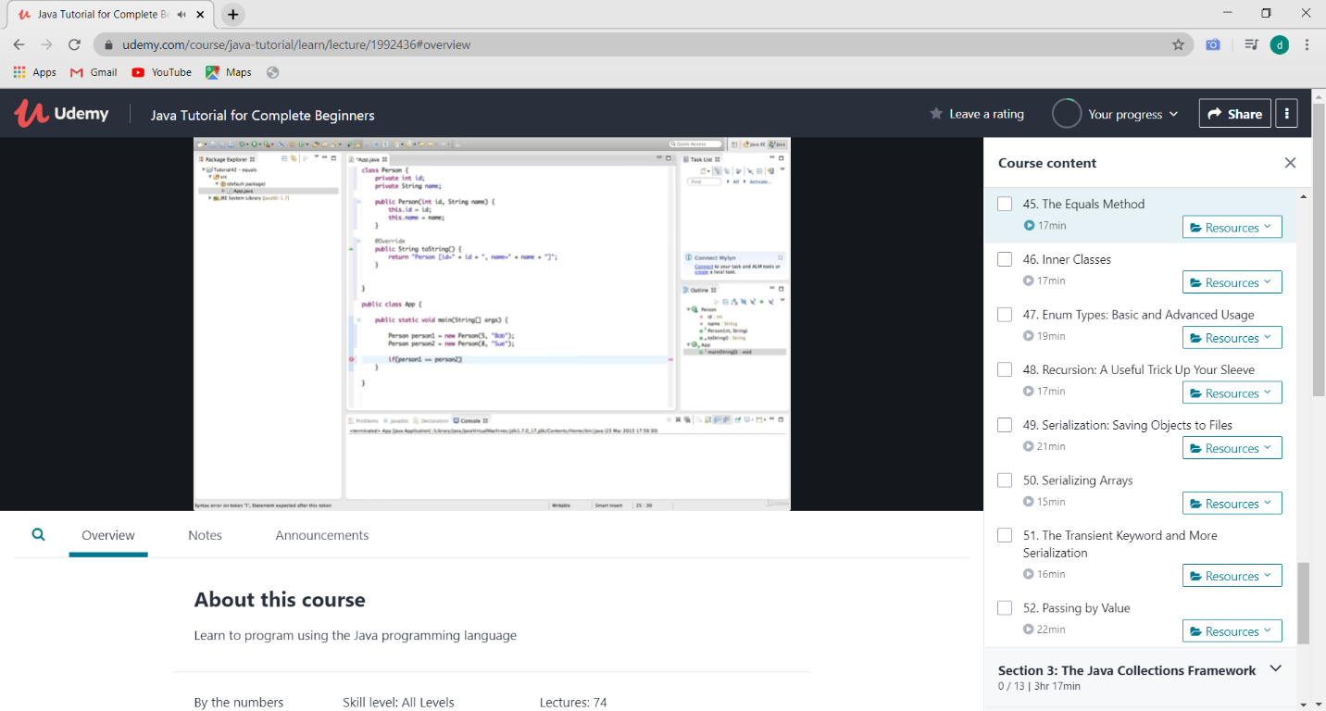

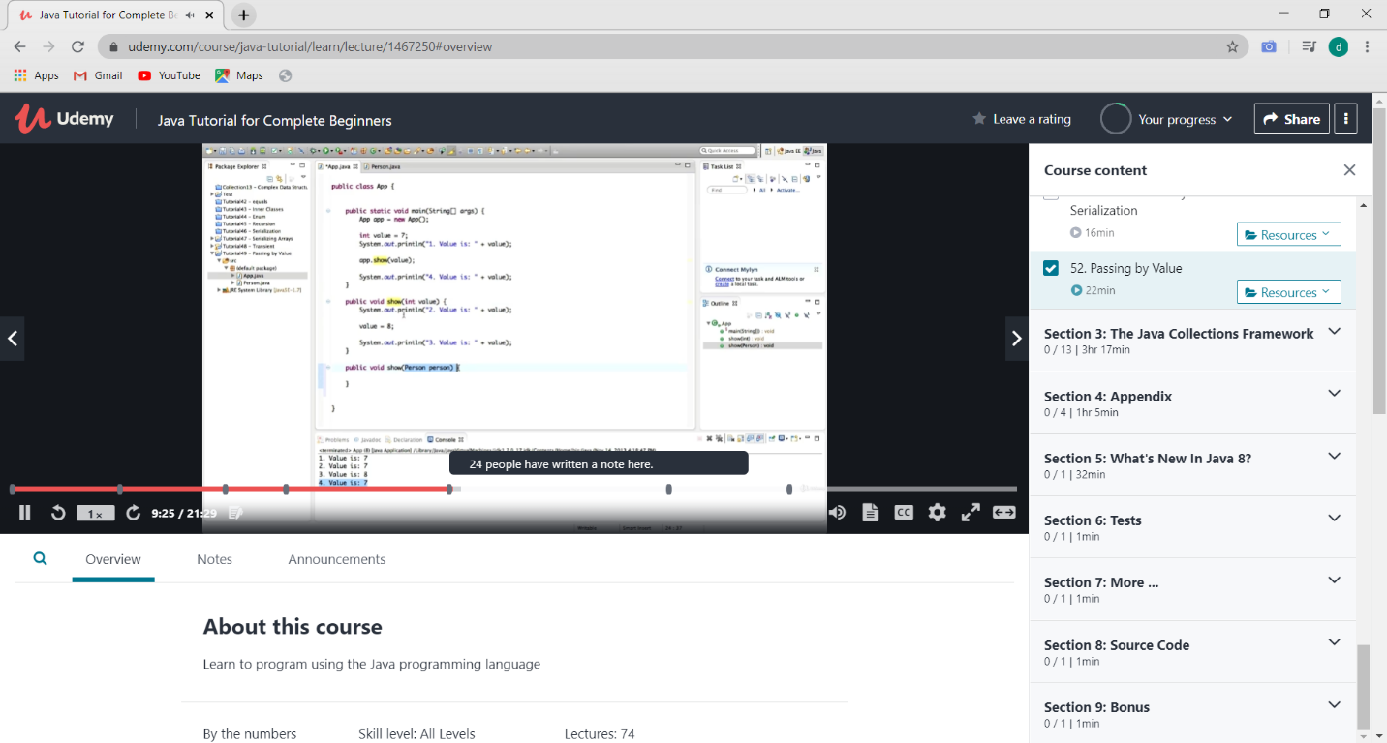

**EQUAL METHOD**

In general both equals () and “==” operator in Java are used to compare objects to check equality but here are some of the differences between the two:

* Main difference between equals () method and == operator is that one is method and other is operator.
* We can use == operators for reference comparison (**address comparison**) and equals () method for **content comparison**. In simple words, == checks if both objects point to the same memory location whereas equals () evaluates to the comparison of values in the objects.
* If a class does not [override the equals method](https://www.geeksforgeeks.org/overriding-equals-method-in-java/), then by default it uses equals(Object o) method of the closest parent class that has overridden this method

**The Transient Keyword and More Serialization**

* **transient** is a variables modifier used in [serialization](http://quiz.geeksforgeeks.org/serialization-in-java/).
* At the time of serialization, if we don’t want to save value of a particular variable in a file, then we use **transient** keyword.
* When JVM comes across **transient**keyword, it ignores original value of the variable and save default value of that variable data type.