DAILY ASSESSMENT FORMAT

|  |  |  |  |
| --- | --- | --- | --- |
| **Date:** | **15/06/2020** | **Name:** | **DIVYASHREE LV** |
| **Course:** | **Digital Marketing** | **USN:** | **4AL17EC030** |
| **Topic:** | **Introduction to Digital Marketing** | **Semester & Section:** | **6TH Sem ‘A’ sec** |
| **FORENOON SESSION DETAILS** | | | |
| **Image of session** | | | |

## Report

**3 Consumer moments of truth:**

* Zero moments of truth
* First moments of truth
* Second moments of truth

## Digital marketing :

* **Digital marketing** is the use of the Internet, mobile devices, social media, search engines, and other channels to reach consumer
* Digital marketing is on the rise and includes search result ads, email ads, and promoted tweets

# Website Marketing:

* Pay-Per-Click (PPC) Advertising PPC advertising enables marketers to reach Internet users on a number of digital platforms through paid ads.
* Marketers can set up PPC campaigns on Google, Bing, LinkedIn, Twitter, Pinterest, or Facebook and show their ads to people searching for terms related to the products or services.

# Video Marketing:

* YouTube has become the second most popular search engine and a lot of users are turning to YouTube before they make a buying decision, to learn something, read a review, or just to relax.
* There are several video marketing platforms, including Facebook Videos, Instagram, or even TikTok to use to run a video marketing campaign.

# Digital Marketing Challenges:

* Digital marketing poses special challenges for its purveyors.
* Digital channels are proliferating rapidly, and digital marketers have to keep up with how these channels work, how they're used by receivers, and how to use

these channels to effectively market their products or services. In addition, it's becoming more difficult to capture receivers' attention, because receivers are increasingly inundated with competing ads.

* Digital marketers also find it challenging to analyse the vast troves of data they capture and then exploit this information in new marketing efforts.
* The challenge of capturing and using data effectively highlights that digital marketing requires an approach to marketing based on a deep understanding of consumer behaviour.

**For example**, it may require a company to analyse new forms of consumer behaviour, such as using website heatmaps to learn more about the customer journey.

|  |  |  |  |
| --- | --- | --- | --- |
| **Date:** | **15/06/2020** | **Name:** | **DIVYASHREE LV** |
| **Course:** | **Java** | **USN:** | **4AL17EC030** |
| **Topic:** | **Java Collection Frame Work** | **Semester& Section:** | **6th sem & ‘A’ sec** |

**AFTERNOON SESSION DETAILS**

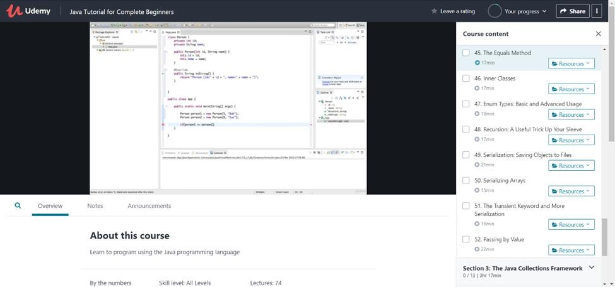

**Image of session:**

**Report:**

# Linked List

* Linked List are linear data structures where the elements are not stored in contiguous locations and every element is a separate object with a data part and address part.
* The elements are linked using pointers and addresses.
* Each element is known as a node.
* Due to the dynamicity and ease of insertions and deletions, they are preferred over the arrays.
* It also has few disadvantages like the nodes cannot be accessed directly instead we need to start from the head and follow through the link to reach to a node we wish to access.

# HashMap: Retrieving Objects via a Key

**HashMap** is a part of Java’s collection since Java 1.2. It provides the basic implementation of the Map interface of Java. It stores the data in (Key, Value) pairs.

# Sets

* Set is an interface which extends Collection. It is an unordered collection of objects in which duplicate values cannot...
* Basically, Set is implemented by HashSet, LinkedHashSet or TreeSet (sorted representation).
* Set has various methods to add, remove clear, size, etc to enhance the usage of this interface

# Sorting Lists in Java

We can use the following methods to sort the list:

* + Using stream.sorted() method
  + Using Comparator.reverseOrder() method
  + Using Comparator.naturalOrder() method
  + Using Collections.reverseOrder() method
  + Using Collections.sort() method