DAILY ASSESSMENT FORMAT

|  |  |  |  |
| --- | --- | --- | --- |
| **Date:** | **16/06/2020** | **Name:** | **DIVYASHREE LV** |
| **Course:** | **Statistical Learning** | **USN:** | **4AL17EC030** |
| **Topic:** | * **Case Study on statistics & probability theory** * **Solution for case study** | **Semester & Section:** | **6TH Sem ‘A’ sec** |
| **FORENOON SESSION DETAILS** | | | |
| **Image of session** | | | |

# Report :

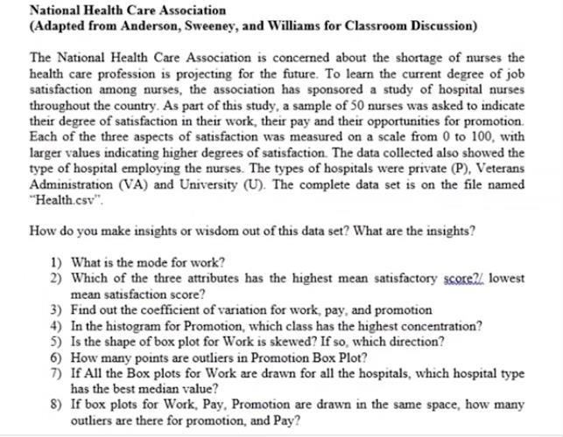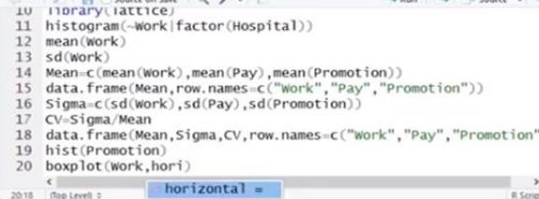

**Case Study:**

**For the above Case study questions, Answers were discussed as shown below.**

|  |  |  |  |
| --- | --- | --- | --- |
| **Date:** | **16/06/2020** | **Name:** | **DIVYASHREE LV** |
| **Course:** | **Java Tutorial for Complete Beginners** | **USN:** | **4AL17EC030** |
| **Topic:** | * **Natural Ordering** * **Queues** * **Using Iterators** * **Implementing Iterable** * **Deciding Which Collection to Use** * **Complex Data Structures** | **Semester& Section:** | **6th sem & ‘A’ sec** |

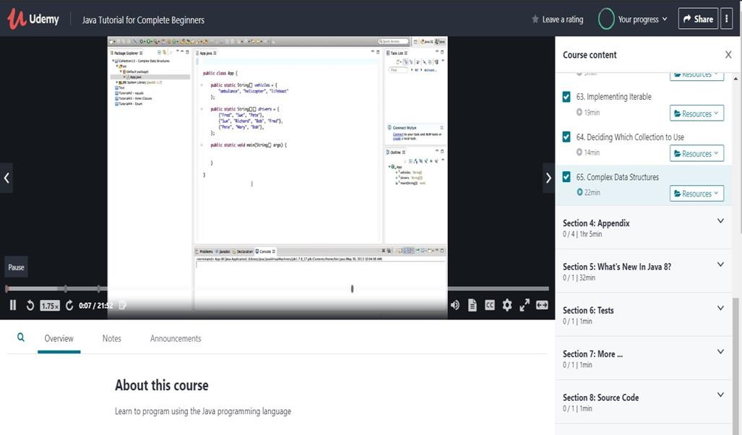

AFTERNOON SESSION DETAILS

Image of session:

Report:

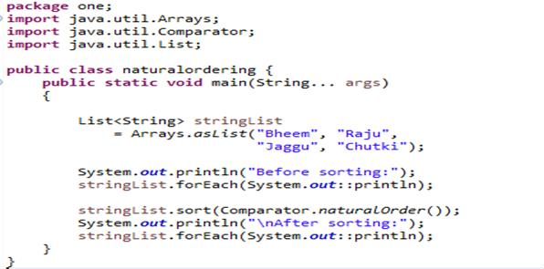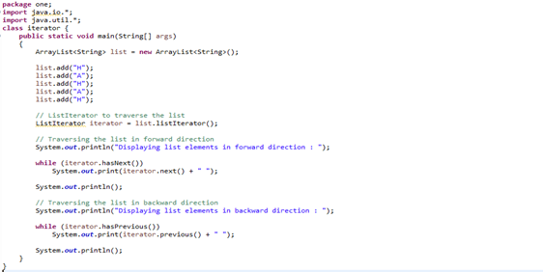

Java:

* **Natural Ordering.**
* **Example programs using Queues were practiced in Java.**
* **Learnt how to use Iterators in Java Programming language.**
* **Also learnt how to implement Iterable in Java.**
* **Deciding Which Collection to Use in Java.**
* **Complex Data Structures was seen with an example.**

Example for Iterators.