**DAILY ONLINE ACTIVITIES SUMMARY**

|  |  |  |  |  |  |  |  |  |
| --- | --- | --- | --- | --- | --- | --- | --- | --- |
| **Date:** | **29th May 2020** | | | | | **Name:** | **Dsouza Elston Ronald** | |
| **Sem & Sec** | **6th A section** | | | | | **USN:** | **4AL17CS029** | |
| **Online Test Summary** | | | | | | | | |
| **Subject** | | **Operations Research(OR)** | | | | | | |
| **Max. Marks** | | **30** | | **Score** | | | **30** | |
| **Certification Course Summary** | | | | | | | | |
| **Course** | **Full Stack Web Developer-Beginner to Advanced** | | | | | | | |
| **Certificate Provider** | | | **Udemy** | | **Duration** | | | **20 hours** |
| **Coding Challenges** | | | | | | | | |
| 1. Python program to print all lowercase and uppercase letters in string 2. given these 3 strings write a function that detects whether str3 is a valid shuffle of str1 and str2. 3. Write a c program to solve a system of linear congruences by applying the Chinese Remainder Theorem. 4. write java program to find whether number is amstrong numbr or not. 5. Write a Java Program to find longest substring without repeating characters in a string. | | | | | | | | |
| **Status: Completed** | | | | | | | | |
| **Uploaded the report in Github** | | | | | **Yes** | | | |
| **If yes Repository name** | | | | | <https://github.com/alvas-education-foundation/elston-dsouza> | | | |
| **Uploaded the report in slack** | | | | | **Yes** | | | |

Online Test Details: (Attach the snapshot and briefly write the report for the same)

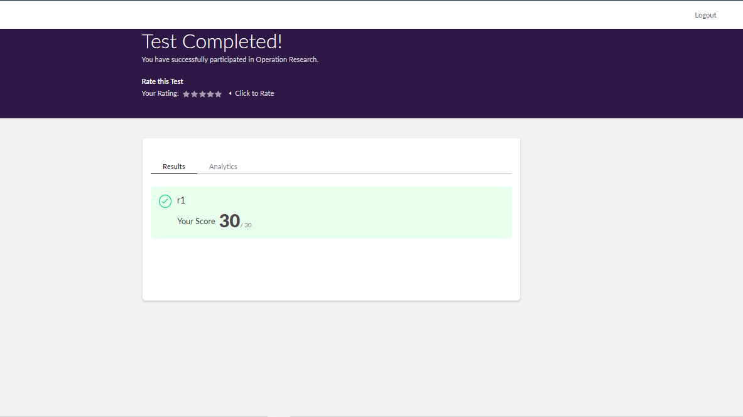

The above assessment was done by me on 29th May 2020 from 2.00 to 02.45 9m and the details of assessment is as above.

Certification Course Details: (Attach the snapshot and briefly write the report for the same)

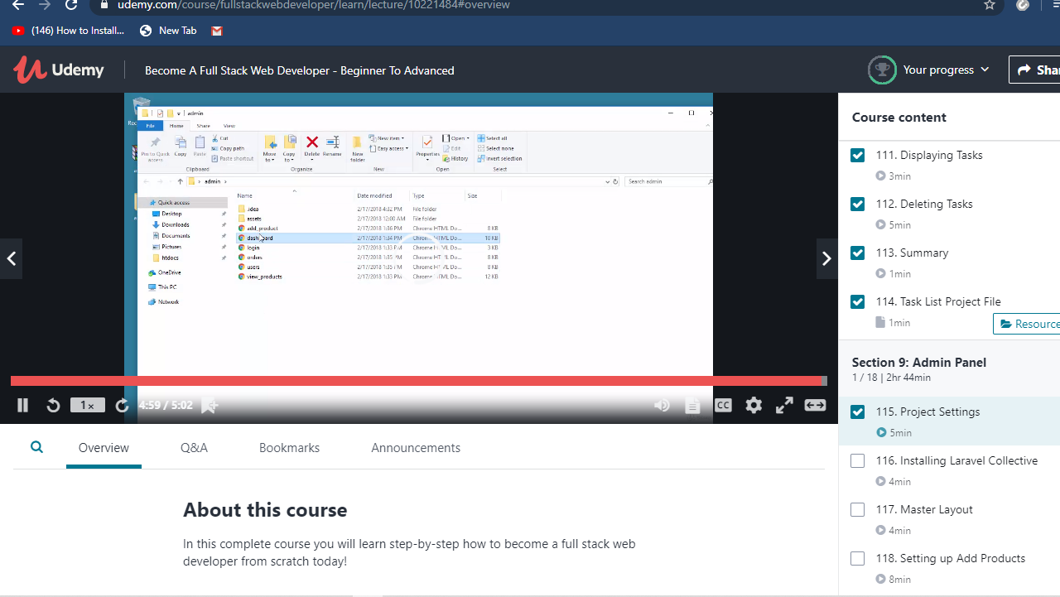

The above course is being taken up by me which is based on full stack web development. The course has started with the HTML basics as well as the various concepts in HTML. The details of the course and certificate provider is mentioned in the above form.

Coding Challenges Details: (Attach the snapshot and briefly write the report for the same)

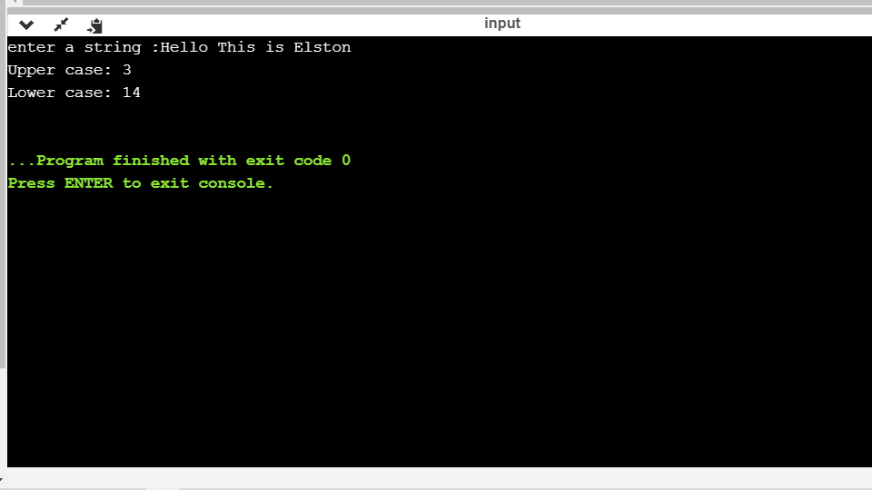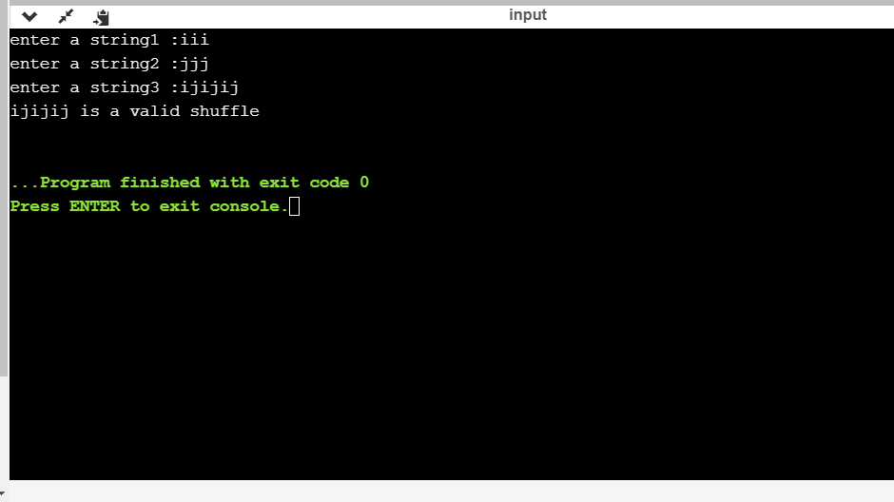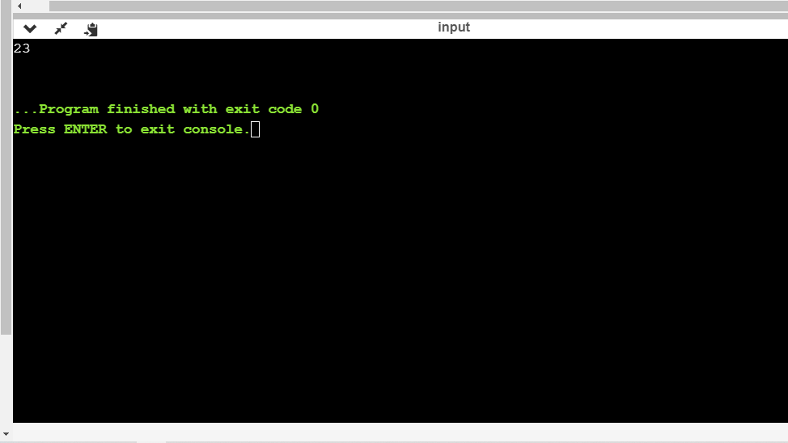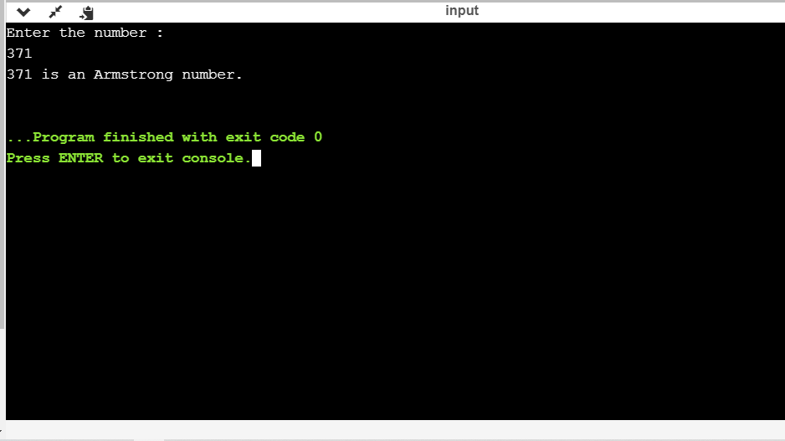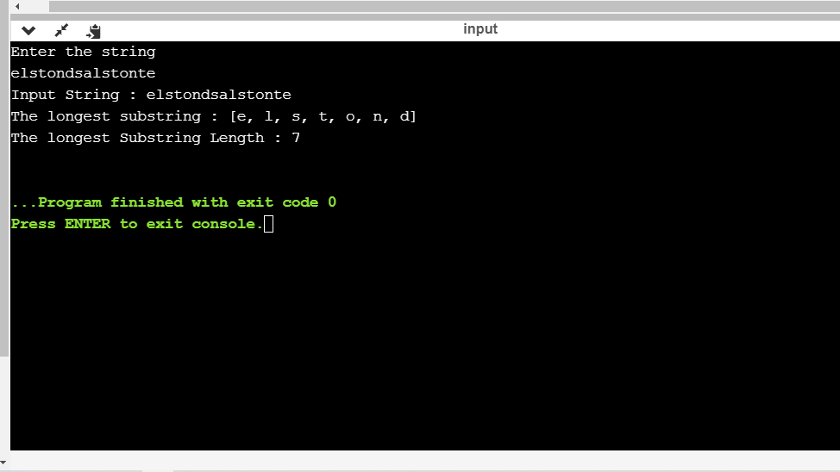

The above the programs were written and executed and the output of the same is displayed above. The code for the given 5 programs have been uploaded to the github repository and the link to the same is provided on the form.