**DAILY ONLINE ACTIVITIES SUMMARY**

|  |  |  |  |  |  |  |  |  |
| --- | --- | --- | --- | --- | --- | --- | --- | --- |
| **Date:** | **31th May 2020** | | | | | **Name:** | **Dsouza Elston Ronald** | |
| **Sem & Sec** | **6th A section** | | | | | **USN:** | **4AL17CS029** | |
| **Online Test Summary** | | | | | | | | |
| **Subject** | |  | | | | | | |
| **Max. Marks** | |  | | **Score** | | |  | |
| **Certification Course Summary** | | | | | | | | |
| **Course** | **Step into Robotic Process Automation(RPA)** | | | | | | | |
| **Certificate Provider** | | | **Guvi** | | **Duration** | | | **3 hours** |
| **Coding Challenges** | | | | | | | | |
|  | | | | | | | | |
| **Status: Completed** | | | | | | | | |
| **Uploaded the report in Github** | | | | | **Yes** | | | |
| **If yes Repository name** | | | | | <https://github.com/alvas-education-foundation/elston-dsouza> | | | |
| **Uploaded the report in slack** | | | | | **Yes** | | | |

Online Test Details: (Attach the snapshot and briefly write the report for the same)

Certification Course Details: (Attach the snapshot and briefly write the report for the same)

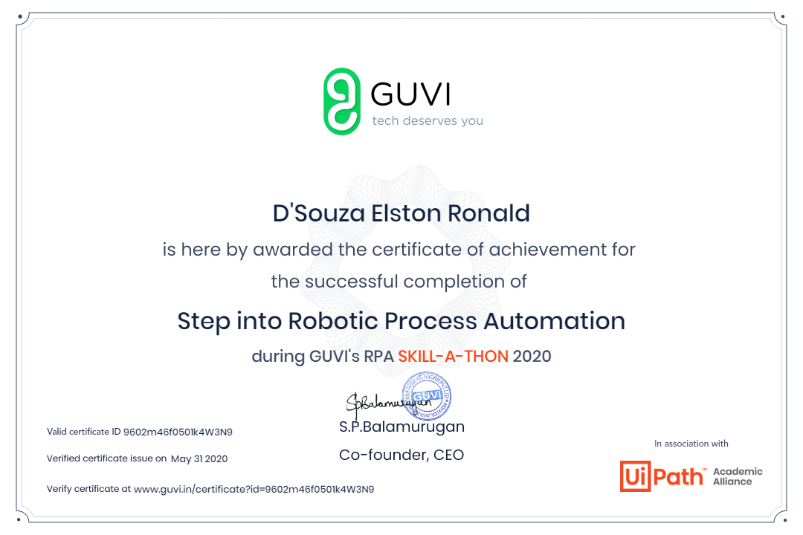

Certificate received on completion of the RPA course conducted by GUVI

Coding Challenges Details: (Attach the snapshot and briefly write the report for the same