## DAILY ONLINE ACTIVITIES SUMMARY

|  |  |  |  |  |  |  |  |  |
| --- | --- | --- | --- | --- | --- | --- | --- | --- |
| **Date:** | **2nd June 2020** | | | | | **Name:** | **Dsouza Elston Ronald** | |
| **Sem & Sec** | **6th A section** | | | | | **USN:** | **4AL17CS029** | |
| **Online Test Summary** | | | | | | | | |
| **Subject** | | **Computer Graphics and Visualization(CGV)** | | | | | | |
| **Max. Marks** | | **30** | | **Score** | | | **30** | |
| **Certification Course Summary** | | | | | | | | |
| **Course** | **Full Stack Web Developer-Beginner to Advanced** | | | | | | | |
| **Certificate Provider** | | | **Udemy** | | **Duration** | | | **20 hours** |
| **Coding Challenges** | | | | | | | | |
| 1. Python program to return a list containing first and last element using list slicing method. 2. Given an array of positive integers. Write a C Program to find inversion count of array. 3. Write a program to check if given linked list has a loop or not. | | | | | | | | |
| **Status: Completed** | | | | | | | | |
| **Uploaded the report in Github** | | | | | **Yes** | | | |
| **If yes Repository name** | | | | | <https://github.com/alvas-education-foundation/elston-dsouza> | | | |
| **Uploaded the report in slack** | | | | | **Yes** | | | |

Online Test Details: (Attach the snapshot and briefly write the report for the same)

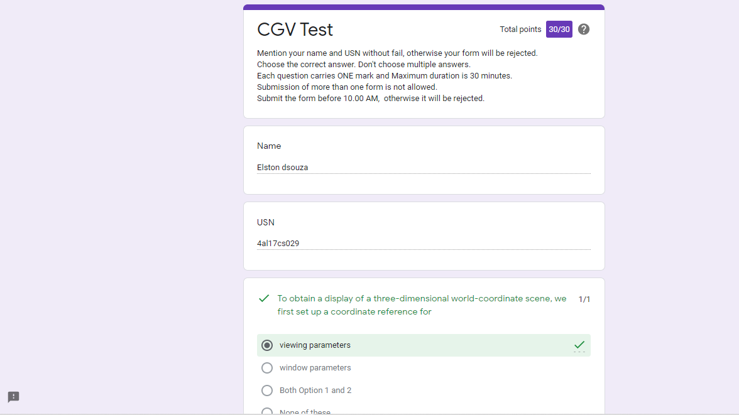

The above assessment was done by me on 2nd June 2020 from 9.30 to 10.00pm and the details of assessment is as above.

Certification Course Details: (Attach the snapshot and briefly write the report for the same)

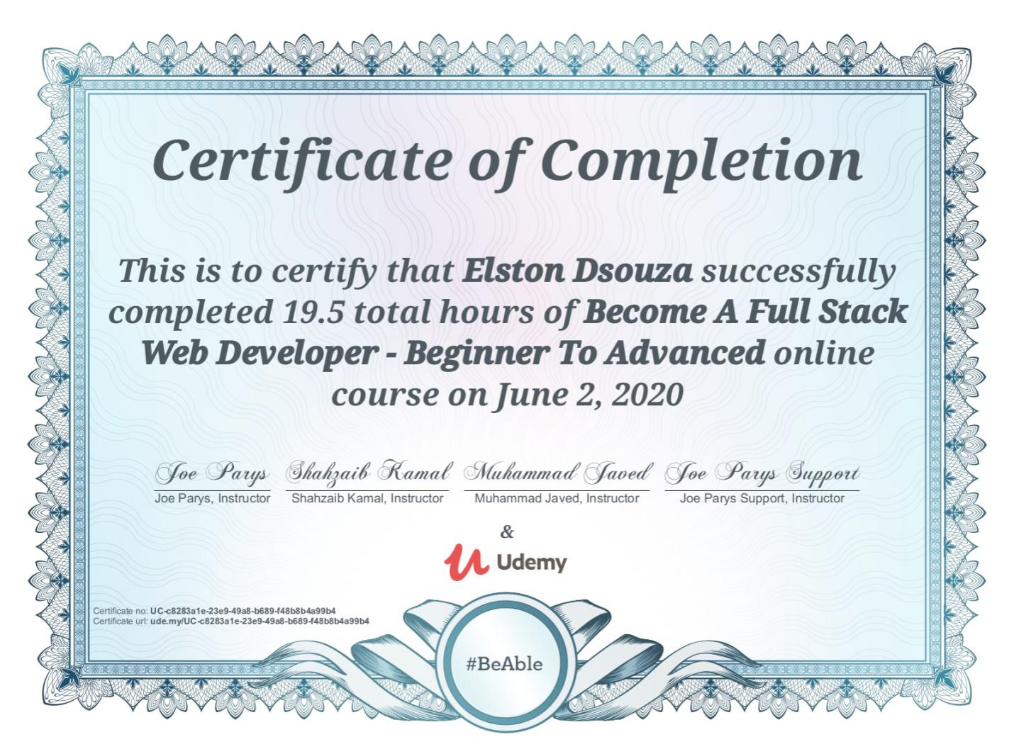

The above course is being taken up by me which is based on full stack web development. The course has started with the HTML basics as well as the various concepts in HTML. The details of the course and certificate provider is mentioned in the above form.

Coding Challenges Details: (Attach the snapshot and briefly write the report for the same)

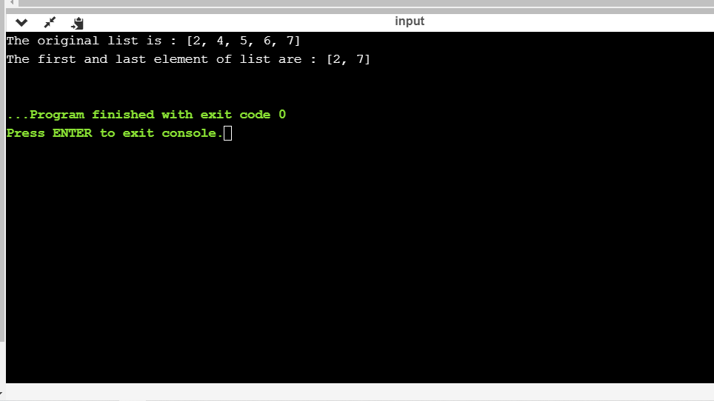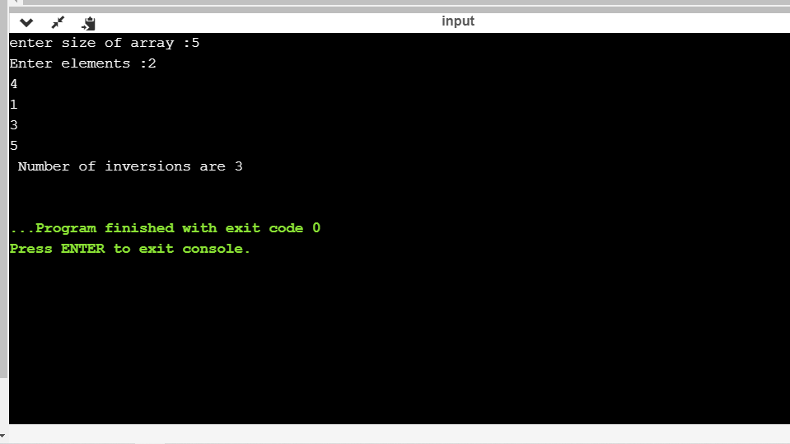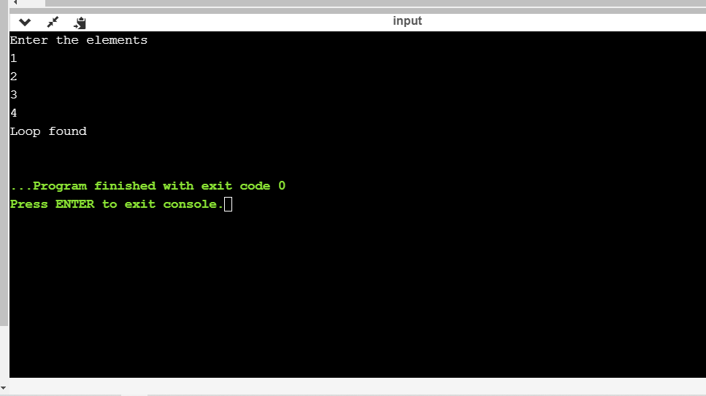

The above the programs were written and executed and the output of the same is displayed above. The code for the given 3 programs have been uploaded to the github repository and the link to the same is provided on the form.