## DAILY ONLINE ACTIVITIES SUMMARY

|  |  |  |  |  |  |  |  |  |
| --- | --- | --- | --- | --- | --- | --- | --- | --- |
| **Date:** | **7th June 2020** | | | | | **Name:** | **Dsouza Elston Ronald** | |
| **Sem & Sec** | **6th A section** | | | | | **USN:** | **4AL17CS029** | |
| **Online Test Summary** | | | | | | | | |
| **Subject** | | **System Software and Compiler Design(SSCD)** | | | | | | |
| **Max. Marks** | | **30** | | **Score** | | | **23** | |
| **Certification Course Summary** | | | | | | | | |
| **Course** | **Python with Machine Learning** | | | | | | | |
| **Certificate Provider** | | | **Great Learning** | | **Duration** | | | **5 hours** |
| **Coding Challenges** | | | | | | | | |
| 1. Write a java Program to print smallest and biggest possible palindrome word in a given string. 2. Python program the first and last 5 elements. | | | | | | | | |
| **Status: Completed** | | | | | | | | |
| **Uploaded the report in Github** | | | | | **Yes** | | | |
| **If yes Repository name** | | | | | <https://github.com/alvas-education-foundation/elston-dsouza> | | | |
| **Uploaded the report in slack** | | | | | **Yes** | | | |

Online Test Details: (Attach the snapshot and briefly write the report for the same)

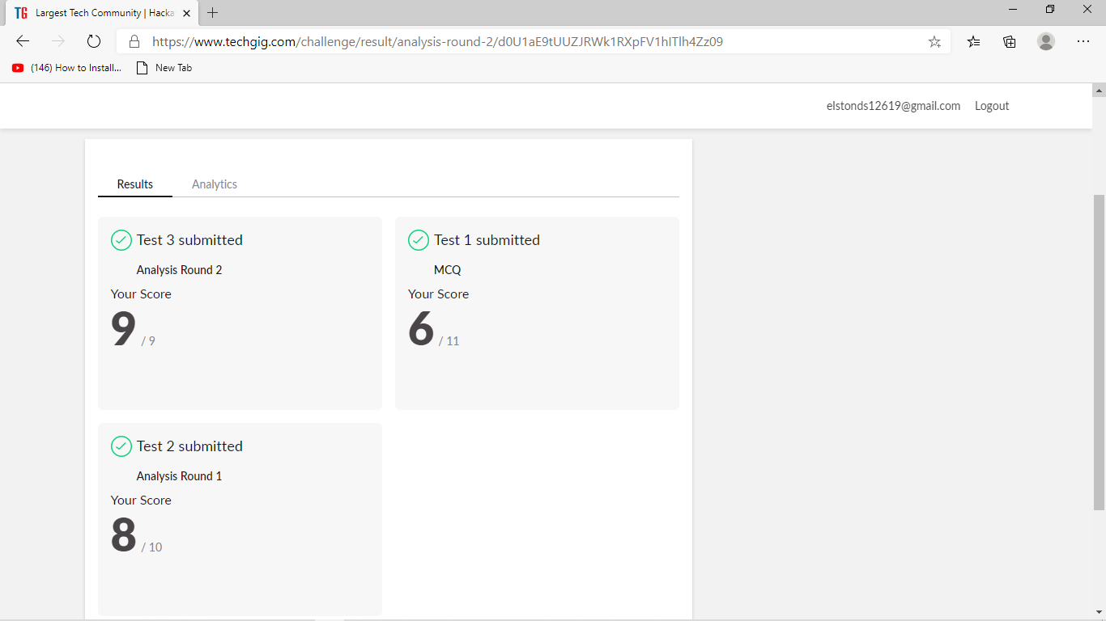

The above assessment was done by me on 7th June 2020 from 9.30 to 10.30am and the details of assessment is as above.

Certification Course Details: (Attach the snapshot and briefly write the report for the same)

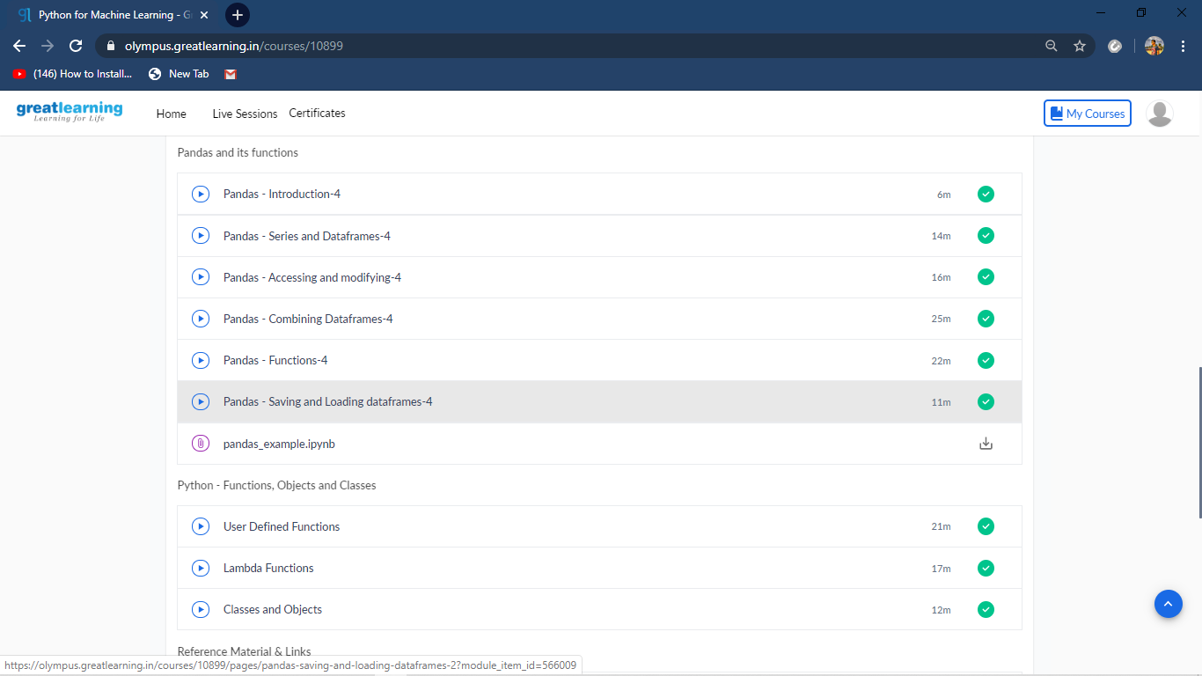

The above course is being taken up by me which is based on Python with Machine Learning. The course has started with the Python basics as well as the various concepts in Python. The details of the course and certificate provider is mentioned in the above form.

Coding Challenges Details: (Attach the snapshot and briefly write the report for the same)

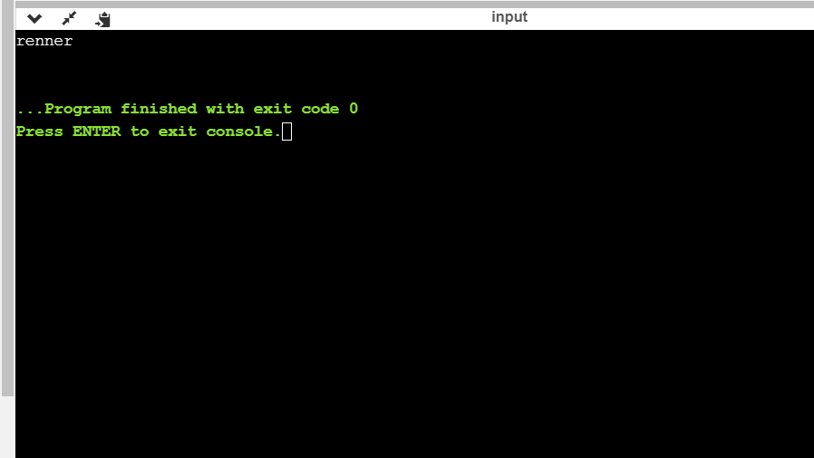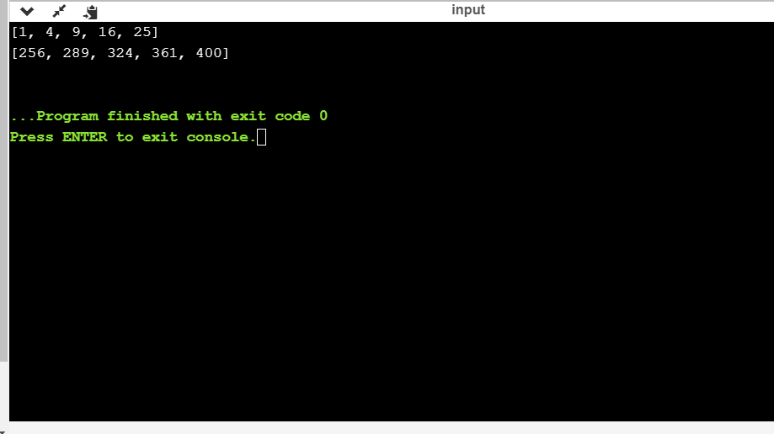

The above the programs were written and executed and the output of the same is displayed above. The code for the given 2 programs have been uploaded to the github repository and the link to the same is provided on the form.