## DAILY ONLINE ACTIVITIES SUMMARY

|  |  |  |  |  |  |  |  |  |
| --- | --- | --- | --- | --- | --- | --- | --- | --- |
| **Date:** | **8th June 2020** | | | | | **Name:** | **Dsouza Elston Ronald** | |
| **Sem & Sec** | **6th A section** | | | | | **USN:** | **4AL17CS029** | |
| **Online Test Summary** | | | | | | | | |
| **Subject** | | **Cryptography, Network security and Cyber laws(CNSC)** | | | | | | |
| **Max. Marks** | | **60** | | **Score** | | | **36** | |
| **Certification Course Summary** | | | | | | | | |
| **Course** | **Python with Machine Learning** | | | | | | | |
| **Certificate Provider** | | | **Great Learning** | | **Duration** | | | **5 hours** |
| **Coding Challenges** | | | | | | | | |
| 1. Write a python function that will take a string and checks whether it is a palindrome or not. 2. Java program to delete a node from the middle of the singly linked list. 3. C Program to Generate All the Set Partitions of n Numbers Beginning from 1 and so on. 4. Write C++ program to Check whether a number can be represented as difference of two squares | | | | | | | | |
| **Status: Completed** | | | | | | | | |
| **Uploaded the report in Github** | | | | | **Yes** | | | |
| **If yes Repository name** | | | | | <https://github.com/alvas-education-foundation/elston-dsouza> | | | |
| **Uploaded the report in slack** | | | | | **Yes** | | | |

Online Test Details: (Attach the snapshot and briefly write the report for the same)

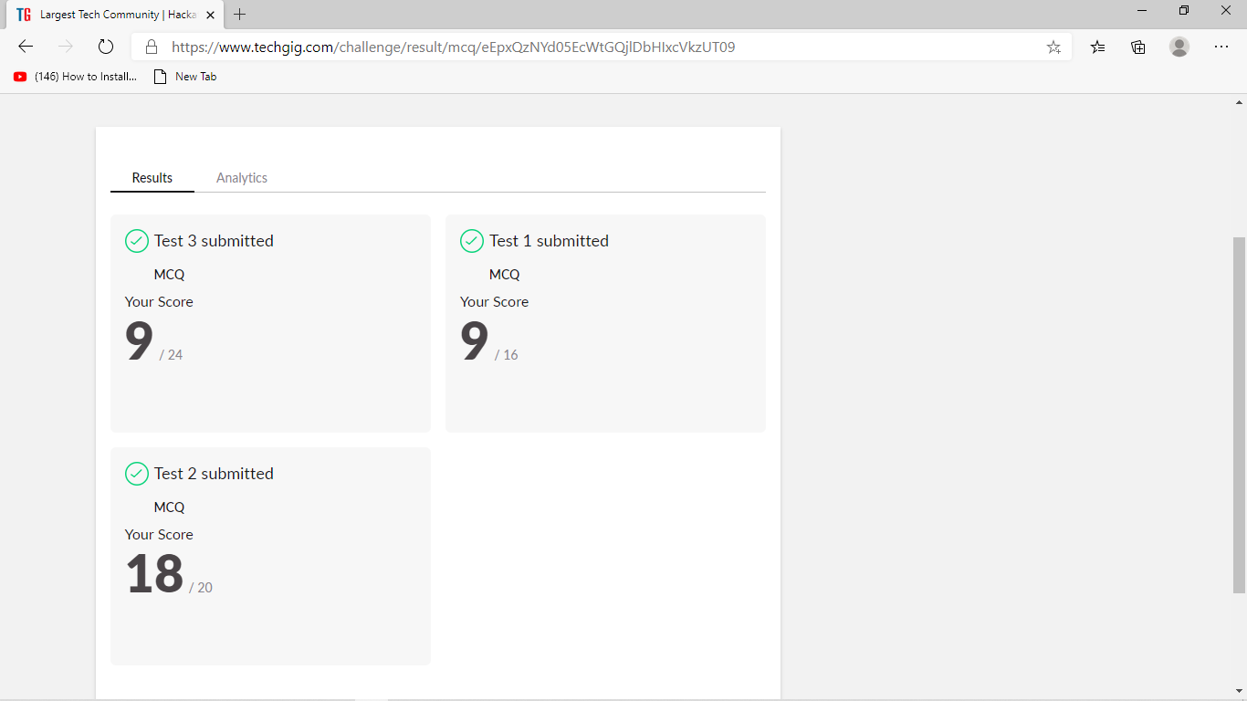

The above assessment was done by me on 8th June 2020 from 3.30 to 4.00pm and the details of assessment is as above.

Certification Course Details: (Attach the snapshot and briefly write the report for the same)

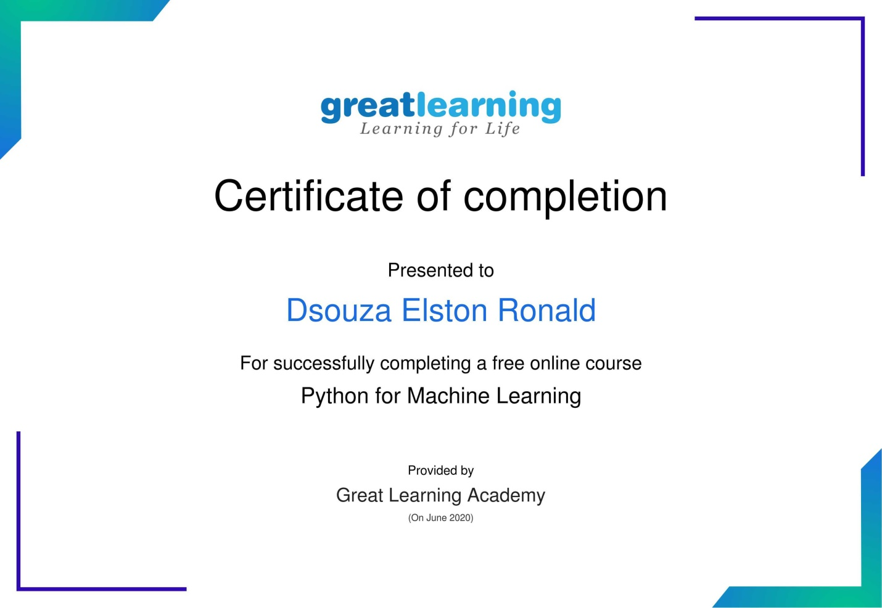

The above course is being taken up by me which is based on Python with Machine Learning. The course has started with the Python basics as well as the various concepts in Python. The details of the course and certificate provider is mentioned in the above form.

Coding Challenges Details: (Attach the snapshot and briefly write the report for the same)

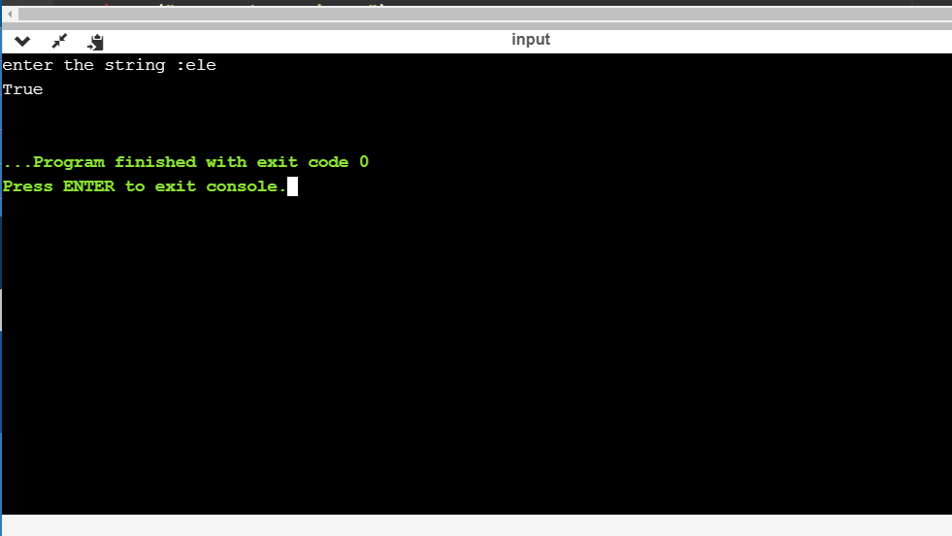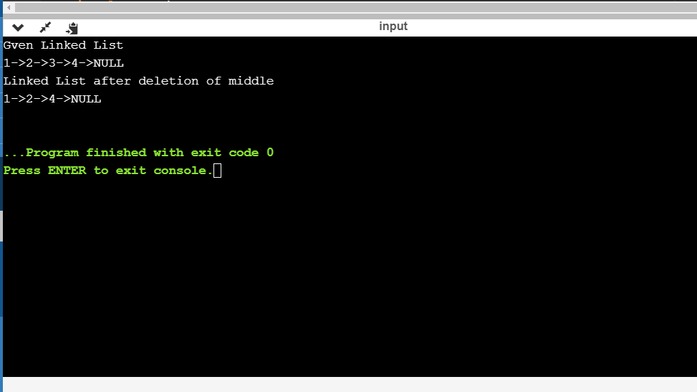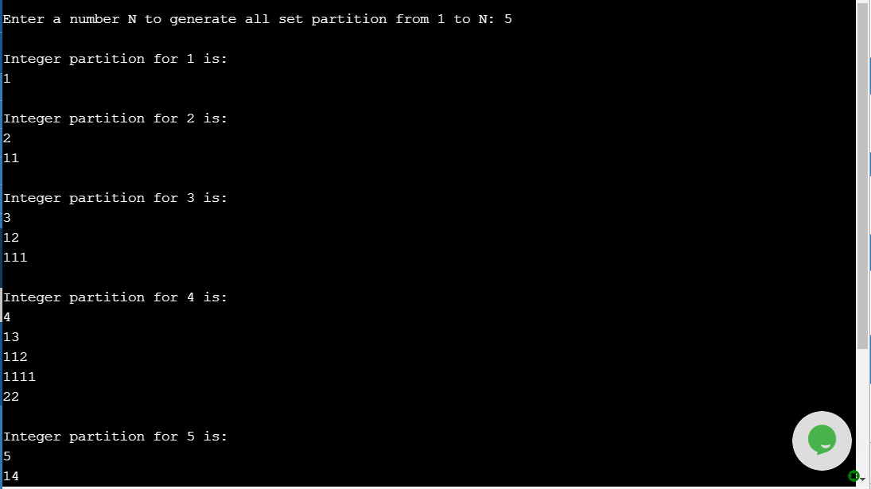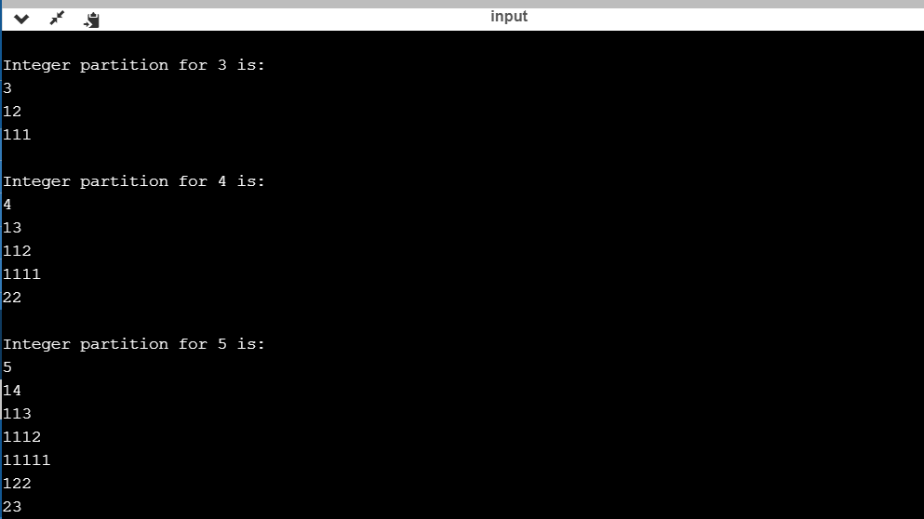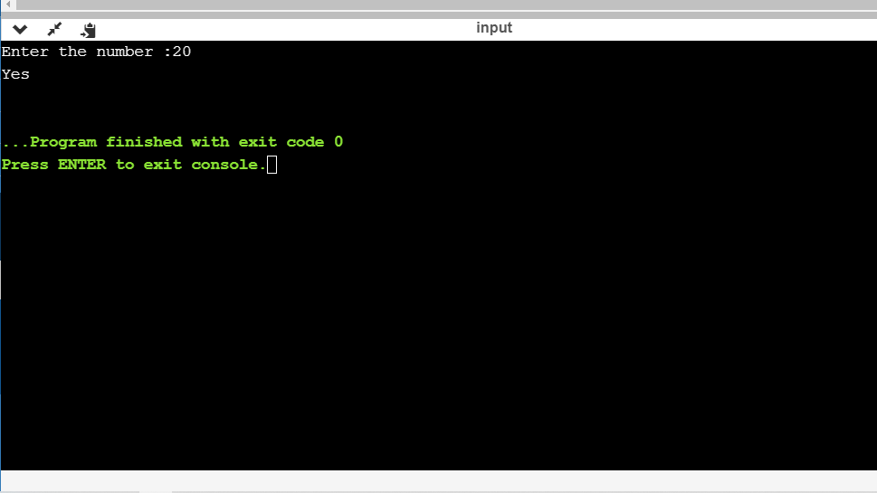

The above the programs were written and executed and the output of the same is displayed above. The code for the given 4programs have been uploaded to the github repository and the link to the same is provided on the form.