## DAILY ONLINE ACTIVITIES SUMMARY

|  |  |  |  |  |  |  |  |  |
| --- | --- | --- | --- | --- | --- | --- | --- | --- |
| **Date:** | **9th June 2020** | | | | | **Name:** | **Dsouza Elston Ronald** | |
| **Sem & Sec** | **6th A section** | | | | | **USN:** | **4AL17CS029** | |
| **Online Test Summary** | | | | | | | | |
| **Subject** | | **Computer Graphics and Visualization(CGV) & Cryptography, Network security and Cyber laws(CNSC)** | | | | | | |
| **Max. Marks** | | **30 & 60** | | **Score** | | | **28 & 35** | |
| **Certification Course Summary** | | | | | | | | |
| **Course** | **Ethical Hacking Creating a Keylogger** | | | | | | | |
| **Certificate Provider** | | | **Udemy** | | **Duration** | | | **1 hour** |
| **Coding Challenges** | | | | | | | | |
| 1. Write a Java Program to print smallest and biggest possible palindrome word in a given string 2. Write a Python to implement Perfect Sum Problem 3. Write a Python program to count the number of even and odd numbers from a series of numbers. 4. Write a Java Program to remove all white spaces from a string without using replace() 5. Write a C Program to rotate the matrix by K times. | | | | | | | | |
| **Status: Completed** | | | | | | | | |
| **Uploaded the report in Github** | | | | | **Yes** | | | |
| **If yes Repository name** | | | | | <https://github.com/alvas-education-foundation/elston-dsouza> | | | |
| **Uploaded the report in slack** | | | | | **Yes** | | | |

Online Test Details: (Attach the snapshot and briefly write the report for the same)

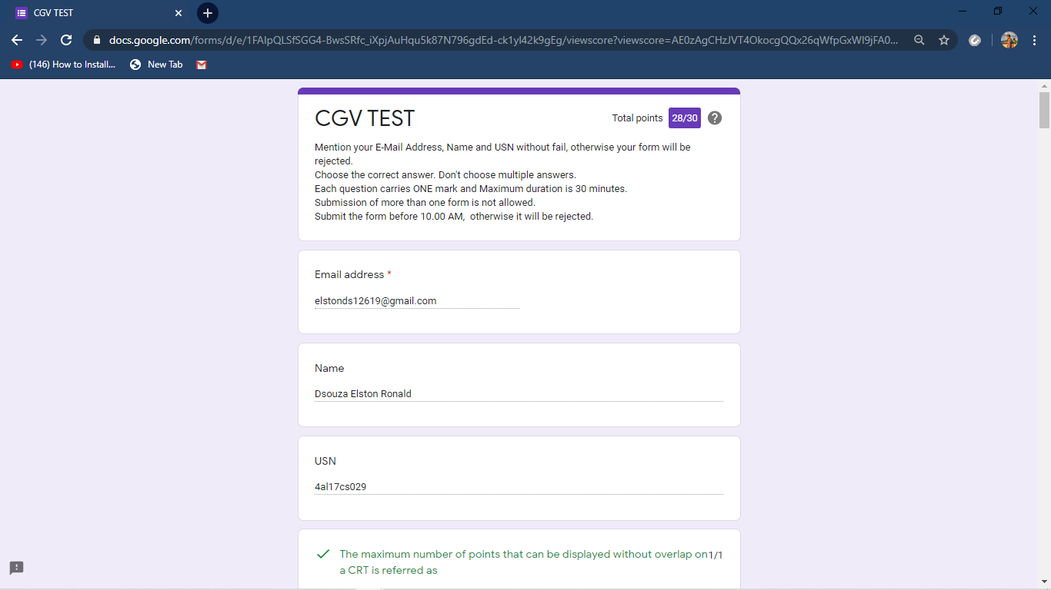

The above assessment was done by me on 9th June 2020 from 9.30 to 10.00am and the details of assessment is as above.

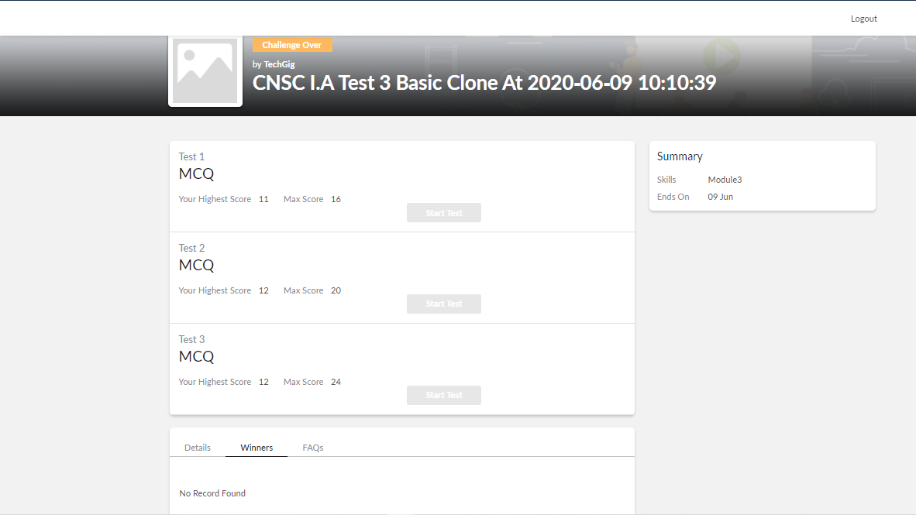

The above assessment was done by me on 9th June 2020 from 2.20 to 3.00pm and the details of assessment is as above.

Certification Course Details: (Attach the snapshot and briefly write the report for the same)

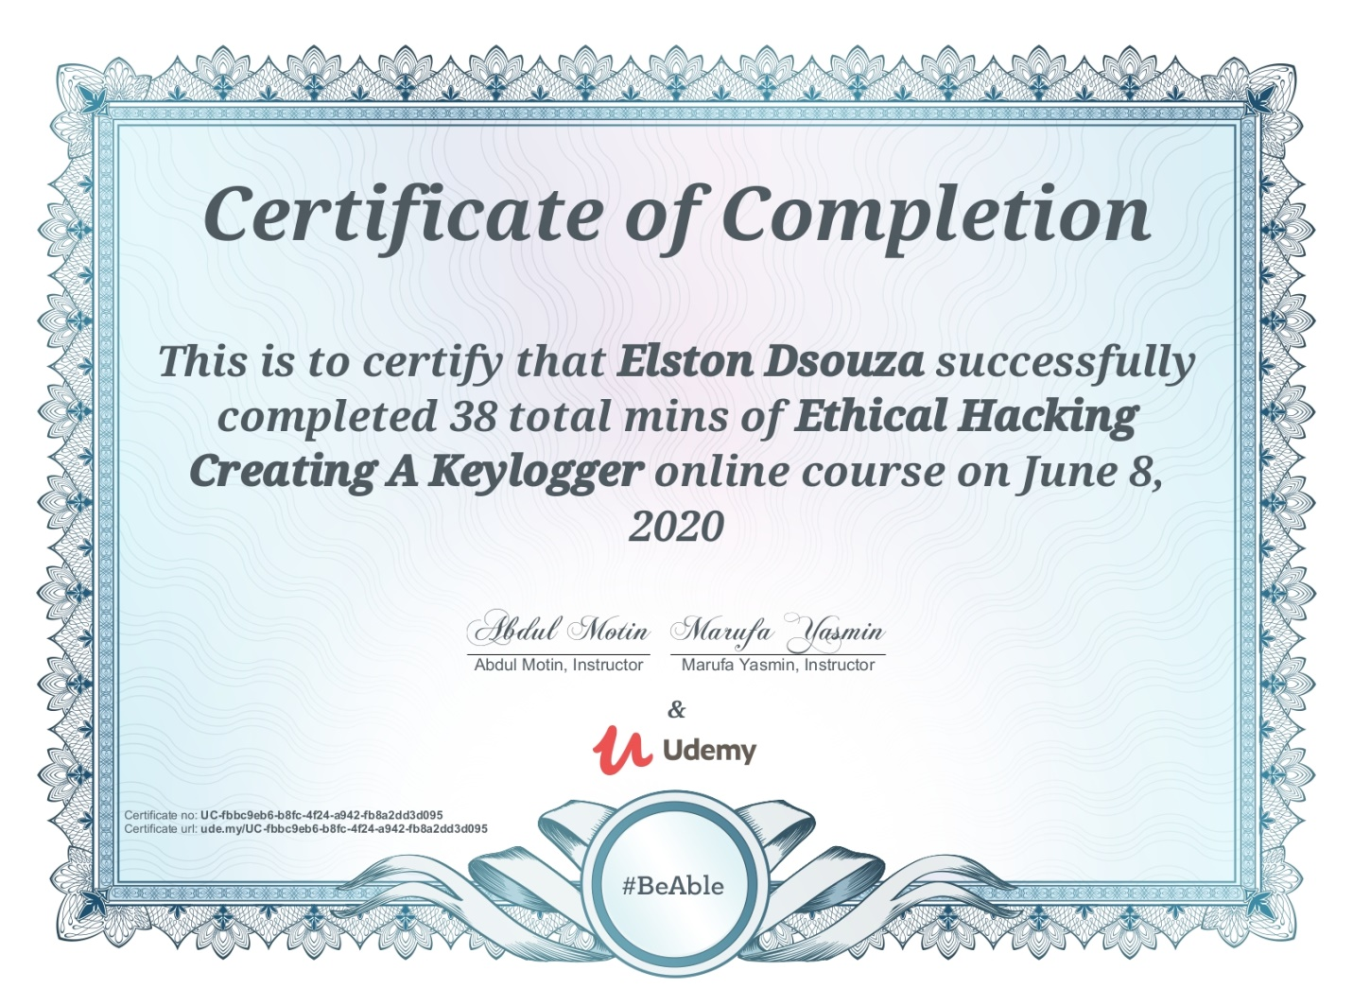

The above course is being taken up by me which is based on Ethical Hacking Creating a Keylogger.The details of the course and certificate provider is mentioned in the above form.

Coding Challenges Details: (Attach the snapshot and briefly write the report for the same)

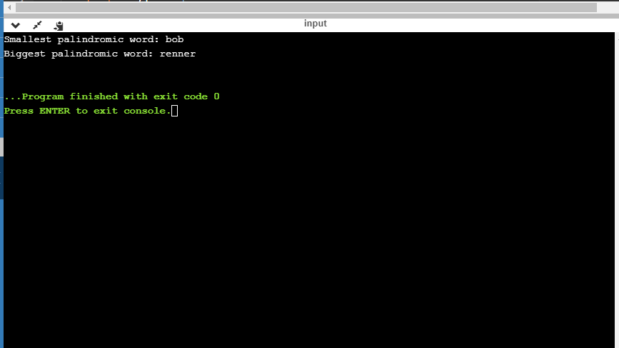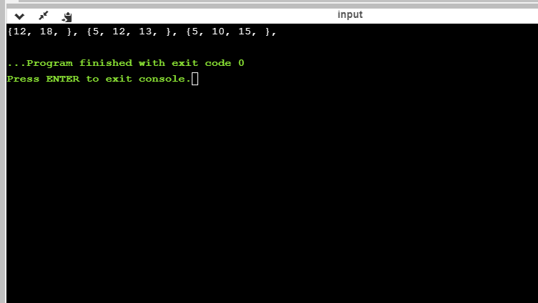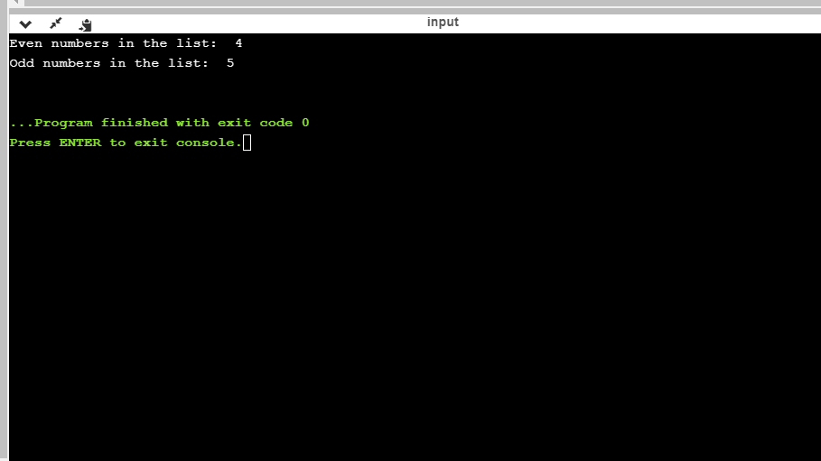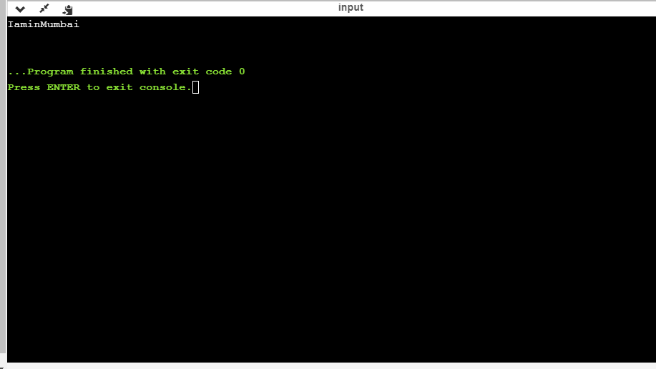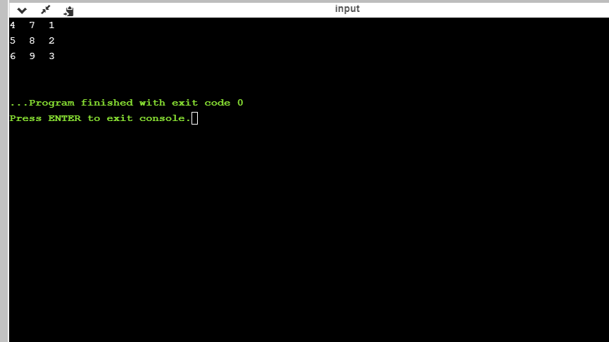

The above the programs were written and executed and the output of the same is displayed above. The code for the given 5 programs have been uploaded to the github repository and the link to the same is provided on the form.