## DAILY ONLINE ACTIVITIES SUMMARY

|  |  |  |  |  |  |  |  |  |
| --- | --- | --- | --- | --- | --- | --- | --- | --- |
| **Date:** | **11th June 2020** | | | | | **Name:** | **Dsouza Elston Ronald** | |
| **Sem & Sec** | **6th A section** | | | | | **USN:** | **4AL17CS029** | |
| **Online Test Summary** | | | | | | | | |
| **Subject** | | **PAP Assignment -3** | | | | | | |
| **Max. Marks** | | **20** | | **Score** | | | **17** | |
| **Certification Course Summary** | | | | | | | | |
| **Course** | **The Complete PHP 7 guide for Web Developers** | | | | | | | |
| **Certificate Provider** | | | **Eduonix** | | **Duration** | | | **4 hours** |
| **Coding Challenges** | | | | | | | | |
| 1. Write a Java program to find the nodes which are at the maximum distance in a Binary Tree. 2. Write a python function that converts a string to all uppercase, provided it contains at least 2 uppercase characters in the first 4 characters. Else print the string as it is. | | | | | | | | |
| **Status: Completed** | | | | | | | | |
| **Uploaded the report in Github** | | | | | **Yes** | | | |
| **If yes Repository name** | | | | | <https://github.com/alvas-education-foundation/elston-dsouza> | | | |
| **Uploaded the report in slack** | | | | | **Yes** | | | |

Online Test Details: (Attach the snapshot and briefly write the report for the same)

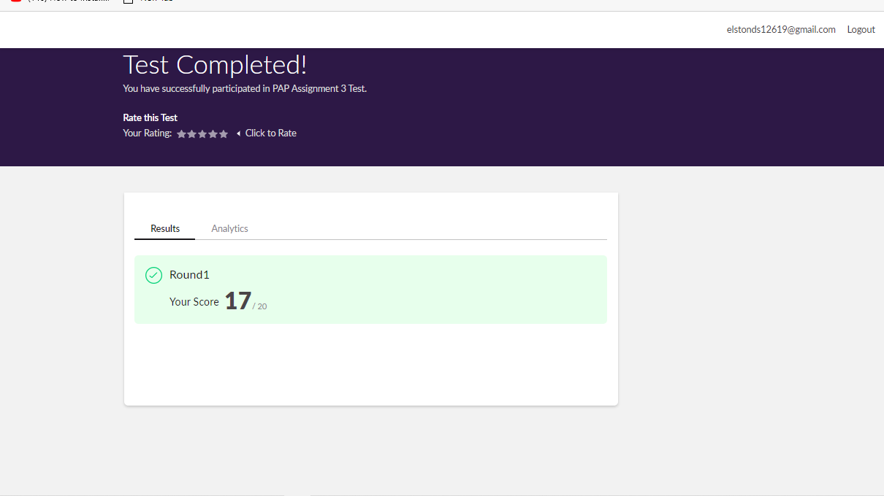

The above assessment was done by me on 11th June 2020 from 1.00 to 1.25pm and the details of assessment is as above.

Certification Course Details: (Attach the snapshot and briefly write the report for the same)

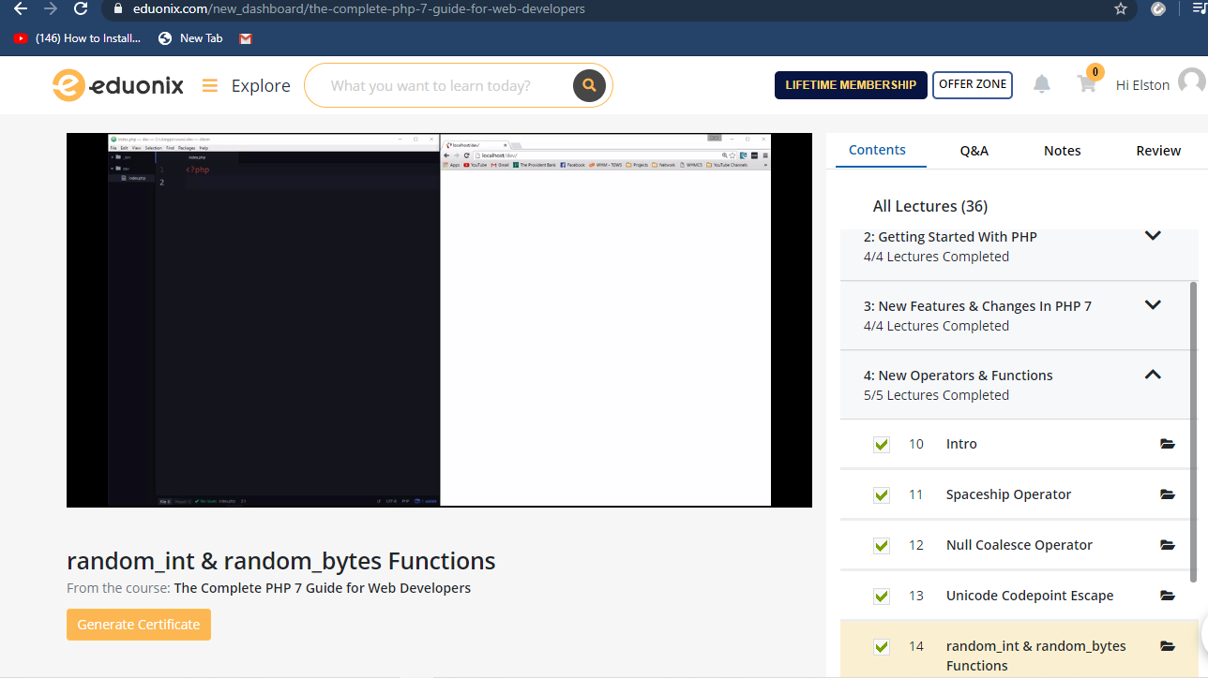

The above course is being taken up by me which is based on PHP 7 and its various concepts .The details of the course and certificate provider is mentioned in the above form.

Coding Challenges Details: (Attach the snapshot and briefly write the report for the same)

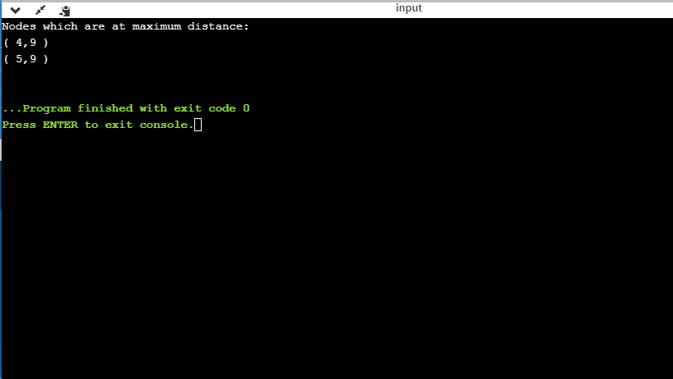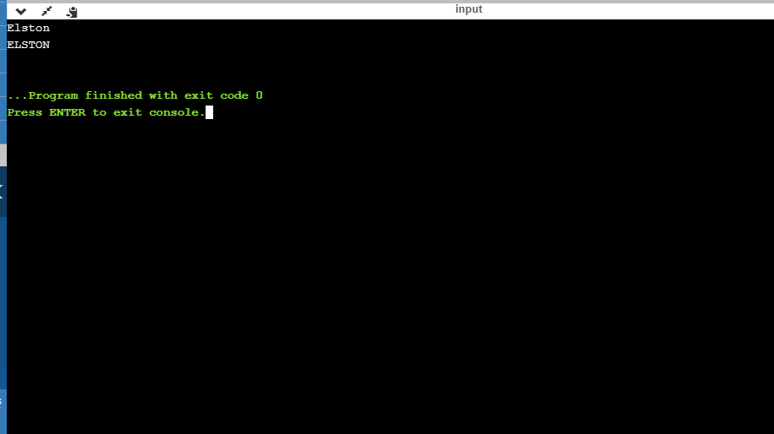

The above the programs were written and executed and the output of the same is displayed above. The code for the given 2 programs have been uploaded to the github repository and the link to the same is provided on the form.