## DAILY ONLINE ACTIVITIES SUMMARY

|  |  |  |  |  |  |  |  |  |
| --- | --- | --- | --- | --- | --- | --- | --- | --- |
| **Date:** | **13th June 2020** | | | | | **Name:** | **Dsouza Elston Ronald** | |
| **Sem & Sec** | **6th A section** | | | | | **USN:** | **4AL17CS029** | |
| **Online Test Summary** | | | | | | | | |
| **Subject** | | **Python Application Programming(PAP)** | | | | | | |
| **Max. Marks** | | **30** | | **Score** | | | **28** | |
| **Certification Course Summary** | | | | | | | | |
| **Course** | **The Complete PHP 7 guide for Web Developers** | | | | | | | |
| **Certificate Provider** | | | **Eduonix** | | **Duration** | | | **4 hours** |
| **Coding Challenges** | | | | | | | | |
| 1. Write a Python program to print the pattern. 2. Java program to find the firstt non repeated character of a given String. 3. Write a Java program to find whether given matrix is sparse matrix or not. 4. C program to generate electricity bill. | | | | | | | | |
| **Status: Completed** | | | | | | | | |
| **Uploaded the report in Github** | | | | | **Yes** | | | |
| **If yes Repository name** | | | | | <https://github.com/alvas-education-foundation/elston-dsouza> | | | |
| **Uploaded the report in slack** | | | | | **Yes** | | | |

Online Test Details: (Attach the snapshot and briefly write the report for the same)

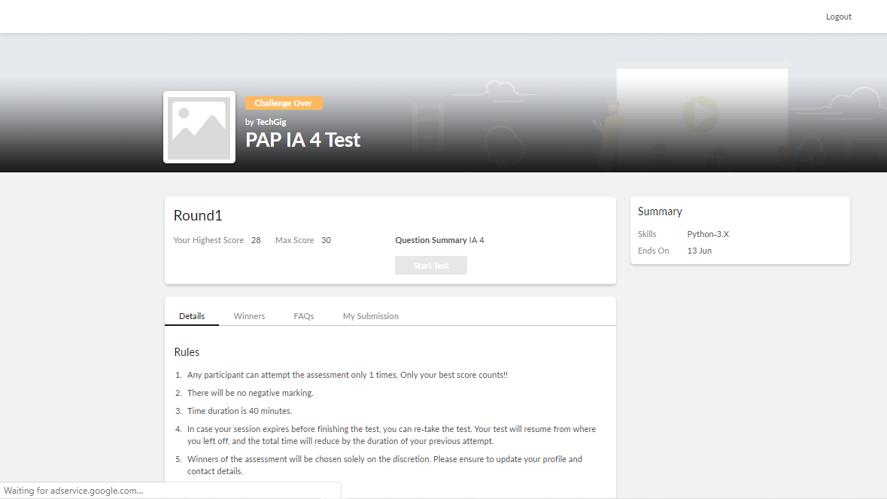

The above test was taken on 13th June from 10.30 to 11.10 am . Details of test are as follows.

Certification Course Details: (Attach the snapshot and briefly write the report for the same)

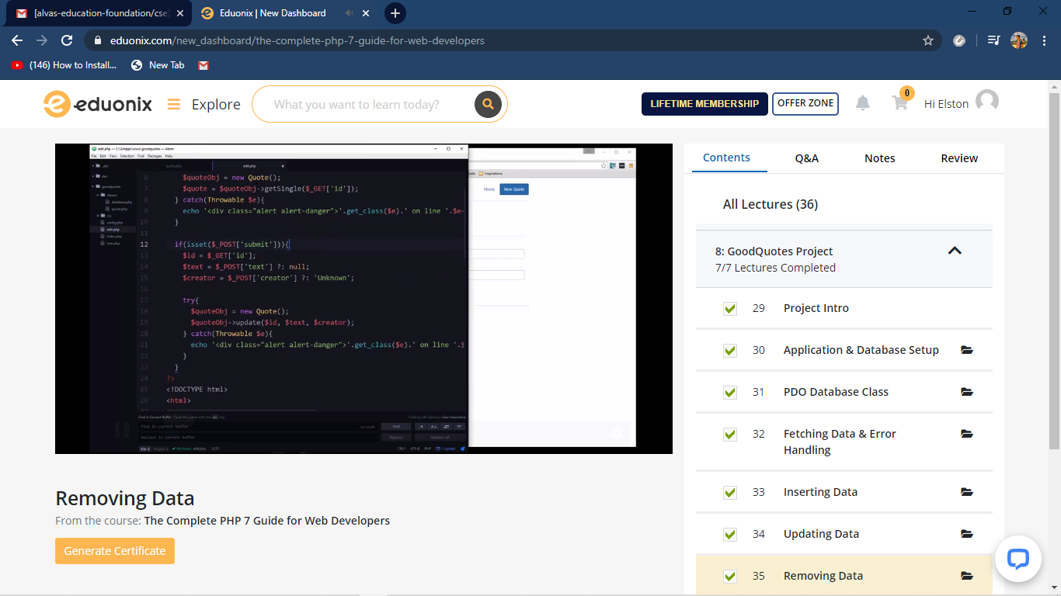

The above course is being taken up by me which is based on PHP 7 and its various concepts .The details of the course and certificate provider is mentioned in the above form.

Coding Challenges Details: (Attach the snapshot and briefly write the report for the same)

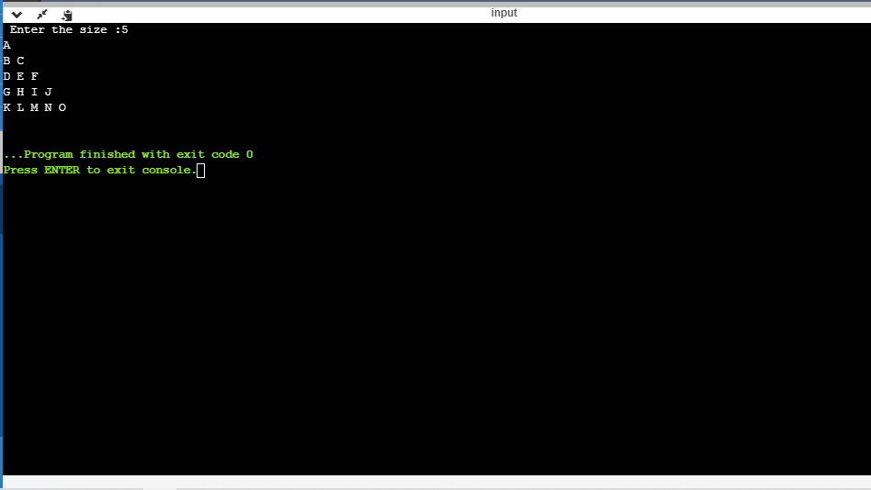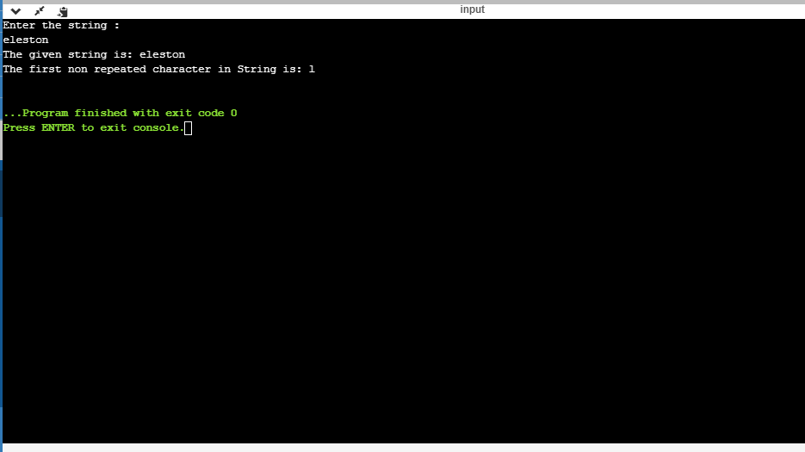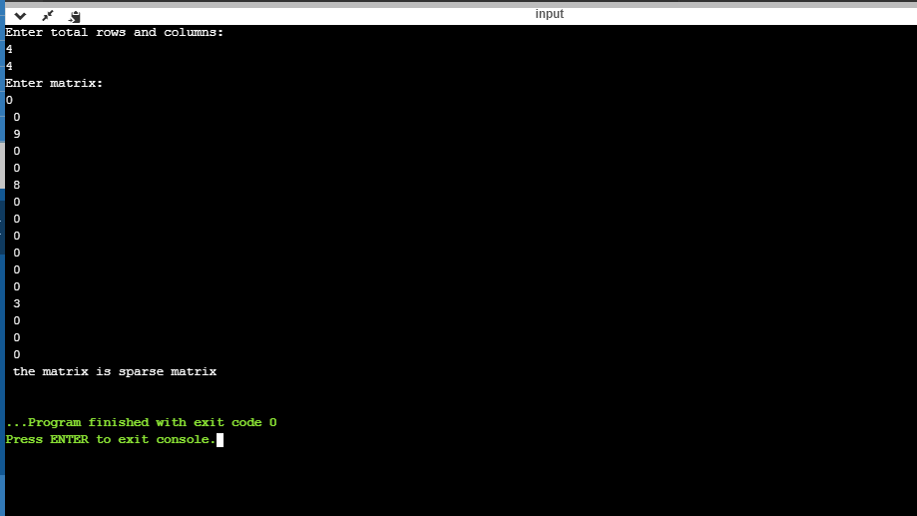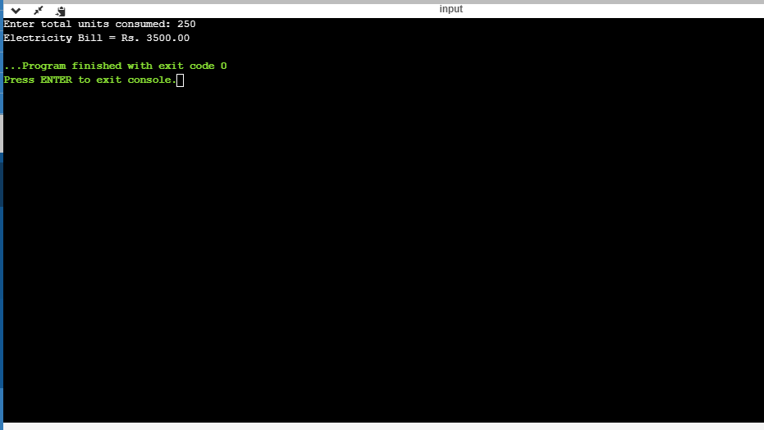

The above the programs were written and executed and the output of the same is displayed above. The code for the given 4 programs have been uploaded to the github repository and the link to the same is provided on the form.