## DAILY ONLINE ACTIVITIES SUMMARY

|  |  |  |  |  |  |  |  |
| --- | --- | --- | --- | --- | --- | --- | --- |
| **Date:** | **15th June 2020** | | | | **Name:** | **Dsouza Elston Ronald** | |
| **Sem & Sec** | **6th A section** | | | | **USN:** | **4AL17CS029** | |
| **Assesments** | | | | | | | |
| 1.The Programming assessment of the session ”Programming in C”  Condudcted by Mr.Vivek Sharma.The answer is as follows in github repository  <https://github.com/alvas-education-foundation/elston-dsouza>  2.The programming solutions of “data analytics with machine learning” conducted by Mr.Badusha Moideen are given in the above github repository  <https://github.com/elstonds/Python_application_in_DA_and_ML/tree/master/DAY1> | | | | | | | |
| **Online Test Summary** | | | | | | | |
| **Python assessment.** | | | | | | |
| **Max score: 20** | | **Score** | **18** | | | |
| **Status: Completed** | | | | | | | |
| **Uploaded the report in Github** | | | | **Yes** | | | |
| **If yes Repository name** | | | | <https://github.com/alvas-education-foundation/elston-dsouza> | | | |
| **Uploaded the report in slack** | | | | **Yes** | | | |

Test details:

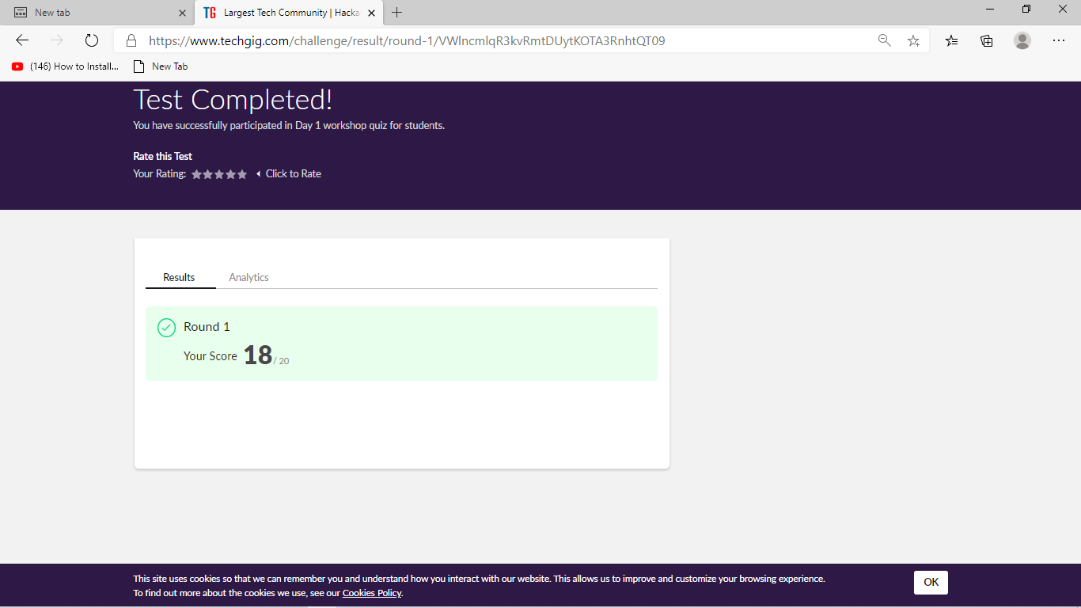

Above test taken on 15th june at 7.00pm .Details are above

Assesment details:

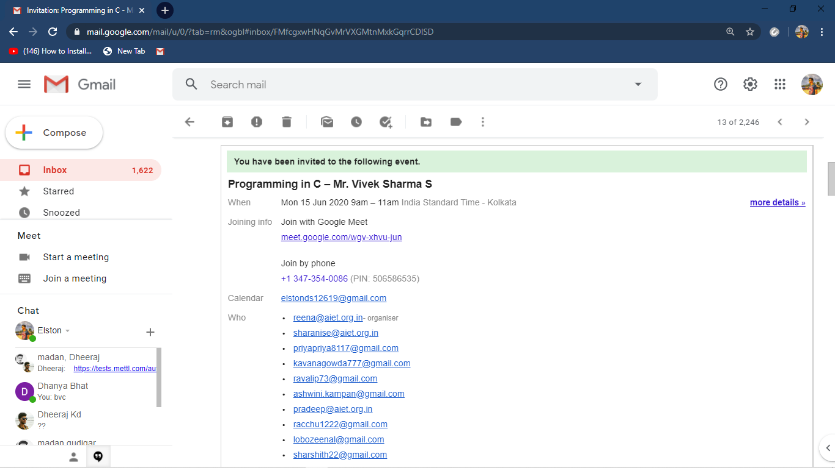

The above session was regarding Programming in C.In this various concpts of C as well as related topics were covered.The Session was from 9.00 to 10.30 am.

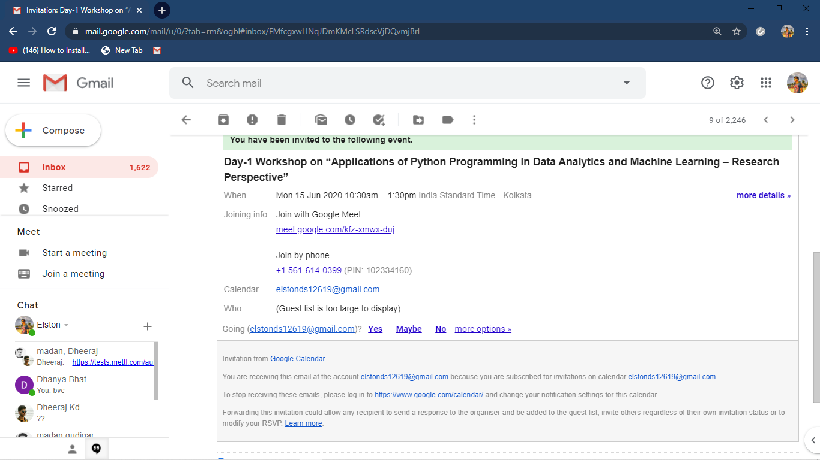

The above session was regarding Data Analytics with Machine Learning.In this various concpts of Python as well as related topics were covered.The Session was from 10.30 am to 1.00pm.